00 th January 20 xx,
- KU Leuven, Department of Chemistry, Celestijnenlaan 200F - P. O. Box 2404, B-3001 Leuven, Belgium.
* Corresponding author. E-mail: wim.dehaen@kuleuven.be
‡ Electronic Supplementary Information (ESI) available: characterisation, material and equipment specifications are available within supporting information. DOI: 10.1039/x0 xx00000 x
Accepted 00 th January 20 xx
DOI: 10.1039/x0 xx00000 x
www.rsc.org/
Synthesis of Guerbet ionic liquids and extractants as β-branched biosourceable hydrophobes‡
Giacomo Damilanoª, Koen Binnemansª, and Wim Dehaen*ª
This study investigates the synthesis of β-branched amines and β-branched quaternary ammonium chloride ionic liquids as novel extractants. The synthesis methodology was tailored to facilitate the reaction scale-up and the use of biorenewable starting materials. The developed process is an overall green, easy and straightforward synthesis of β-branched amines, and ammonium salts, starting from linear aldehydes. In order to evaluate the potential of the synthesised materials in applications, the rheology, density, thermal stability, chemical stability, phase transitions, mutual solubility with water of the novel extractants was studied.
Introduction
In 2012, the European Union plan ‘towards a sustainable European future’ supported a transition towards a more sustainable development.¹ Shifting from a fossil-based to a bio-based circular economy is key to this transition.² Because cost efficiency is the driving force for industry, the exploitation of cheap non-food biomass is the key for accessing a circular bioeconomy. Efficient use of platform biochemicals happens through reactions with a high atom economy (i.e. condensation, ketonisation, esterification and etherification reactions). These reactions are the means to a competitive synthesis of renewable building blocks.³ A successful example of sustainable biosourcing is ethanol. Nowadays, over 90% of ethanol derives from biomass fermentation, which overcame petrochemical synthesis in economic and environmental sustainability.^{3,4}
Tapping on biomaterials gathered the interest of both academic and industrial researchers.⁵ This shifted the focus back to condensation reactions as a mean to upgrade low-weight alcohols. The Guerbet reaction, discovered in 1909, is the condensation of linear alcohols to β-branched alcohols (i.e. Guerbet alcohols). Guerbet alcohols are surfactants with reduced viscosity, low irritation profile, and high thermal stability.⁶ Because of these features, Guerbet alcohols, acids and esters find wide use in detergents, cosmetics, emulsifiers, antistatic additives, inks, lubricants, and waxes.⁷ By conversion of Guerbet alcohols to amines new extractants for solvent extraction of metals could be designed.⁸ Quaternisation of these amines could lead to new quaternary ammonium ionic liquids (ILs).^{9,10}
A recent market analysis described the industrial under-usage of Guerbet additives in fine products; giving evidence of the potential economical worth of these compounds.¹¹ Currently, many chemical manufacturers (i.e. BASF, SASOL, Evonik) are commercialising Guerbet alcohols for industrial applications.¹² This highlights the commercial relevance of these compounds and the interest in devising a sustainable synthesis towards them.
Scheme 1. General reaction scheme of Guerbet condensation.
The Guerbet condensation can be rationalised as a three-step one-pot reaction. It comprises an alcohol oxidation, an aldol condensation and a reduction step (Scheme 1). Although Guerbet condensation produces ß-branched alcohols in a neat and straightforward way, the reaction has a low efficiency. Harsh reaction conditions are required and cause reduced selectivity towards the desired product.
A growing number of studies is aiming at devising suitable conditions to promote Guerbet condensation at an industrial scale. Yet, most of the discovered pathways still require harsh reactions conditions and suffer either from a narrow reaction scope, use of scarce and noxious catalysts, or a limited selectivity.^{13–16} The limits of the reported procedures are due to an elusive optimisation of reaction conditions, which at the same time would have to favour the alcohol oxidation and the unsaturated aldehyde reduction.¹⁴ Lack of optimal reaction conditions favours the formation of by-products (i.e. resulting from Tishchenko, Cannizzaro, Dieckmann reactions), limiting the overall yield.^{13,17–19}
In 2016, Biermann et al. suggested an alternative approach, based on splitting up the reaction in its composing steps (i.e. oxidation, condensation and reduction).^{13,20} Although effective, it relies on biocatalysis, which is a valuable approach but limited by the enzyme turnover number and substrate affinity. Because of the reported slow conversion and poor affinity of most enzymes for fatty alkyl chains, this approach was not suited to our goal.^{21,22} For the use in solvent extraction of metal ions, the amines and the ionic liquids have to be hydrophobic. Hydrophobicity is observed in compounds with a high carbon content. Therefore, the use of long alkyl chains could serve to this goal. However, this lengthening of the alkyl chains comes at a price, namely a sharp increase in viscosity due to the extensive dispersive interactions. The introduction of branching in the chains lowers the efficacy of these interactions, hence limiting the increase in viscosity.
Scheme 2. General reaction scheme of Hofmann elimination.
Moreover, branching in the β-position was designed to support ammonium ion base stability. Base instability of ammonium compounds is reported to be mainly due to Hofmann elimination. Hofmann elimination is an E2 degradation process caused by the concerted deprotonation in β to the nitrogen atom of an ammonium ion together with the cleavage of the nitrogen-carbon bond, resulting in the formation of a tertiary amine and an alkene (Scheme 2).^{23–25} Base-stable hydrophobic ionic liquids are of interest for solvent extraction of metal ions from alkaline media.²⁶
The β-branched structure hinders Hofmann elimination by reducing the number of β-protons and, more importantly, by increasing the steric hindrance around the remaining β-protons. This approach was effective in a former research on di(2-ethylhexyl)dimethylammonium (BEDMA) ionic liquids.²⁷
The structural similarity of our compounds to methyl-tri(octyl)-ammonium chloride (main component of Aliquat 336®), tri(octyl)amine (TOA, main component of Alamine 336®), and tri(2-ethylhexyl)amine (TEHA) suggest that they could be potential competitors in extractive metallurgical processes, while being stable at a broader pH range.
We report herein an adaptation of the Guerbet synthetical pathway to achieve a green and scalable procedure for the synthesis of longer-chain Guerbet aldehydes (Scheme 3). Then, the β-branched aldehydes were used in the synthesis of nitrogen derivatives (i.e. tertiary amine and ammonium ionic liquids), which are unreported, to the best of our knowledge, in the literature. Under the optimised reaction conditions, we were able to synthesise compounds in multigram scale, allowing for the physical characterisation of the produced materials.²⁷
Scheme 3. General schematic representation of the studied synthetic pathway.
Experimental
Chemicals and solvents
l-Lysine (98%, 56-87-1) and tri-N-octylamine (97%, 1116-76-3) were purchased from Acros Organics (Geel, Belgium). N-Methylformamide (99%, 123-39-7) was purchased from Alfa Aesar (Karlsruhe, Germany). Dimethyl carbonate (≥99.8%, 616-38-6) was purchased from Carl-Roth (Karlsruhe, Germany). formamide (99.5%, 75-12-7), calcium chloride anhydrous (95%+, 10043-52-4), and formic acid (99-100%, 64-18-6) were purchased from Chem-Lab (Zedelgem, Belgium). Palladium on activated carbon (10% Pd, unreduced, 7440-05-3) was purchased from J&K Scientific (Overpelt, Belgium). 1-hexanal (99.9%, 66-25-1), 1-heptanal (98.3%, 111-71-7), 1-octanal (99.8%, 124-13-0), 1-nonanal (99.2%, 124-19-6), 1-decanal (97.8%, 112-31-2), deuterochloroform (99.8 atom % D with 0.03 % (v/v) TMS, 865-49-6) and Raney®-Nickel 2800, slurry in water (≥89%, 7440-02-0) were purchased from Sigma-Aldrich (Diegem, Belgium). Sodium hydrogencarbonate (>99%, 144-55-8) was purchased from Fisher Scientific (Merelbeke, Belgium).
Petroleum ether (technical grade), methanol (technical grade), isopropanol (technical grade) and sodium hydroxide (Norma-pur) were obtained from VWR (Heverlee, Belgium). Petroleum ether was distilled prior to use to remove high boiling residues; all other chemicals were used without any further purification.
Instrumentation
Nuclear magnetic resonance spectra were recorded on a Bruker Avance 400 spectrometer. Fourier transform infrared spectra were recorded in ATR mode (attenuated total reflectance) on a Bruker Vertex 70 spectrometer equipped with a Bruker Platinum ATR module and a diamond crystal. HRMS spectra were acquired on a quadrupole orthogonal acceleration time-of-flight mass spectrometer (Synapt G2 HDMS, Waters, Milford, MA). Samples were infused at 3 uL/min and spectra were obtained in positive (or negative) ionization mode with a resolution of 15000 (FWHM) using leucine enkephalin as lock mass. The water content in samples was measured using a Mettler-Toledo V30S volumetric Karl Fischer titrator. Viscosities and densities were measured on an Anton-Paar Lovis 2000 M/ME rolling-ball viscometer and DMA 4500 M densitometer. TGA and DSC analysis were carried out on a TA Instruments TGA Q500 and a TA Instruments DSC Q2000 respectively, with a heating/cooling rate of 10 °C min⁻¹. Ionic liquids were pre-dried for 120 min at 80 °C before of the TGA measurement. Vacuum measurement were carried out with the Pfeiffer TPG 201 digital manometer. An Ismatec Reglo ICC peristaltic pump was used for the dropping of the reagents.
2-Butyl-1-octanal
The synthesis was carried out following the ESI. General procedures 9 and 10 with 1-hexanal (99.9%, 200 g, 200 cm³, 2 mol), L-lysine (14.7 g, 0.5 mmol), isopropanol (156 g, 260 cm³, 2.6 mol) and palladium over carbon (10% w/w loading, 6 g). Isolated yield 122.04 g, 66.3%. Colourless clear oil. Boiling point: (100 ± 5) °C, (1.5 ± 0.15) mbar. Density: 0.83050 g cm⁻³ (20.02 °C). Dynamic viscosity: 2.432 mPa/s (20.00 °C), Kinetic viscosity: 2.929 mm²/s (20.00 °C). ¹H NMR (400 MHz, CDCl₃, δ/ppm): 0.84 - 0.93 (6 H, m), 1.20 - 1.38 (13 H, m), 1.38 - 1.54 (2 H, m), 1.56 - 1.68 (2 H, m), 2.22 (1 H, ttd, J 8.36, 5.49, 5.45, 3.16), 9.56 (1 H, d, J 3.20). ¹³C NMR (100 MHz, CDCl₃, δ/ppm): 205.8, 52.0, 31.7, 29.4, 29.3, 29.0, 28.6, 27.1, 22.8, 22.6, 14.1, 13.9. IR (Diamond-ATR, neat, cm⁻¹): 2957, 2927, 2857, 2692, 1725, 1688, 1640, 1465, 1378, 1132, 1076, 1029, 936, 913, 896, 797, 725, 649, 565, 499, 488, 459, 446, 429, 420, 409. HRMS Calcd. for C₁₂H₂₄O: 184.1827 Found: [M-44] 137.0826.
2-Pentyl-1-nonanal
The synthesis was carried out following the ESI. General procedures 9 and 10 with 1-heptanal (98.3%, 232.33 g, 284 cm³, 2 mol), L-lysine (14.7 g, 0.5 mmol), isopropanol (156 g, 260 cm³, 2.6 mol) and palladium over carbon (10% w/w loading, 7 g). Isolated yield 173.74 g, 68%. Colourless clear oil. Boiling point: (109 ± 1) °C, (0.29 ± 0.029) mbar. Density: 0.83144 g cm⁻³ (20.02 °C). Dynamic viscosity: 4.085 mPa/s (20.00 °C), Kinetic viscosity: 4.913 mm²/s (20.00 °C). ¹H NMR (400 MHz, CDCl₃, δ/ppm): 0.73 - 1.03 (6 H, m), 1.19 - 1.36 (16 H, m), 1.36 - 1.51 (2 H, m), 1.51 - 1.79 (3 H, m), 2.22 (1 H, ttd, J 8.39, 5.49, 5.45, 3.17), 9.55 (1 H, d, J 3.18). ¹³C NMR (100 MHz, CDCl₃, δ/ppm): 205.8, 52.0, 31.9, 31.8, 29.7, 29.1, 29.0, 28.9, 27.1, 26.8, 22.7, 22.5, 14.1, 14.0. IR (Diamond-ATR, neat, cm⁻¹): 2956, 2925, 2855, 2693, 1725, 1459, 1378, 1266, 1042, 893, 821, 737, 724, 571, 473, 450, 406. HRMS Calcd. for C₁₄H₂₈O: 212.2140 Found: [M+1] 213.2208.
2-Hexyl-1-decanal
The synthesis was carried out under the ESI. General procedures 9 and 10 with 1-octanal (99.8%, 256.93 g, 314 cm³, 2 mol), L-lysine (14.7 g, 0.5 mmol), isopropanol(156 g, 260 cm³, 2.6 mol) and palladium over carbon (10% w/w loading, 8 g). Isolate yield 171.80 g, 67%. Colourless clear oil. Boiling point: (110 ± 1) °C, (0.40 ± 0.04) mbar. Density: 0.83162 g cm⁻³ (20.02 °C). Dynamic viscosity: 5.409 mPa/s (20.00 °C), Kinetic viscosity: 6.504 mm²/s (20.00 °C). ¹H NMR (400 MHz, CDCl₃, δ/ppm): 0.77 - 0.95 (6 H, m), 1.12 - 1.36 (20 H, m), 1.36 - 1.53 (3 H, m), 1.53 - 1.75 (2 H, m), 2.16 - 2.27 (1 H, m), 9.55 (1 H, d, J 3.18). ¹³C NMR (100 MHz, CDCl₃, δ/ppm): 205.8, 52.0, 31.9, 31.7, 29.7, 29.4, 29.4, 29.3, 29.0, 27.1, 27.1, 22.7, 22.6, 14.1, 14.1. IR (Diamond-ATR, neat, cm⁻¹): 2955, 2923, 2854, 2690, 1726, 1466, 1378, 1303, 1144, 962, 783, 722, 665, 565, 506, 484, 473, 462, 448, 437, 429, 419, 413. HRMS Calcd. for C₁₆H₃₂O: 240.2453 Found: [M-44] 197.1035.
2-Heptyl-1-undecanal
The synthesis was carried out under the ESI. General procedures 9 and 10 with 1-nonanal (99.2%, 286.77 g, 346 cm³, 2 mol), L-lysine (14.7 g, 0.5 mmol), isopropanol(156 g, 260 cm³, 2.6 mol) and palladium over carbon (10% w/w loading, 9 g). Isolate yield 179.21 g, 63%. Colourless clear oil. Boiling point: (128 ± 1) °C, (0.42 ± 0.042) mbar. Density: 0.83306 g cm⁻³ (20.02 °C). Dynamic viscosity: 7.201 mPa/s (20.00 °C), Kinetic viscosity: 8.645 mm²/s (20.00 °C). ¹H NMR (400 MHz, CDCl₃, δ/ppm): 0.81 - 0.95 (7 H, m), 1.18 - 1.37 (29 H, m), 1.37 - 1.52 (3 H, m), 1.52 - 1.69 (3 H, m), 2.22 (1 H, ttd, J 8.41, 5.49, 5.44, 3.15), 9.55 (1 H, d, J 3.09). ¹³C NMR (100 MHz, CDCl₃, δ/ppm): 205.8, 52.0, 31.9, 31.8, 29.7, 29.7, 29.5, 29.5, 29.3, 29.1, 29.0, 27.1, 22.7, 22.6, 14.1, 14.1. IR (Diamond-ATR, neat, cm⁻¹): 2955, 2922, 2853, 2689, 1727, 1651, 1465, 1377, 1069, 892, 809, 721, 662, 558, 526, 503, 497, 473, 455, 441, 430, 420, 412. HRMS Calcd. for C₁₈H₃₆O: 268.2766 Found: [M-44] 193.1949.
2-Octyl-1-dodecanal
The synthesis was carried out under the ESI. General procedures 9 and 10 with 1-decanal (97.8%, 318.38 g, 387 cm³, 2 mol), L-lysine (14.7 g, 0.5 mmol), isopropanol(156 g, 260 cm³, 2.6 mol) and palladium over carbon (10% w/w loading, 10 g). Isolate yield 202.38 g, 68.6%. Colourless clear oil. Melting point: (18.5 ± 1) °C, 1003 mbar. Boiling point: (145 ± 1) °C, (0.31 ± 0.031) mbar. Density: 0.84467 g cm⁻³ (20.02 °C). Dynamic viscosity: 15.82 mPa/s (20.00 °C), Kinetic viscosity: 18.73 mm²/s (20.00 °C). ¹H NMR (400 MHz, CDCl₃, δ/ppm): 0.84 - 0.92 (6 H, m), 1.16 - 1.35 (31 H, m), 1.36 - 1.49 (2 H, m), 1.56 - 1.67 (2 H, m), 2.22 (1 H, ttd, J 8.41, 5.53, 5.43, 3.14), 9.55 (1 H, d, J 3.21). ¹³C NMR (100 MHz, CDCl₃, δ/ppm): 205.8, 52.0, 31.9, 31.9, 29.7, 29.6, 29.6, 29.5, 29.4, 29.3, 29.2, 29.0, 27.1, 22.7, 22.7, 14.1, 14.1. IR (Diamond-ATR, neat, cm⁻¹): 2955, 2922, 2853, 2691, 1727, 1690, 1465, 1377, 1051, 721, 583, 506, 493, 473, 458, 453, 442, 434, 426, 414, 407. HRMS Calcd. for C₂₀H₄₀O: 296.3079 Found: [M-44] 252.2678.
Di(2-butyl-octyl)methylamine
The synthesis was carried out following the ESI. General procedure 11 with 2-butyl-1-octanal (90.3 g, 0.5 mol), formic acid (69.1 g, 56.6 cm³, 1.5 mol), N-methyl-formamide (133 g, 130 cm³, 2.25 mol), and Raney nickel (0.15 g). Isolated yield 77.8 g, 86.4%. Colourless clear oil. Density: 0.81769 g cm⁻³ (20.02 °C). Dynamic viscosity: 16.568 mPa/s (20.00 °C), Kinetic viscosity: 20.262 mm²/s (20.00 °C). ¹H NMR (400 MHz, CDCl₃, δ/ppm): 0.80 - 0.96 (12 H, m), 1.17 - 1.33 (32 H, m), 1.40 - 1.48 (1 H, m), 2.04 (4 H, d, J 7.08), 2.09 (3 H, s). ¹³C NMR (100 MHz, CDCl₃, δ/ppm): 63.7, 43.3, 35.8, 32.3, 32.0, 32.0, 29.9, 28.9, 26.6, 23.3, 22.7, 14.2, 14.1. IR (Diamond-ATR, neat, cm⁻¹): 2955, 2922, 2871, 2853, 2791, 2763, 1690, 1459, 1377, 1303, 1102, 1037, 864, 767, 722. HRMS Calcd. for C₂₅H₅₃N: 367.4178 Found: [M+1] 368.4261.
Di(2-pentyl-nonyl)methylamine
The synthesis was carried out following the ESI. General procedure 11 with 2-pentyl-1-nonanal (85.29 g, 0.4 mol), formic acid (69.1 g, 56.6 cm³, 1.5 mol), N-methyl-formamide (133 g, 130 cm³, 2.25 mol), Raney nickel (0.15 g). Isolated yield 61.18 g, 71.9%. Colourless clear oil. Density: 0.81811 g cm⁻³ (20.02 °C). Dynamic viscosity: 25.06 mPa/s (20.00 °C), Kinetic viscosity: 30.631 mm²/s (20.00 °C). ¹H NMR (400 MHz, CDCl₃, δ/ppm): 2.09 (3 H, s), 2.04 (4 H, d, J 7.06), 1.40 - 1.49 (2 H, m), 1.17 - 1.35 (41 H, m), 0.82 - 0.95 (12 H, m). ¹³C NMR (100 MHz, CDCl₃, δ/ppm): 63.7, 43.4, 35.9, 32.5, 32.3, 32.3, 30.3, 29.4, 26.7, 26.3, 22.8, 22.7, 32.0, 14.2, 14.1. IR (Diamond-ATR, neat, cm⁻¹): 2955, 2921, 2853, 2791, 2763, 1690, 1459, 1377, 1301, 1102, 1035, 863, 722. HRMS Calcd. for C₂₉H₆₁N: 423.4804 Found: [M+1] 424.4863.
Di(2-hexyl-decyl)methylamine
The synthesis was carried out following the ESI. General procedure 11 with 2-hexyl-1-decanal (120.13 g, 0.5 mol), formic acid (69.1 g, 56.6 cm³, 1.5 mol), N-methyl-formamide (133 g, 130 cm³, 2.25 mol), nickel-Raney (0.15 g). Isolate yield 94.96 g, 79.2%. Colourless clear oil. Density: 0.82189 g cm⁻³ (20.02 °C). Dynamic viscosity: 33.283 mPa/s (20.00 °C), Kinetic viscosity: 40.496 mm²/s (20.00 °C). ¹H NMR (400 MHz, CDCl₃, δ/ppm): 0.82 - 0.96 (12 H, m), 1.16 - 1.35 (49 H, m), 1.39 - 1.50 (3 H, m), 2.04 (4 H, d, J 7.02), 2.09 (3 H, s). ¹³C NMR (100 MHz, CDCl₃, δ/ppm): 63.7, 43.4, 35.9, 32.0, 32.0, 30.3, 30.0, 29.7, 29.4, 26.7, 26.6, 22.8, 22.7, 14.1, 32.3. IR (Diamond-ATR, neat, cm⁻¹): 2955, 2921, 2852, 2791, 1691, 1459, 1377, 1302, 1034, 850, 721. HRMS Calcd. for C₃₃H₆₉N: 479.5430 Found: [M+1] 480.5513.
Di(2-heptyl-undecyl)methylamine
The synthesis was carried out following the ESI. General procedure 11 with 2-heptyl-1-undecanal (134.88 g, 0.5 mol), formic acid (69.1 g, 56.6 cm³, 1.5 mol), N-methyl-formamide (133 g, 130 cm³, 2.25 mol), nickel-Raney (0.15 g). Isolate yield 117.64 g, 87.4%. Colourless clear oil. Density: 0.82521 g cm⁻³ (20.02 °C). Dynamic viscosity: 42.956 mPa/s (20.00 °C), Kinetic viscosity: 52.055 mm²/s (20.00 °C). ¹H NMR (400 MHz, CDCl₃, δ/ppm): 0.84 - 0.93 (12 H, m), 1.18 - 1.32 (57 H, m), 1.40 - 1.48 (2 H, m), 2.04 (4 H, d, J 7.05), 2.09 (3 H, s). ¹³C NMR (100 MHz, CDCl₃, δ/ppm): 63.7, 43.4, 35.9, 14.1, 22.7, 32.3, 32.0, 32.0, 30.3, 30.3, 29.8, 29.7, 29.5, 29.4, 26.7. IR (Diamond-ATR, neat, cm⁻¹): 2955, 2921, 2852, 2791, 1731, 1690, 1460, 1377, 1301, 1034, 857, 720. HRMS Calcd. for C₃₇H₇₇N: 535.6056 Found: [M+1] 536.6127.
Di(2-octyl-dodecyl)methylamine
The synthesis was carried out following the ESI. General procedure 11 with 2-octyl-1-dodecanal (150 g, 0.5 mol), formic acid (69.1 g, 56.6 cm³, 1.5 mol), N-methyl-formamide (133 g, 130 cm³, 2.25 mol), nickel-Raney (0.15 g). Isolate yield 125.53 g, 83.8%. Colourless clear oil. Density: 0.82628 g cm⁻³ (20.02 °C). Dynamic viscosity: 48.272 mPa/s (20.00 °C), Kinetic viscosity: 58.421 mm²/s (20.00 °C). ¹H NMR (400 MHz, CDCl₃, δ/ppm): 0.88 (12 H, t, J 6.61), 1.19 - 1.34 (64 H, m), 1.39 - 1.49 (2 H, m), 2.04 (3 H, d, J 7.02), 2.09 (2 H, s). ¹³C NMR (100 MHz, CDCl₃, δ/ppm): 63.7, 43.4, 35.8, 14.1, 22.7, 26.7, 32.3, 32.0, 30.3, 29.8, 29.7, 29.7, 29.4, 29.4. IR (Diamond-ATR, neat, cm⁻¹): 2955, 2921, 2852, 1730, 1689, 1462, 1377, 1301, 1179, 1036, 720. HRMS Calcd. for C₄₁H₈₅N: 591.6682 Found: [M+1] 592.6763.
Tri(2-butyl-octyl)amine
The synthesis was carried out following the ESI. General procedure 12 with 2-butyl-1-octanal (14.59 g, 0.08 mol), formic acid (45.0 g, 36.88 cm³, 0.75 mol), formamide (33.8 g, 29.89 cm³, 0.75 mol), nickel-Raney (0.15 g). Isolate yield 6.58 g, 47.8%. Colourless clear oil. Density: 0.82859 g cm⁻³ (20.02 °C). Dynamic viscosity: 72.161 mPa/s (20.00 °C), Kinetic viscosity: 87.089 mm²/s (20.00 °C). ¹H NMR (400 MHz, CDCl₃, δ/ppm): 2.02 (6 H, d, J 5.97), 1.12 - 1.38 (56 H, m), 0.84 - 0.94 (19 H, m). ¹³C NMR (100 MHz, CDCl₃, δ/ppm): 61.1, 36.4, 32.4, 32.1, 32.0, 14.1, 14.2, 22.8, 23.4, 26.8, 29.1, 30.1, 30.1, 30.0. IR (Diamond-ATR, neat, cm⁻¹): 2955, 2922, 2872, 2855, 2791, 2763, 1457, 1419, 1377, 1300, 1230, 1192, 1165, 1141, 1113, 1099, 1041, 855, 779, 724, 560, 490, 468, 452, 444, 437, 426, 419, 411, 403. HRMS Calcd. for C₃₆H₇₅N: 521.5899 Found: [M+1] 522.5970.
Tri(2-hexyl-decyl)amine
The synthesis was carried out following the ESI. General procedure 12 with 2-hexyl-1-decanal (25.96 g, 28.95 cm³, 0.1 mol), formic acid (45.0 g, 36.88 cm³, 0.75 mol), formamide (33.8 g, 29.89 cm³, 0.75 mol), nickel-Raney (0.15 g). Isolate yield 17.54 g, 70.6%. Colourless clear oil. Density: 0.82979 g cm⁻³ (20.02 °C). Dynamic viscosity: 90.088 mPa/s (20.00 °C), Kinetic viscosity: 108.57 mm²/s (20.00 °C). ¹H NMR (400 MHz, CDCl₃, δ/ppm): 0.83 - 0.94 (18 H, m), 1.11 - 1.37 (76 H, m), 2.01 (6 H, d, J 5.84). ¹³C NMR (100 MHz, CDCl₃, δ/ppm): 61.1, 36.4, 14.1, 22.7, 22.8, 26.8, 26.8, 29.5, 29.8, 30.1, 30.4, 32.0, 32.0, 32.4, 32.4. IR (Diamond-ATR, neat, cm⁻¹): 2955, 2920, 2871, 2852, 2803, 1458, 1377, 1298, 1156, 1077, 890, 721, 543, 478, 458, 451, 438, 420, 410, 404. HRMS Calcd. for C₄₈H₉₉N: 689.7777 Found: [M+1] 690.7862.
Tri(2-heptyl-undecyl)amine
The synthesis was carried out following the ESI. General procedure 12 with 2-heptyl-1-undecanal (27.90 g, 0.1 mol), formic acid (45.0 g, 36.88 cm³, 0.75 mol), formamide (33.8 g, 29.89 cm³, 0.75 mol), nickel-Raney (0.15 g). Isolate yield 20.88 g, 77.8%. Colourless clear oil. Density: 0.83287 g cm⁻³ (20.02 °C). Dynamic viscosity: 103.19 mPa/s (20.00 °C), Kinetic viscosity: 123.90 mm²/s (20.00 °C). ¹H NMR (400 MHz, CDCl₃, δ/ppm): 1.15 - 1.35 (87 H, m), 2.01 (6 H, d, J 5.87), 0.84 - 0.94 (18 H, m). ¹³C NMR (100 MHz, CDCl₃, δ/ppm): 61.1, 14.1, 22.7, 36.4, 32.4, 32.0, 32.0, 30.4, 30.4, 29.9, 29.8, 29.5, 29.4, 26.9, 26.9. IR (Diamond-ATR, neat, cm⁻¹): 2955, 2920, 2871, 2851, 1465, 1377, 1297, 1104, 1077, 889, 721, 480, 462, 437, 421, 407. HRMS Calcd. for C₅₄H₁₁₁N: 773.8716 Found: [M+1] 773.8679.
Tri(2-octyl-dodecyl)amine
The synthesis was carried out following the ESI. General procedure 12 with 2-octyl-1-dodecanal (28.54 g, 0.1 mol), formic acid (45.0 g, 36.88 cm³, 0.75 mol), formamide (33.8 g, 29.89 cm³, 0.75 mol), nickel-Raney (0.15 g). Isolate yield 22.59 g, 77.8%. Colourless clear oil. Melting point: -3.03 °C, Heat of fusion: 3.990 J/g; Crystallization temperature: -18.50 °C, Heat of crystallization: 3.450 J/g. Density: 0.83355 g cm⁻³ (20.02 °C). Dynamic viscosity: 104.56 mPa/s (20.00 °C), Kinetic viscosity: 125.44 mm²/s (20.00 °C). ¹H NMR (400 MHz, CDCl₃, δ/ppm): 0.82 - 0.92 (18 H, m), 1.13 - 1.36 (99 H, m), 2.01 (6 H, d, J 5.90). ¹³C NMR (100 MHz, CDCl₃, δ/ppm): 61.1, 36.4, 14.1, 22.7, 26.9, 32.4, 30.4, 29.4, 29.5, 29.8, 29.8, 29.9, 32.0, 32.0. IR (Diamond-ATR, neat, cm⁻¹): 2955, 2920, 2851, 1465, 1377, 1298, 1151, 1073, 887, 720, 555, 474, 464, 436, 419, 412, 404. HRMS Calcd. for C₆₀H₁₂₃N: 857.9655 Found: [M+1] 859.8108.
Di(2-butyl-octyl)dimethylammonium chloride ([C_{8,β4}C_{8,β4}C₁C₁N][Cl])
The synthesis was carried out following the ESI. General procedure 13 with di(2-butyl-octyl)methylamine (0.843 g, 2.3 mmol), calcium chloride (95%, 0.6 g, 5.4 mmol), dimethyl carbonate (2.80 g, 3 cm³, mmol), methanol (0.792 g, 1 cm³, mmol). Isolate yield 0.902 g, 94.2%. Yellow clear oil. ¹H NMR (400 MHz, CDCl₃, δ/ppm): 1.83 (1 H, p, J 5.54, 5.46), 1.13 - 1.63 (32 H, m), 0.90 (12 H, dt, J 12.91, 6.61), 3.37 - 3.51 (11 H, m). ¹³C NMR (100 MHz, CDCl₃, δ/ppm): 70.5, 33.8, 33.5, 33.2, 31.7, 29.4, 28.4, 26.3, 22.8, 22.6, 14.1, 14.1, 14.0, 50.7, 50.6, 50.8. IR (Diamond-ATR, neat, cm⁻¹): 3372, 3010, 2954, 2925, 2856, 1626, 1486, 1466, 1377, 1042, 971, 892, 725, 582, 518, 510, 492, 467, 459, 426, 419, 414. HRMS Calcd. for [C₂₆H₅₆N][Cl]: 417.4101 Found: [M-35] 382.4415.
Di(2-pentyl-nonyl)dimethylammonium chloride ([C_{9,β5}C_{9,β5}C₁C₁N][Cl])
The synthesis was carried out following the ESI. General procedure 13 with di(2-pentyl-nonyl)methylamine (0.877 g, 2.1 mmol), calcium chloride (95%, 0.6 g, 5.4 mmol), dimethyl carbonate (2.80 g, 3 cm³, mmol), methanol (0.792 g, 1 cm³, mmol). Isolate yield 0.915 g, 93.3%. Amber clear oil. ¹H NMR (400 MHz, CDCl₃, δ/ppm): 1.77 - 1.85 (1 H, m), 1.12 - 1.57 (41 H, m), 0.81 - 0.99 (12 H, m), 3.32 - 3.56 (11 H, m). ¹³C NMR (100 MHz, CDCl₃, δ/ppm): 71.9, 70.5, 53.5, 50.7, 33.8, 33.7, 33.2, 31.9, 31.8, 29.7, 29.2, 26.3, 26.0, 22.6, 22.6, 14.1, 14.0. IR (Diamond-ATR, neat, cm⁻¹): 3379, 2954, 2922, 2853, 1709, 1487, 1466, 1377, 971, 901, 722, 669, 558, 507, 486, 463, 456, 446, 439, 425, 417. HRMS Calcd. for [C₃₀H₆₄N][Cl]: 473.4727 Found: [M-35] 438.5037.
Di(2-hexyl-decyl)dimethylammonium chloride ([C_{10,β6}C_{10,β6}C₁C₁N][Cl])
The synthesis was carried out following the ESI. General procedure 13 with di(2-hexyl-decyl)methylamine (0.866 g, 1.8 mmol), calcium chloride (95%, 0.6 g, 5.4 mmol), dimethyl carbonate (2.80 g, 3 cm³, mmol), methanol (0.792 g, 1 cm³, mmol). Isolate yield 0.768 g, 80.29%. Amber clear oil. ¹H NMR (400 MHz, CDCl₃, δ/ppm): 1.57 - 1.65 (1 H, m), 0.98 - 1.27 (49 H, m), 0.63 (12 H, t, J 6.72), 3.02 - 3.35 (10 H, m). ¹³C NMR (100 MHz, CDCl₃, δ/ppm): 71.2, 70.1, 53.3, 50.4, 48.7, 39.7, 33.5, 32.8, 31.5, 31.6, 29.5, 29.2, 29.2, 29.0, 26.0, 26.0, 22.4, 22.4. IR (Diamond-ATR, neat, cm⁻¹): 3357, 2954, 2921, 2852, 1739, 1674, 1485, 1465, 1377, 1072, 889, 720, 579, 493, 481, 473, 451, 427, 420, 415. HRMS Calcd. for [C₃₄H₇₂N][Cl]: 529.5353 Found: [M-35] 494.5663.
Di(2-heptyl-undecyl)dimethylammonium chloride ([C_{11,β7}C_{11,β7}C₁C₁N][Cl])
The synthesis was carried out following the ESI. General procedure 13 with di(2-heptyl-undecyl)methylamine (0.824 g, 1.5 mmol), calcium chloride (95%, 0.6 g, 5.4 mmol), dimethyl carbonate (2.80 g, 3 cm³, mmol), methanol (0.792 g, 1 cm³, mmol). Isolate yield 0.886 g, 98.4%. Amber clear oil. ¹H NMR (400 MHz, CDCl₃, δ/ppm): 1.77 - 1.83 (1 H, m), 1.09 - 1.57 (57 H, m), 0.88 (12 H, t, J 6.63), 3.28 - 3.60 (10 H, m). ¹³C NMR (100 MHz, CDCl₃, δ/ppm): 72.0, 70.5, 53.5, 50.7, 33.8, 33.2, 31.9, 31.8, 29.7, 29.7, 29.6, 29.6, 29.3, 29.2, 26.3, 22.7, 22.6, 14.1, 14.1. IR (Diamond-ATR, neat, cm⁻¹): 2954, 2921, 2852, 1673, 1485, 1465, 1377, 1076, 966, 917, 721, 587, 489, 466, 459, 434, 414. HRMS Calcd. for [C₃₈H₈₀N][Cl]: 585.5979 Found: [M-35] 550.6298.
Di(2-octyl-dodecyl)dimethylammonium chloride ([C_{12,β8}C_{12,β8}C₁C₁N][Cl])
The synthesis was carried out following the ESI. General procedure 13 with di(2-octyl-dodecyl)methylamine (0.826 g, 1.4 mmol), calcium chloride (95%, 0.6 g, 5.4 mmol), dimethyl carbonate (2.80 g, 3 cm³, mmol), methanol (0.792 g, 1 cm³, mmol). Isolate yield 0.757 g, 84.5%. Dark brown oil. Density: 0.82628 g cm⁻³ (20.02 °C). Dynamic viscosity: 48.27 mPa/s (20.00 °C), Kinetic viscosity: 58.42 mm²/s (20.00 °C). ¹H NMR (400 MHz, CDCl₃, δ/ppm): 3.38 - 3.51 (10 H, m), 1.80 (1 H, d, J 5.67), 1.21 - 1.51 (65 H, m), 0.88 (12 H, dd, J 6.97, 2.08). ¹³C NMR (100 MHz, CDCl₃, δ/ppm): 71.9, 70.5, 53.6, 50.7, 33.8, 33.2, 31.8, 31.8, 29.7, 29.5, 29.4, 29.3, 26.3, 26.3, 22.7, 22.6, 14.1, 14.1. IR (Diamond-ATR, neat, cm⁻¹): 3353, 2954, 2922, 2853, 1713, 1668, 1652, 1485, 1465, 1377, 969, 894, 722, 588, 564, 531, 508, 488, 476, 468, 458, 440, 421, 414, 404. HRMS Calcd. for [C₄₂H₈₈N][Cl]: 641.6605 Found: [M-35] 606.6912.
Results and discussion
Step I. Alcohol oxidation
In the literature, complete conversion and full selectivity is reported for the oxidation of linear and branched alcohols to aldehydes.^{28–30} The process is virtually optimal and sustainable; so, competing with these research studies was not an objective of our research. Biermann et al. demonstrated the feasibility of this step, in tandem to the following step.^{13,31,32} Moreover, aldehydes themselves are abundantly available natural products (e.g. cynnamaldehyde, vanillin, citral, piperonal).
Step II. Aldol condensation
The aldol condensation is a two-step reaction directed to the formation of a C-C double bond in β to the aldehyde group. The homo aldol condensation is an important industrial reaction giving access to α,β-unsaturated aldehydes, which are a versatile synthetical class of compounds.³³ α,β-Unsaturated aldehydes are very reactive, which turns them into useful intermediates for organic synthesis, but makes them also sensitive to both light and oxygen.^{19,33,34}
In the literature, the aldol condensation was carried out with various catalysts, amongst which inorganic bases,³⁵ Lewis acids,³⁶ amines,³⁷ and amino-acids.^{38,39} Amino-acid catalysed condensations are appealing because of the low-cost, high turnover and low-risk safety profile, which grants them the status of green bio-catalysts. Amino acids are reported as efficient catalysts in enamine-activated reactions.^{14,40–43} Amino acids hold a privileged position within bio-catalysis, since they are bearing both an amino and an acid function.⁴⁴ This flexibility, coupled to the robustness of the catalyst, allowed to use amino acids in many multi-step one-pot reactions.⁴⁵
l-Lysine is present in the class I aldolase active site as a catalytic enamine forming moiety.⁴⁶ Hence, it is foreseeable that l-lysine itself could be a catalyst for aldol condensation. In several protocols, l-lysine was reported to result under mild conditions in quantitative conversion to the target product.^{38,39} Thus, we focused on l-lysine as the catalyst, also in relation to its availability, low-cost, and safety profile.³⁸ We performed various tests to reproduce and improve the literature results from a lab-scale to an industrially scalable green process.³⁸
Table 1. Solvent effect on aldol conversion.
Solvent | Yield (%)
Cyclohexane | 42 (24 h)⁶
Diethyl ether | 0 (6 h)⁶
Methyl tert-butyl ether | 0 (6 h)⁶
2-Methyl-THF | 0 (6 h)³,⁵,⁶
Dimethyl sulphoxide (DMSO) | 16 (24 h)
Water | 10 (3 h)⁵
Acetonitrile | 0 (6 h)⁴,⁶
Methanol | 53 (24 h)⁵
Ethanol | ≈99 (6 h)¹,²,³,⁶
Propyl alcohol | ≈99 (6 h)¹,²,³,⁶
Isopropyl alcohol | ≈99 (6 h)¹,²,³,⁶,⁷
1-Butanol | ≈99 (6 h)¹,²,³,⁶
2-Butanol | ≈99 (6 h)¹,²,³,⁶
tert-Butanol | 41 (6 h)⁶
Glycerol | 7 (6 h)⁶
Methyl acetate | 0 (6 h)⁶
Propyl acetate | 0 (6 h)⁶
Isopropyl acetate | 6−7% (6 h)⁶
tert-Butyl acetate | 0 (6 h)⁶
Acetone | 2 (24 h)
Dimethyl carbonate (DMC) | 0 (6 h)⁶
¹ only solvent and product signals observed.
² trace signals of intermediate and/or starting material observed.
³ terminal carbon area not viable. Yield deduced not by signal ratio but by the absence of side-product signals or starting materials.
⁴ very broad signals, only qualitative result.
⁵ byproduct observed.
⁶ non-deuterated solvent.
⁷ confirmed via GC-MS
The reported yield is an rough estimate obtained by the peak ratio between the ratio of the integration of the terminal carbon area (i.e. 0.71-1.06 ppm) and the unsaturated aldehyde signals (i.e. 9.36, 6.36 ppm). In the evaluation it has to be considered that the aldehydic proton is labile and in a basic environment, signal intensity comparison is best between proximal areas, and strong signals near the ones in analysis may influence the overall integration results. Signal integration has a minimum error above 5 %.
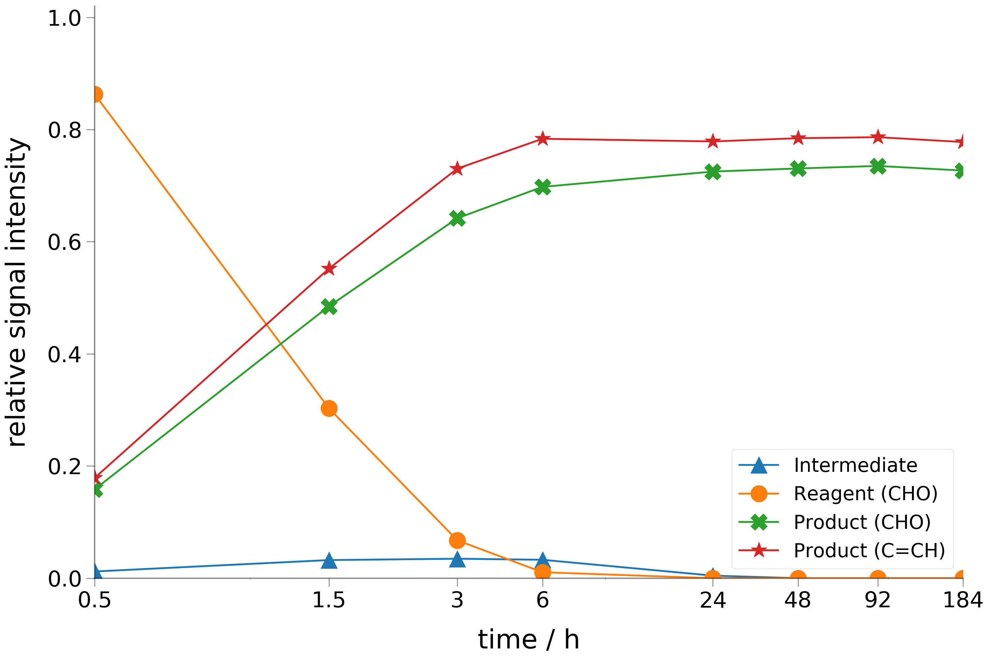
Figure 1. Reaction screening of l-Lysine catalysed hexanal condensation at room temperature (22 °C) via ¹H NMR in deuterochloroform. The signal intensity was normalised against the integration range 1.08 - 0.73 ppm. The linear aldehyde (orange full circle marker; ¹H NMR, 1H(s) 9.71 - 9.58 ppm) reacts with the L-lysine forming an enamino-adduct (blue triangle marker; 1H NMR, 1H(s) 10.07 - 9.97 ppm), which condenses with a second aldehyde equivalent to form the α,ß-unsaturated aldehyde (red star marker ,¹H NMR, 1H(s) 9.30 – 9.19 ppm; green cross marker ,¹H NMR, 1H(t) 6.50 – 6.20 ppm).
We performed a screening of solvents beneficial to the process and the environment (ESI. General procedure 1).^{47–51} Solvent choice affected both reaction rate and selectivity. We achieved selective conversion in weak and mildly polar solvents (i.e. ethanol, isopropanol). Amongst the tested solvents, most alcoholic solvents gave quantitative conversion within 6 h at room temperature (20-22 °C). In alcoholic solvents, the reaction rate showed an inverse proportionality to the solvent chain length and branching. Overall, isopropanol and ethanol were the best performers. In all tested solvents, the reaction achieved a selective conversion towards the E-stereoisomer, confirmed via ¹H NMR coupling constants.^{52,53} This stereo selectivity appears therefore not to be influenced by the solvent.
Reaction by-products were observed in polar protic solvents (i.e. methanol, water, acetonitrile). Stabilisation of polar intermediates and solvent coordination to the carbonyl oxygen may be some of the underlying factors responsible for undesired condensation reactions (i.e. Mannich, cyclic aldols, lactones and glycols). Solvents containing an ester or ketone group curtailed the l-lysine catalytic activity. This could be due to a competitive inhibition caused by the solvent in the l-lysine interaction with the aldehyde.^{17–19}
We tested catalyst loading at various concentrations reporting quantitative conversion within a reasonable time scale (≈6 h) with a minimum of 0.05 eq. of l-lysine (ESI. General procedure 2). Below this concentration, the reaction was significantly slower. In order to reduce solvent consumption and to facilitate the upscaling of the reaction, we also optimised the substrate concentration (ESI. General procedure 3). Reactions at about and below a concentration of 5 mol L⁻¹ resulted in quantitative conversion without substantial by-product formation.
A direct proportionality between the reaction temperature and the reaction rate was observed. This was deduced by the initial higher conversion rate (Figure 1) which occurred in conjunction to a noticeable heat release from the reaction pot. This may be indicative of an self-catalytic reaction, in which the heat released by the exotermic condensation step accelerates the imino-intermediate formation with L-Lysine; favouring the overall reaction conversion. Under the same conditions, substrates with longer chains required longer reaction times. Attempting the reaction at 40 °C allowed us to observe quantitative conversion and selectivity for all the substrates within 4.5−6 h.
We tested the reaction scope under the optimised conditions (ESI. General procedure 4). We used 2-ethyl-1-butanal to study the substrate scope of the reaction. Not having hydrogen atoms in the position α to the aldehyde, the aldol reaction product resulting from 2-ethyl-1-butanal could not undergo the dehydration step. The reaction achieved only partial conversion to the 2,2,4-triethyl-3-hydroxyhexanal derivative after several days. The low yield may be caused by steric hindrance. Moreover, computational thermodynamics analysis showed aldol condensation to be favoured by the exergonic dehydration step, which stabilises products over reagents, supporting and exploiting the reduced reactivity.¹⁴ All of these results suggest that the dehydration step is rate-limiting. Under current conditions, the process is therefore limited to aldehydes comprising two hydrogen atoms in the α position with respect to the aldehyde functionality. Branched aldehydes such as 3,7-dimethyl-oct-6-enal(citronellal) and 3,7-dimethyl-octanal(dihydrocitronellal), having their branching further in the chain, were also tested; they showed quantitative conversion in about 6 h at 40 °C. Citronellal therefore showed catalyst compatibility thanks to its isolated double bonds and minor sterical hindrance.
We tested the reaction up to 2 mole scale without major variations (ESI. General procedure 5). The exothermic reaction may need of temperature control at larger scales. We found mixing not to be critical to the reaction outcomes (vide. ESI. General procedure 1). α,β-Unsaturated aldehydes are sensitive to both light and oxygen. Because of this sensitivity, our attempts to isolate them caused partial product decomposition. Isolation was possible via flash chromatography or via batch solvent extraction.³⁸ Thus, avoidance of intermediate purification would improve process sustainability. Hence, we avoided isolation and used the crude adduct directly in the next step.
Step III. Chemoselective alkene reduction
Selective reduction of α,ß-unsaturated aldehydes was reported using a wide variety of catalysts and reaction conditions.^{54–56}. The interest in these compounds rises from their use as versatile precursors. Some examples of possible derivatives are unsaturated alcohols, saturated alcohols, and saturated aldehydes. In our study, the latter product was synthesised via a catalytic chemoselective alkene reduction.
Both palladium on carbon (Pd/C) and a nickel sulphide (Ni_{x}-S_{y}) were reported as selective catalysts for the reduction of 2-ethyl-2-hexenal under 0.9MPa of hydrogen pressure.⁵⁵ In a benchmark study of 15 catalysts tested for the reduction of 2-ethyl-2-hexenal, palladium on carbon showed the highest degree of selectivity towards the saturated aldehyde under harsh conditions (240 °C, 7 h, 6 MPa).⁵⁷ On the other hand, under mild conditions, palladium on carbon displayed full selectivity for the aldehyde derivative with various substrates (i.e. cinnamaldehyde, citral).^{58,59} Although nickel has a higher elemental abundance, we preferred palladium on carbon because of the high selectivity, high activity at near atmospheric pressure, and reduced health risk profile. On these premises, we proceeded in further optimising the reaction conditions.
We achieved a complete conversion within 48 hours at atmospheric pressure with a minimum of 3% w/w of the catalyst (Pd/C with 10% Pd loading ) (ESI. General procedure 6). In contrast to what has been reported, the palladium catalyst showed gradual deactivation and we needed to reactivate the catalyst after use (ESI. General procedure 7).⁵⁵ The deactivation rate was limited and dependent on the reaction conditions. After two days in contact with the α,ß-unsaturated aldehyde, we observed no further catalytic activity. Hence, facilitating the hydrogren transfer to the liquid phase was central to outrun catalyst deactivation. This could be achieved via increasing the interfacial area between the heterogeneous phases through vigorous mixing and via adjusting the topology of the reaction vessel. This was acted by moving from stirring the solution in a round bottom flask to a conical flask shaken on a orbital shaker; which increased the liquid-gas interfacial area, favouring hydrogen absorption by the solution.
After use, the catalyst was separated via vacuum filtration on Celite. The catalyst was removed from the Celite pad and reactivated via methanol washes (ESI. General procedure 7). The catalyst could thus be recycled up to 5 times without a remarkable difference in activity (The test was carried out at 0.1 mole scale). We tested the reaction up to one mole of product. Furthermore, telescoping was applicable allowing to directly couple aldol condensation and alkene reduction in a one-pot two step reaction (ESI. General procedure 8).
Purification of the crude sample was acted via a batch extraction followed by a high vacuum distillation (ESI. General procedure 10). With the exception of 2-butyl-octan-1-al, direct distillation was not applicable for the synthesised compounds. At the conditions of distillation, thermal decomposition processes impeded the achievement of the vacuum levels needed for the distillation and the material decomposed before getting distilled. Batch extraction was beneficial to avoid the decomposition processes. Aqueous solutions of organic and inorganic acids were tested as work-up, but they were not able to remove the impurities from the organic layer (i.e. 10% v/v of hydrochloric acid, sulphuric acid, formic acid, phosphoric acid, and acetic acid). The crude reaction mixture was miscible with all common organic solvents (i.e. alcohols, esters, ethers, alkanes, acetone, DMSO, DMF, dimetylcarbonate). In further miscibility tests, formic acid was found to be poorly miscible with the aldehyde and able to remove the impurities from the crude reaction mixture via catalysing condensation processes. This allowed to define an extractive reactive purification procedure for the reaction mixture. Then, distillation was used to ensure complete purification of the β branched aldehyde and to avoid possible degradative processes (e.g. aldol condensation).
Step IV. Modified Leuckart-Wallach reaction
By reacting a mixture of formamide and formic acid with an aldehyde or a ketone, the Leuckart reaction yields a mixture of amines and formyl amines.⁶⁰ The reaction is also known as the Leuckart-Wallach reaction after Otto Wallach, who extended the reaction scope to primary and secondary amines.⁶¹ In 1930s, a renewed interest encouraged investigations on the reaction pathway and the optimal reaction conditions.^{62–69} These studies tested a wide variety of conditions and showed a remarkable variability of the reaction yields in relation to minor procedural variations (i.e. water content, amine, temperature, catalysts, addition).⁶³ Because of this variability, the reaction pathway was never fully identified.
Following the reported results, we tailored the reaction to our substrates. In general, the Leuckart reaction forms primary amines in good to excellent yields. However, we achieved tertiary amines with traces of primary amines, secondary amines, and their formyl derivatives. A similar product distribution was previously reported by Horii et al for the reaction of hydrophobic aldehydes (i.e. 1-hexanal), but using urea and formic acid as in-situ precursor of formamide.⁷⁰
The substrates used in this study were immiscible with formic acid and water, suggesting hydrophobicity might be a key element of the divergence with the literature results.^{60,62} This allowed us to define a straightforward procedure towards tertiary amines.
The reaction optimisation was carried out with 2-butyl-octan-1-al as substrate. Initial reaction screening was done via the microwave procedure reported by Loupy et al.⁶⁵ This procedure showed to be effective with Guerbet aldehydes, achieving a mixture of amines and formyl amines with a significant component of the tertiary amine.
By cross-comparing the results achieved by Kost et al., Horii et al. and Loupy et al, a set of favourable conditions was devised to facilitate a batch Leuckart reaction.^{62,65,70} Two sets of conditions were tested: in the former, all the reagents were mixed at once, in the latter, the reagents were dropped onto the hot amide over a period of 1.5 h.
The one-pot procedure was ineffective, achieving an adduct unstable to the formyl acidic cleavage procedure (HCl, 100 °C, 1 h). The ¹H NMR spectra of the adduct was compatible with a double imino urea intermediate (we achieved similar results with the procedure of Yang et al).⁷¹ This hypothesis was also compatible with a reported equilibrium between urea, formic acid and formamide (Scheme 4).⁷⁰ However, full material characterisation was not carried out because it was out of the scope of our research. Adding the reagents to the hot amide achieved instead a mixture of amines and formyl amines (ESI. General procedure 12). To reach full converson, the reaction time was adjusted to 3.5 h.
Scheme 4. General reaction scheme if the interconversion of between urea and formamide in presence of formic acid.
The purification was realised via an anti-solvent separation of the tertiary amine. In methanol, the tertiary amine phase-separated, allowing for an easy purification of the final product. Because the crude mixture could easily form a suspension in methanol, we worked with small volumes to easily break the emulsion via centrifugation of the sample. The concentrated methanol washings yielded a mixture of amines and formyl amines, which could partly substitute the Guerbet aldehyde in following batches. This variation did not significantly affect the final product yield. We then attempted the substitution of formamide with the N-methyl formamide. This modification was successful, allowing us to synthesise the mono methyl derivative (ESI. General procedure 11). Also, the substitution of formamide with N,N-dimethyl formamide was tested but it did not yielded the dimethyl amino derivative.
Step V. Dimethyl carbonate quaternisation
Scheme 5. Nucleophilic substitution of dimethyl carbonate. Reaction mechanism is outlined for the B_{AC}2 and the B_{AL}2, which takes place at about 90 °C and above 120 °C respectively. The methylation temperature has a strong dependency to the nucleophile strength.
Methylation reactions commonly involve carcinogenous chemicals. In the latest years, the use of dimethyl carbonate (DMC) as green and effective methylation agent has been described as a safer alternative to noxious chemicals such as methyl halides, dimethyl sulphate or trimethyloxonium tetrafluoroborate.^{72–74} Clear advantages are the harmlessness and low cost of this material.^{75,76}
Methylation with dimethyl carbonate happens at above 120 °C, whereas acylation is the main reaction occurring at about 90 °C (Scheme 5).⁷⁴ β-Branched amines required harsh reaction conditions for methylation process. Due to the immiscibility of the reagents, reaction kinetics were slow, but, at high pressure and temperature, thermodynamics pushed the reaction to completion.⁷⁷ This approach is also advantageous for the eventual metathesis process, which happens because the driving force of the metathesis is the methyl carbonate anion decomposition. In standard conditons, the hydrolysis of methyl carbonate to carbon dioxide and methanol is irreversible. This forces the metathesis and, in the presence of an adequate excess of acid, it allows to attain a quantitative conversion, leaving only trace impurities. Therefore, an autoclave methylation was carried out with dimethyl carbonate, which could be eventually adapted to an industrial scale.
We ran test reactions in a 15 cm³ polytetrafluoroethylene-lined autoclave. The use of a lining excluded any possible metal-catalysed acceleration of the dimethyl carbonate decomposition to dimethyl ether and methyl acetate.⁷⁸ We tested different reaction temperatures; achieving optimal reaction conditions at 145 °C (ESI. General procedure 13). Above this temperature (i.e. 170 °C), a fishy smell, lower yields, and a darker colour developed; which suggested a partial decomposition of the amino starting material. Below the optimal reaction temperature (i.e. 120 °C), the reaction did not occur.
At 145 °C, the reaction did not go to completion, suggesting that tuning the reaction conditions could help in forcing the reaction equilibrium (e.g. an increase of pressure).^{14,79} To shift the reaction equilibrium to the direction of the products, we used calcium chloride as in situ metathesis reagent. Under these conditions, we observed complete conversion after 48 hours, allowing for the isolation of the ionic liquid in high yields. Then, the excess of calcium chloride was removed via an anti-solvent precipitation and filtration (ESI. General procedure 13).
Physico-chemical characterisation
We carried out preliminary characterisation on some properties relevant to extractive metallurgy. Our analysis focused on practical usability, chemical stability and both environmental and economical viability of the process. Therefore, four main features were adressed: rheology, thermal stability, chemical stability, and water phase interactions (i.e. solubility, saturation, phase interactions).
Rheology addressed the physical usability of the materials. This allowed to assess the most appropriate conditions of usage (e.g. viscous materials requires either dilution or high working temperatures). Moreover, β-branched Guerbet alkyl chains generally hold a remarkably wide liquid range, whose characterisation is valuable in the effort of understanding these novel materials. Stability to process conditions is a requirement for the development of a new process. Hence, both chemical and thermal stabilities were evaluated. Solubility in water was measured to assess the possible process losses and the eventual recovery steps.
In the following paragraphs, we will analyse first the extractants (i.e. tertiary amines) and then the ionic liquids (i.e. ammonium chlorides). If not stated otherwise, characterisations followed the guidelines defined by OECD.⁸⁰
Amines
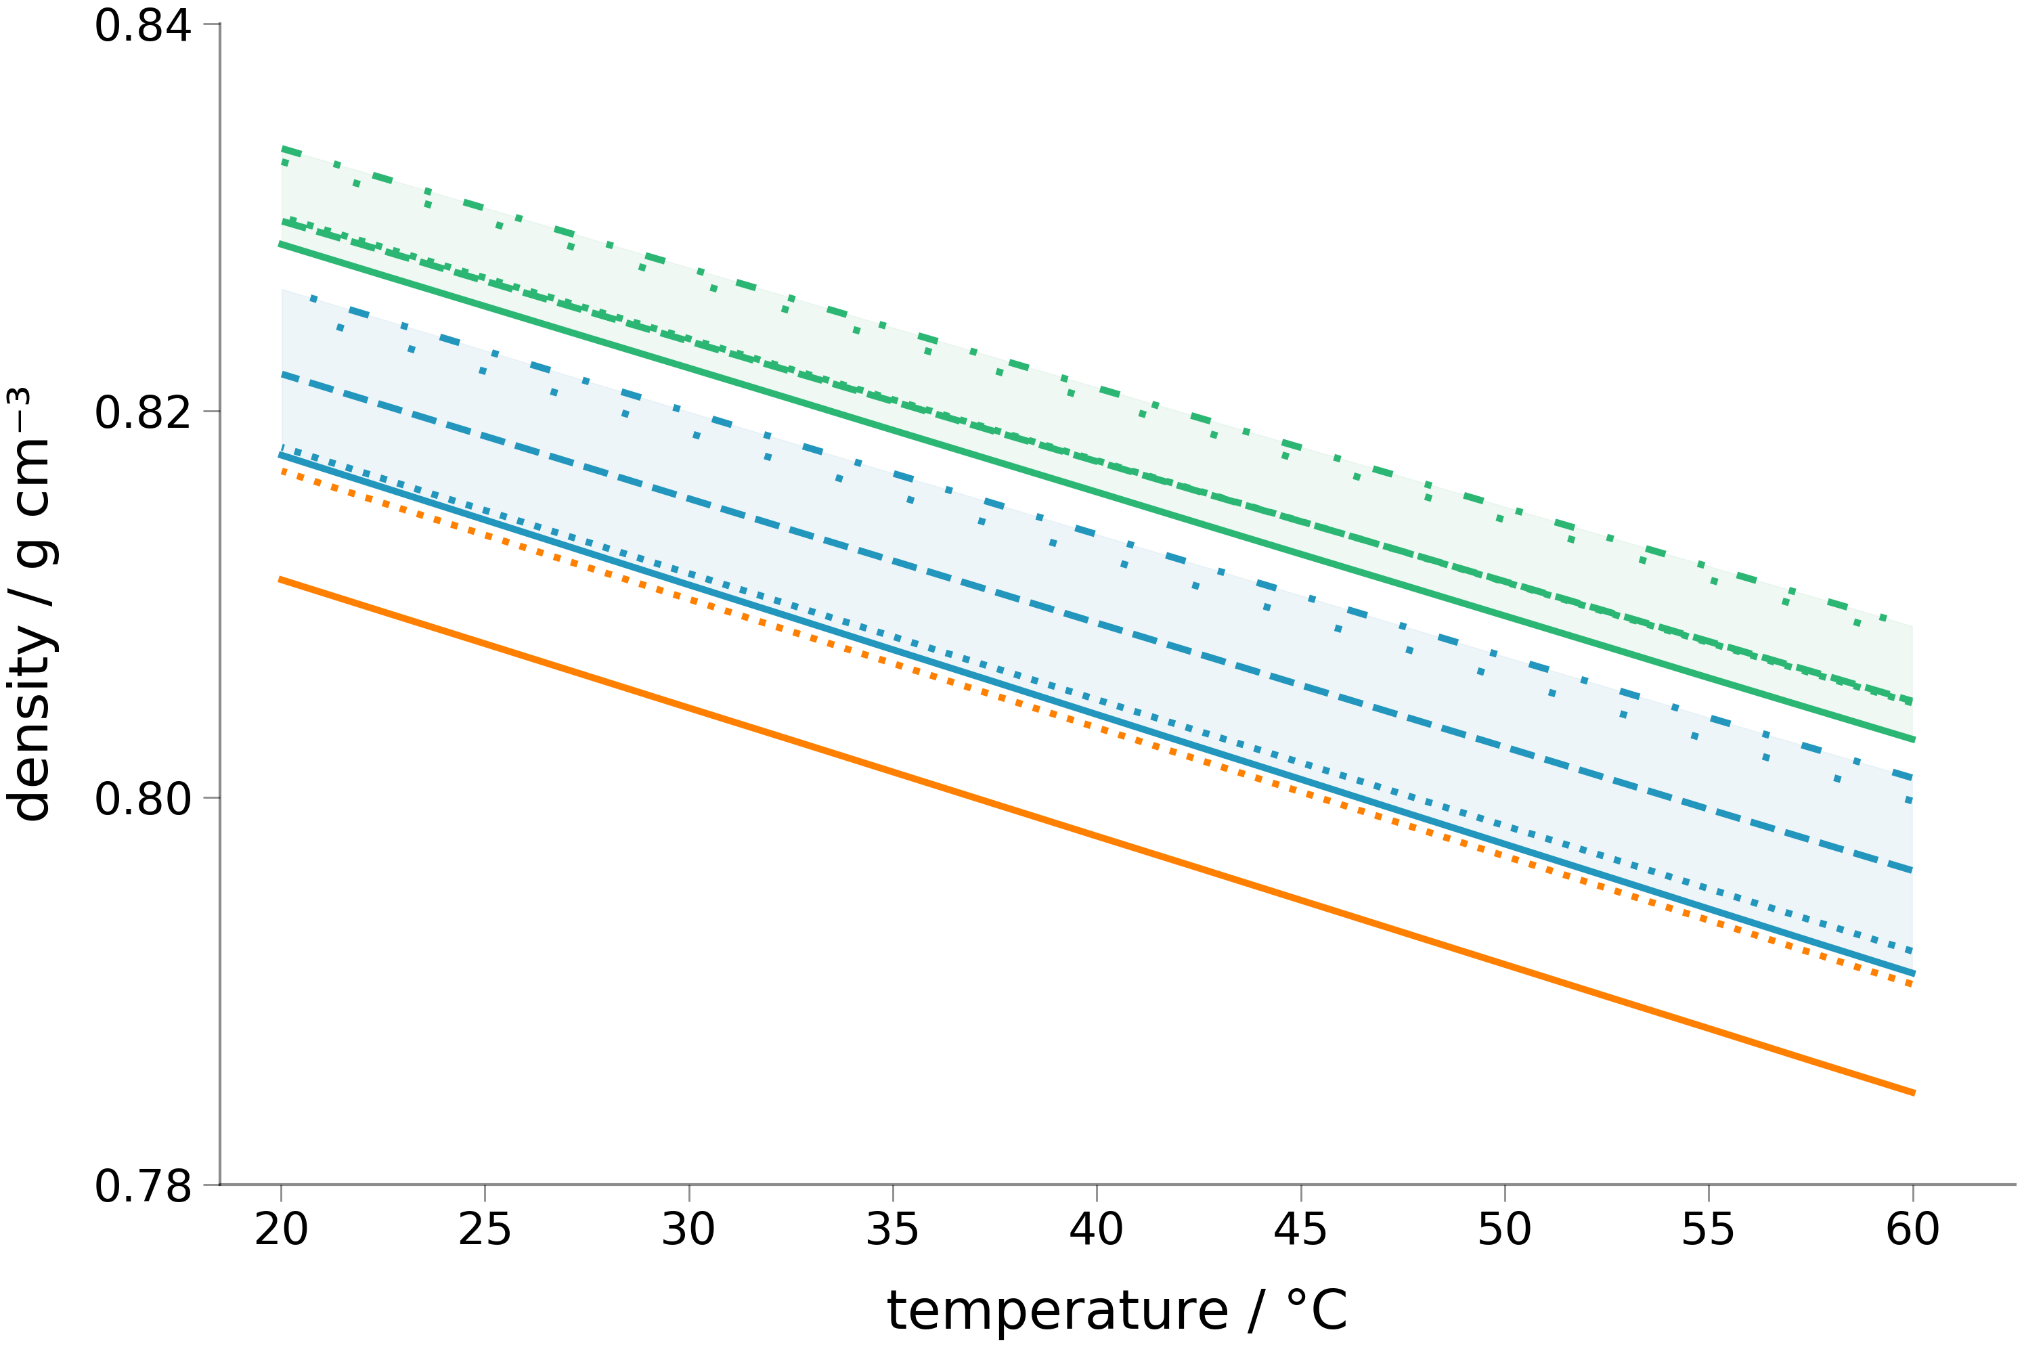
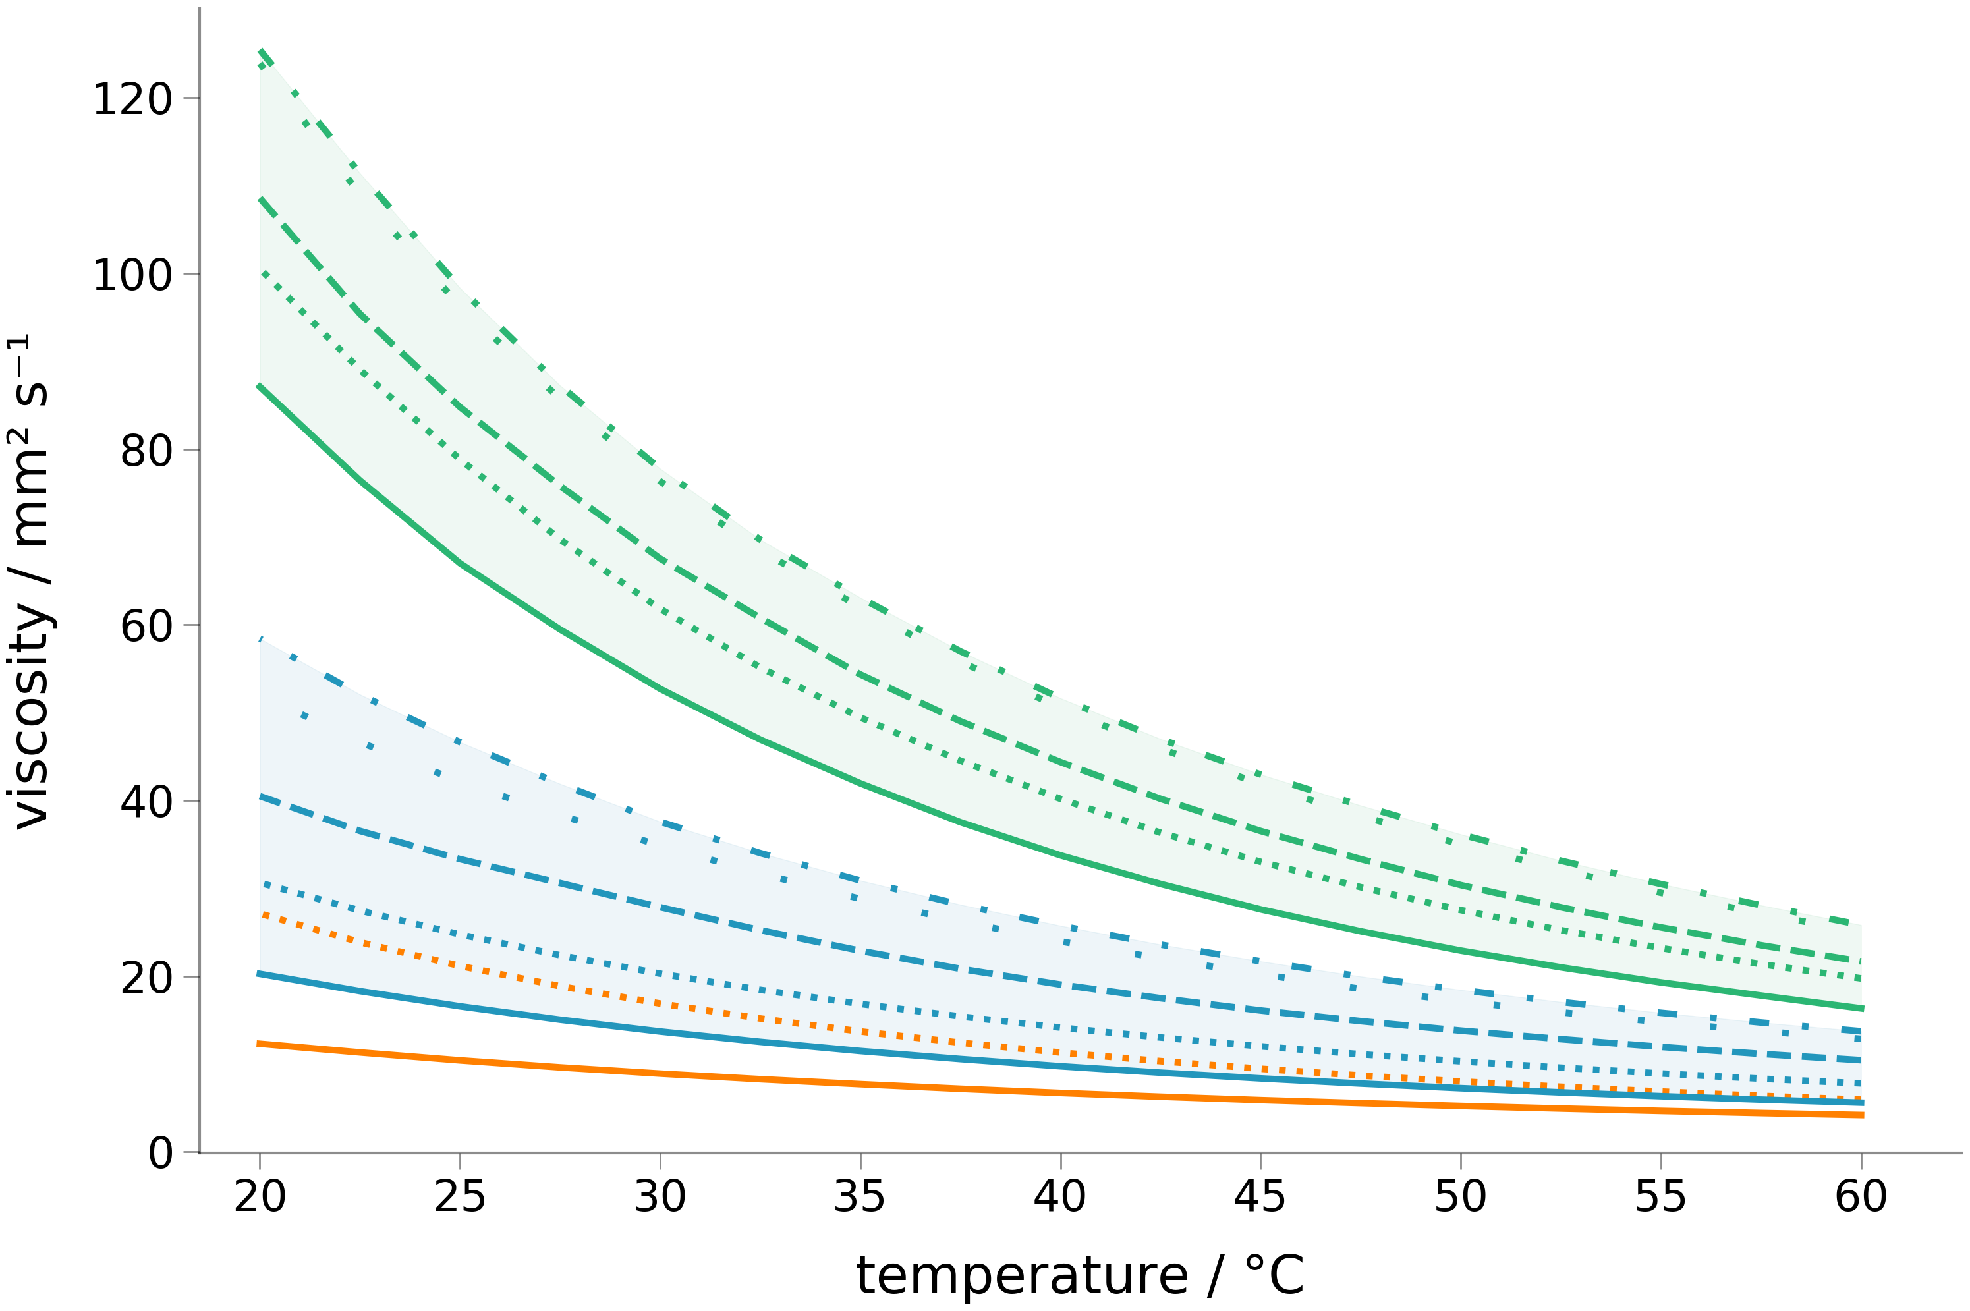

Figure 2. Viscosimetric and densitometric analysis of the synthesised amines. The measurement were carried out between 20 and 60 °C via a scan of 2.5 degrees step. In light blue are shown the di(alkyl)methylamines and in green the tri(alkyl)amines. Each alkyl chain is depicted with a different line-style (e.g. di(2-butyl-octyl)methylamine and tri(2-butyl-octyl)amine are depicted with a full line).
A viscosimetric analysis was carried out via a rolling-ball viscosimeter (Figure 2). By comparing compounds holding about the same number of carbon atoms (i.e. tri(2-ethylhexyl)amine, di(2-butyloctyl)amine and tris(octyl)amine), the viscosimetric analysis shows a clear increase in viscosity with the increase in chain branching. The difference in viscosity is significant at room temperature, but on heating the values lessen and converge at 60 °C. The convergence is especially appearent for the β-branched derivatives, whereas the linear homologue always has a slightly lower viscosity. The reported viscosities are moderate, suggesting a possible use of the materials also as undiluted substances in metallurgical processes.
Densitimetry was carried out via a oscillation densitometer (Figure 2). The density of the synthetised materials ranges between 0.815-0.835 g cm⁻³ at 20 °C and 0.790-0.810 g cm⁻³ at 60 °C. The reduced densities suggest that in a biphasic system the material would generally be on top of a polar solvent, which generally holds a higher density (i.e. water, and methanol).
Preliminary solubility tests in water were carried out via a visual observation of the dissolution of a known amount of sample substance. All the synthesised compounds showed solubilities below 1 g dm⁻³. Then, we tested the lightest derivatives in a more accurate assessment of their water solubility (i.e. di(2-butyl-octyl)methylamine and tri(2-butyl-octyl)amine).
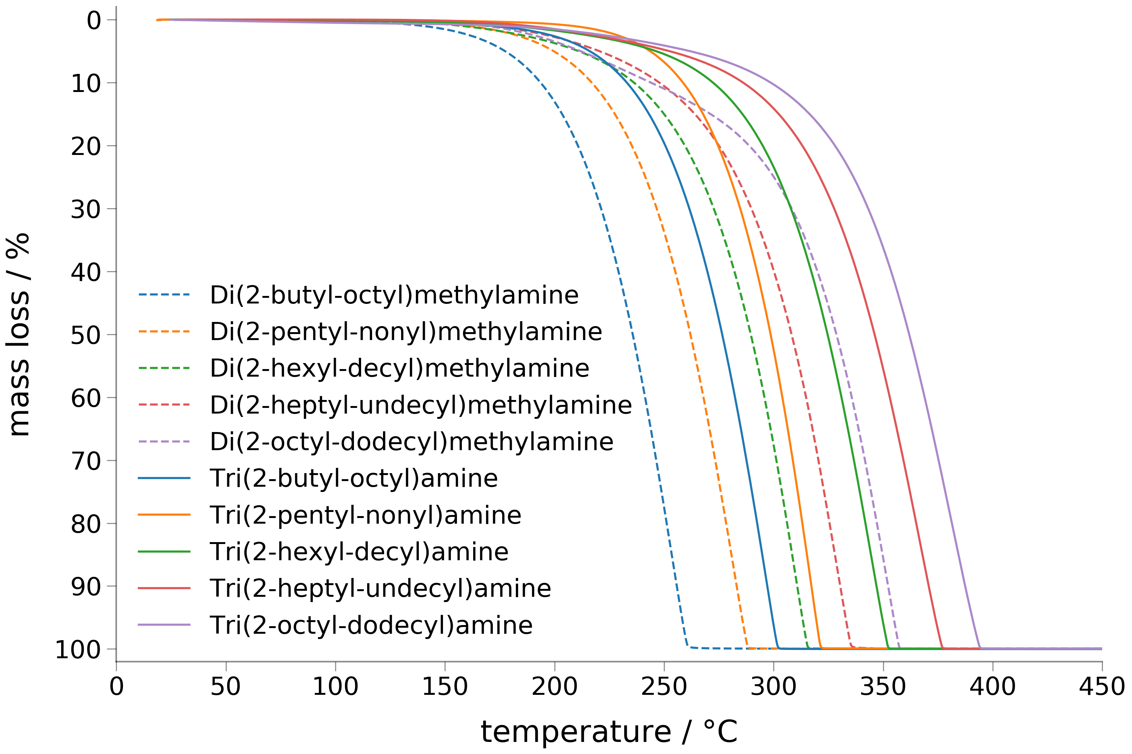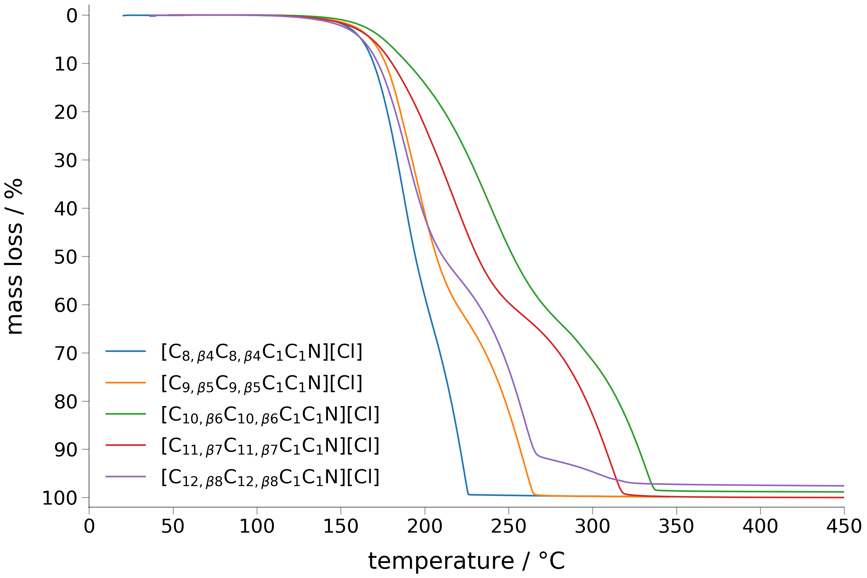
Figure 3. Dynamic TGA thermographs of the synthesised compounds measured under a nitrogen flow of 60 cm³ min⁻¹ with a heating rate of 10 °C min⁻¹ between 20 and 500 °C. In the legend the ammonium ion are reported with the following notation: di(2-butyl-octyl)dimethylammonium chloride ([C_{8,β4}C_{8,β4}C₁C₁N][Cl]), di(2-pentyl-nonyl)dimethylammonium chloride ([C_{9,β5}C_{9,β5}C₁C₁N][Cl]), di(2-hexyl-decyl)dimethylammonium chloride ([C_{10,β6}C_{10,β6}C₁C₁N][Cl]), di(2-heptyl-undecyl)dimethylammonium chloride ([C_{11,β7}C_{11,β7}C₁C₁N][Cl]), and di(2-octyl-dodecyl)dimethylammonium chloride ([C_{12,β8}C_{12,β8}C₁C₁N][Cl]).
The solubility in water was determined via a volumetric titration of an aqueous solution saturated with the substance in analysis (OECD procedure, flask method). The amine concentration in the water layer was characterised in triples via an acid-base titration with a solution of sulphuric acid (ESI. General procedure 14).
Direct titration of the amine saturated solution led to inconclusive results, which were indicative of a titrate concentration below the limit of detection of the titrant solution (below 1 mg dm⁻³ ). To further verify our assumptions, an infrared spectrum of the aqueous layer was recorded. The total absence of signals corresponding to the amino material confirmed a complete insolubility in water.
To assess the chemical stability of the extractants to an alkaline environment it was carried out a shaking test with aqueous and methanolic solutions of sodium hydroxide (ESI. General procedure 15 and General procedure 16). After shaking the samples for one day at 55 °C; the methanol solutions changed from the starting turbid white to a clear yellow whereas the aqueous solution remained clear and colourless. The methanolic was diluted with water and then both the methanolic and the aqueous solutions were extracted with deuterochloroform and subjected to ¹H NMR analysis.
For di(2-butyl-octyl)methylamine and tri(2-butyl-octyl)amine, neither the methanolic system nor the aqueous showed significant decomposition, suggesting the virtual absence of decomposition under the tested conditions and the potential suitability of the two solvent systems for extractive metallurgical processes under alkaline conditions.
To evaluate the material thermal stability, a set of dynamic thermogravimetric analyses (TGA) was carried out (Figure 3). Thus, the amines showed an increased temperature stability with an increase of the molecular mass. The amine onset decomposition temparature ranges between 200 and 350 °C; however, this is often an overestimation of the actual material stability over a long term usage.^{81–85} Yet, decomposition temperatures fell well above standard working temperatures, suggesting a stabililty well beyond the one needed for the aimed application (Table 2).
Differential scanning calorimetry (DSC) was also carried out in order to determine the phase behaviour of the synthesised materials in the temperature range between -40 and 120 °C. All of the synthesised amine had no phase transition in the assayed range with the exception of tri(2-Octyl-dodecyl)amine, which melted at about -15 °C.
Ionic liquids
Water solubility tests were carried out on the lightest derivative (i.e. di(2-butyl-octyl)dimethylammonium chloride). Preliminary tests carried out via visual dissolution of a known amount of sample showed a water solubility below 1 g dm⁻³. Further assessment was hampered by the formation of a room tempertature stable emulsion (Figure 4 [b]). Heating up the sample caused the resolution of the emulsion, though, the saturated solutions appeared hazy even after several days (Figure 4 [c]). This effect was attributed to molecules of water trapped within the ionic liquid, which would be also consistent with the high amount of water retained in the saturated samples (Table 2).
When tested by FTIR spectroscopy, the cloudy aqueous layer showed the trace presence of the ionic liquid.
After centrifugation (5000 rpm, 20 min), the water phase appeared clear and virtually no signal of the ionic liquid was detected with FTIR spectroscopy. This confirmed the full water insolubility of the ionic liquid. Although emulsion formation was experienced with pure water, aqueous solutions of inorganic salts did not form emulsions. This could be explained by a salting-out effect.
To evaluate the water content of the saturated ionic liquid, each ionic liquid (0.5 cm³) was presaturated via shaking with Milli-Q water (1 cm³). To favour phase separation, the samples were heated at 80 °C for 30 min. By this treatment, we were not able to break the emulsions of the two heaviest derivatives (i.e. di(2-heptyl-undecyl)dimethylammonium chloride and di(2-octyl-dodecyl)dimethylammonium chloride). Hence, we attempted to remove the emulsion via centrifugation, but this did not break it (5000 rpm, 20 min). Therefore, these samples were not characterised for water content. Water content of the three remaining ionic liquids was measured via Karl Fischer titration. The amount of water in the ionic liquid phase showed a reverse trend with respect to increasing chain length (Table 2).
Table 2. Thermal stability of amines and quaternary ammonium ionic liquids.
 | water  saturation (% w/w) | T_{onset} ( °C)
Di(2-butyl-octyl)methylamine | - | 214
Di(2-pentyl-nonyl)methylamine | - | 238
Di(2-hexyl-decyl)methylamine | - | 271
Di(2-heptyl-undecyl)methylamine | - | 288
Di(2-octyl-dodecyl)methylamine | - | 308
Tri(2-butyl-octyl)amine | - | 255
Tri(2-pentyl-nonyl)amine | - | 286
Tri(2-hexyl-decyl)amine | - | 299
Tri(2-heptyl-undecyl)amine | - | 316
Tri(2-octyl-dodecyl)amine | - | 332
Di(2-butyl-octyl)dimethylammonium chloride | 29.26 | 168
Di(2-pentyl-nonyl)dimethylammonium chloride | 23.02 | 171
Di(2-hexyl-decyl)dimethylammonium chloride | 11.27 | 192
Di(2-heptyl-undecyl)dimethylammonium chloride | - | 177
Di(2-octyl-dodecyl)dimethylammonium chloride | - | 169
Degradation onset temperature determined via the step-tangent method, measured under a nitrogen atmosphere with a heating rate of 10 °C min⁻¹ between 20 and 500 °C. Water saturation limit determined via Karl Fischer titration. Water saturation determination was discontinued from di(2-heptyl-undecyl)dimethylammonium chloride because of the formation of a stable emulsion.
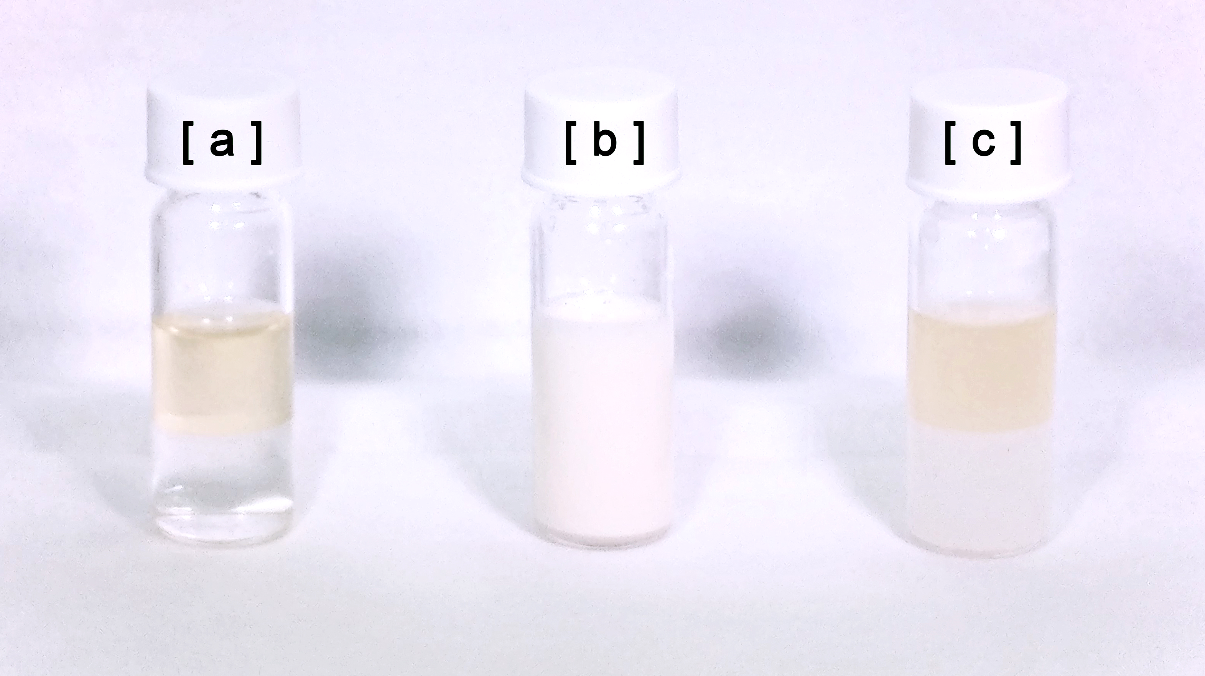
Figure 4. Phase behaviour of di(2-butyloctyl)dimethylammonium chloride in contact with water. [a]. Before shaking. [b]. After shaking. [c]. After shaking and heating at 70 °C.
To evaluate the thermal stability of the ionic liquids, a set of dynamic thermogravimetric analyses was carried out (ESI. General procedure 18). All the ammonium ions had a similar stability with a onset decomposition temperature ranging between 170 and 200 °C (Table 2). Differently from the amines, the increase in the molecular mass did not correlate with an increased thermal stability. All the ionic liquids showed a slope discontiniuity in the thermograph (Figure 3). A similar trend was previously observed in some classes of tri(octyl)methylammonium ionic liquids reported in the literature.⁸⁶
This discontinuity suggests the decomposition of another material with a higher stability with respect to the ammonium ion. If the decomposition of the ammonium ion does go via a Hofmann elimination mechanism, the decomposition product would be a tertiary amine(Scheme 2). In line with the previously acquired results, a tertiary amine would have a higher onset decomposition temperature than the ammonium ion and this could explain the curve discontinuity. Moreover, the analyses showed the presence in some samples of a trace quantity of compounds stable at 500 °C. These were supposedly inorganic salts, residues of the in-situ metathesis. These results suggests that the heavier derivatives may be more prone to withhold salts from precipitating in ethyl acetate. DSC was carried out in order to determine the phase behaviour of the synthesised materials in the temperature range between 0 and 120 °C. All of the synthesised ionic liquids did not show a phase transition in the investigated temperature range.
Chemical stability towards strong bases was determined on all the derivatives. The base stability was determined via shaking the sample with two solutions of sodium hydroxide: one in water and one in methanol. After shaking the samples for one day (2000 rpm, 55 °C); the methanol solutions changed from the starting turbid white to a clear yellow whereas the aqueous solution remained clear and colourless. Then, the methanolic solution was diluted with water and both the methanolic and the aqueous solutions were extracted with deuterochloroform and subjected to ¹H NMR analysis.
The amount of decomposition decreased with increasing chain length. The methanolic system showed significant decomposition for all the derivatives (i.e. ~10-50%), whereas the aqueous system showed significant decomposition only for the di(2-butyl-octyl)dimethylammonium chloride (i.e. ~20%). This confirmed that base stability could be improved by an increase in steric hinderance around the ß carbon of the alkyl chain.
Conclusions
A wide variety of extractants is commercially available but many of them are generally petroleum-derived. Besides, many of the retail available ammonium extractants cannot withstand alkaline conditions; hence, their use is restrained to metal recovery processes with either neutral or acidic conditions.
We developed an effective procedure to synthesise base stable extractants from renewable feedstock. To the best of our knowledge, this is the first study to synthesise and investigate the physico-chemical behaviour of Guerbet amines and ammonium ions. Guerbet aldehydes were targeted as functional precursors of the amino derivatives. They were synthesised in good yield and high purity via a green procedure easily transferrable to a large scale with minor changes. Then, Guerbet aldehydes were converted to tertiary amines via an effective, simple, and moderately yielding scalable procedure. The moderate selectivity of the reaction conditions was complemented by the side products recyclability, which avoided material losses. Then, the synthesised di(alkyl)methylamines were quaternarised via a near quantitative green dimethyl carbonate methylation procedure.
All the synthesised extractants were fully hydrophobic and stable at elevated temperatures. The branched structure hampered ordered intermolecular interactions, extending the extractants liquid range. The stability to alkaline conditions of the ionic liquids was dependent on their mutual solubility with the sodium hydroxide solution in analysis. All of the ionic liquids, but di(2-butyl-octyl)dimethylammonium chloride, were stable under the tested conditions to aqueous alkaline solutions.
Conflict of interest
There are no conflicts to declare.
References
1 European Commission (EC), Next steps for a sustainable European future: European action for sustainability, Brussels, Belgium, 2016.
2 European Commission (EC), Sustainable Agriculture , Forestry and Fisheries in the Bioeconomy: A Challenge for Europe, Brussels, Belgium, 2015.
3 L. Wu, T. Moteki, A. A. Gokhale, D. W. Flaherty and F. D. Toste, Chem, 2016, 1, 32–58.
4 P. Badger, in Trends in new crops and new uses, eds. J. Janick and A. Whipkey, ASHS Press, Alexandria, VA, 2002, pp. 17–21.
5 B. Kamm and M. Kamm, Appl. Microbiol. Biot., 2004, 64, 137–145.
6 M. Guerbet, C.R. Acad. Sci. II. C, 1909, 129–132.
7 A. J. O’Lenick Jr. and A. J. O’Lenick, J. Surfactants Deterg., 2001, 4, 311–315.
8 F. L. Moore, Anal. Chem., 1957, 29, 1660–1662.
9 J. Pernak, M. Smiglak, S. T. Griffin, W. L. Hough, T. B. Wilson, A. Pernak, J. Zabielska-Matejuk, A. Fojutowski, K. Kita and R. D. Rogers, Green Chem., 2006, 8, 798–806.
10 D. M. Eike, J. F. Brennecke and E. J. Maginn, Green Chem., 2003, 5, 323–328.
11 R. Golden and M. Valentini, Regul. Toxicol. Pharmacol., 2014, 69, 178–186.
12 Sasol, Isofol C12 – C32 Guerbet Alcohols, .
13 M. Biermann, H. Gruß, W. Hummel and H. Gröger, ChemCatChem, 2016, 8, 895–899.
14 D. Gabriëls, W. Y. Hernández, B. Sels, P. Van Der Voort and A. Verberckmoes, Catal. Sci. Technol., 2015, 5, 3876–3902.
15 J. H. Earley, R. A. Bourne, M. J. Watson and M. Poliakoff, Green Chem., 2015, 17, 3018–3025.
16 N. M. Eagan, B. M. Moore, D. J. McClelland, A. M. Wittrig, E. Canales, M. P. Lanci and G. W. Huber, Green Chem., 2019, 21, 3300–3318.
17 A. T. Nielsen, J. Org. Chem., 1963, 28, 2115–2119.
18 A. T. Nielsen, J. Am. Chem. Soc., 1957, 79, 2518–2524.
19 A. T. Nielsen, J. Am. Chem. Soc., 1957, 79, 2524–2530.
20 C. M. Moore, O. Staples, R. W. Jenkins, T. J. Brooks, T. A. Semelsberger and A. D. Sutton, Green Chem., 2017, 19, 169–174.
21 F. G. Mutti, T. Knaus, N. S. Scrutton, M. Breuer and N. J. Turner, Science, 2015, 349, 1525–1529.
22 M. Biermann, D. Bakonyi, W. Hummel and H. Gröger, Green Chem., 2017, 19, 405–410.
23 A. W. von Hofmann, Liebigs Ann., 1851, 78, 253–286.
24 A. W. von Hofmann, Proc. R. Soc. Lond., 1851, 357–398.
25 A. W. von Hofmann, Proc. R. Soc. Lond., 1850, 93–131.
26 S. Raiguel, D. Depuydt, T. Vander Hoogerstraete, J. Thomas, W. Dehaen and K. Binnemans, Dalt. Trans., 2017, 46, 5269–5278.
27 K. C. Lethesh, W. Dehaen and K. Binnemans, RSC Adv., 2014, 4, 4472–4477.
28 Y. Yan, J. Yang, Z. Yu, M. Yu, Y.-T. Ma, L. Wang, C. Su, J. Luo, G. P. Horsman and S. Huang, Nat. Commun., 2016, 7, 13083.
29 M. Shibuya, M. Tomizawa, I. Suzuki and Y. Iwabuchi, J. Am. Chem. Soc., 2006, 128, 8412–8413.
30 J. M. Hoover and S. S. Stahl, J. Am. Chem. Soc., 2011, 133, 16901–16910.
31 J. M. Hoover, B. L. Ryland and S. S. Stahl, ACS Catal., 2013, 3, 2599–2605.
32 M. A. Iron and A. M. Szpilman, Chem. Eur. J., 2017, 23, 1368–1378.
33 G. Desimoni, G. Faita and P. Quadrelli, Chem. Rev., 2018, 118, 2080–2248.
34 M. Häusermann, Helv. Chim. Acta, 1951, 34, 1482–1491.
35 Otto, Hertel Boettger, Guenter Wolfgang, Koernig Harro, Wache Rudi, Schanz Wolfgang, Reiss, DE3231794A1, 1982.
36 R. Arias-Ugarte, F. S. Wekesa and M. Findlater, Tetrahedron Lett., 2015, 56, 2406–2411.
37 S. Hünig, Justus Liebigs Ann. Chem., 1950, 569, 198–226.
38 K. A. Ostrowski, D. Lichte, M. Stuck and A. J. Vorholt, Tetrahedron, 2016, 72, 592–598.
39 B. Nozière and A. Córdova, J. Phys. Chem. A, 2008, 112, 2827–2837.
40 M. Lombardo, S. Easwar, F. Pasi, C. Trombini and D. D. Dhavale, Tetrahedron, 2008, 64, 9203–9207.
41 D. B. Ramachary and Y. V. Reddy, Eur. J. Org. Chem., 2012, 2012, 865–887.
42 S. Bertelsen, M. Marigo, S. Brandes, P. Dinér and K. A. Jørgensen, J. Am. Chem. Soc., 2006, 128, 12973–12980.
43 T. D. Beeson and D. W. C. MacMillan, in Asymmetric Organocatalysis 1, ed. List, Georg Thieme Verlag, Stuttgart, 2012.
44 L.-W. Xu and Y. Lu, Org. Biomol. Chem., 2008, 6, 2047–2053.
45 A. Bruggink, R. Schoevaart and T. Kieboom, Org. Process Res. Dev., 2003, 7, 622–640.
46 T. D. Beeson, M. Benohoud, J. W. Bode, S. Chen, M. Christmann, P.-C. Chiang, D. A. DiRocco, Y. C. Fan, T. Furuta, P. García-García, S. Hatakeyama, Y. Hayashi, J. Jia, T. Kawabata, N. J. Kerrigan, O. Kwon, Y. Liu, D. W. C. MacMillan, N. Mase, P. Melchiorre, S. Mukherjee, A. Piisola, P. M. Pihko, T. A. Ramirez, T. Rovis, E. C. Salo, Y. Shi, A. D. Smith, K. Suzuki, H. Takikawa, X.-W. Wang, Y. Wang, A. J. B. Watson, O. A. Wong, P. A. Woods and S. M. Yliniemelä-Sipari, in Asymmetric Organocatalysis 1, ed. B. List, Georg Thieme Verlag, Stuttgart, 2012.
47 C. M. Alder, J. D. Hayler, R. Henderson, A. Redman, L. Shukla, L. E. Shuster and H. F. Sneddon, Green Chem., 2016, 4, 1166–1169.
48 D. Prat, A. Wells, J. Hayler, H. Sneddon, C. R. McElroy, S. Abou-Shehada and P. J. Dunn, Green Chem., 2016, 18, 288–296.
49 I. T. Horváth, Green Chem., 2008, 10, 1024.
50 R. K. Henderson, C. Jiménez-González, D. J. C. Constable, S. R. Alston, G. G. a. Inglis, G. Fisher, J. Sherwood, S. P. Binks and A. D. Curzons, Green Chem., 2011, 13, 854-862.
51 D. Prat, J. Hayler and A. Wells, Green Chem., 2014, 16, 4546–4551.
52 U. Vögeli, D. Herz and W. Von Philipsborn, Org. Magn. Reson., 1980, 13, 200–209.
53 U. Vogeli and W. von Philipsborn, Org. Magn. Reson., 1975, 7, 617–627.
54 D. J. Collins, D. E. Grimes and B. H. Davis, Can. J. Chem. Eng., 1983, 61, 36–39.
55 G. Smedler, Can. J. Chem. Eng., 1989, 67, 51–61.
56 Rylander, Paul N Steele, Duane R, US3655777, 1955.
57 G. Liu, S. Liu, S. Liu, S. Yu, L. Li, F. Liu, C. Xie and X. Song, Catal. Letters, 2017, 147, 987–995.
58 A. B. Crozon, M. Besson and P. Gallezot, New J. Chem., 1998, 22, 269–273.
59 X. Liu, Z. Zhang, Y. Yang, D. Yin, S. Su, D. Lei and J. Yang, Chem. Eng. J., 2015, 263, 290–298.
60 R. Leuckart, J. Prakt. Chem., 1889, 41, 330–340.
61 H. W. Gibson, Chem. Rev., 1969, 69, 673–692.
62 A. N. Kost and I. I. Grandberg, Zh. Obs. Khim., 1954, 1377–1381.
63 T. Lejon, I. Helland, W. Liufang, Z. Jinzhong, H. Xiaoying, J. Møller, A. Senning, X.-K. Yao, H.-G. Wang, J.-P. Tuchagues and M. Ögren, Acta Chem. Scand., 1999, 53, 76–78.
64 F. S. Crossley and M. L. Moore, J. Org. Chem., 1944, 09, 529–536.
65 A. Loupy, D. Monteux, A. Petit, J. M. Aizpurua, E. Domínguez and C. Palomo, Tetrahedron Lett., 1996, 37, 8177–8180.
66 J. F. Bunnett and J. L. Marks, J. Am. Chem. Soc., 1949, 71, 1587–1589.
67 C. B. Pollard and D. C. Young, J. Org. Chem., 1951, 16, 661–672.
68 F. Bruce, William Havertown, Pa. Webers, Vincent J. Racine, Wis., US2603661, 1952.
69 V. J. Webers and W. F. Bruce, J. Am. Chem. Soc., 1948, 70, 1422–1424.
70 Z. Horii, Y. Tamura and Y. Murakami, Yakuga. Zasshi, 1952, 72, 1206–1208.
71 L. Yang, J. Lin, L. Kang, W. Zhou and D. Y. Ma, Adv. Synth. Catal., 2018, 360, 485–490.
72 F. Trotta, P. Tundo and G. Moraglio, J. Org. Chem., 1987, 52, 1300–1304.
73 P. Tundo and M. Selva, Acc. Chem. Res., 2002, 35, 706–716.
74 P. Tundo, Pure Appl. Chem., 2001, 73, 1117–1124.
75 M. Fabris, V. Lucchini, M. Noè, A. Perosa and M. Selva, Chem. Eur. J., 2009, 15, 12273–12282.
76 G. Fiorani, A. Perosa and M. Selva, Green Chem., 2018, 20, 288–322.
77 D. Weisshaar, G. Earl, E. Villa, J. Zierke, C. Fry, K. Becvar, S. Li and M. Schafer, Int. J. Chem. Kinet., 2010, 42, 221–225.
78 M. Selva, M. Fabris and A. Perosa, Green Chem., 2011, 13, 863–872.
79 R. S. Kalb, M. Damm and S. P. Verevkin, React. Chem. Eng., 2017, 2, 432–436.
80 OECD Guidelines for the Testing of Chemicals, Section 1: Physical-Chemical properties, OECD Publishing, Paris, 1981.
81 K. J. Baranyai, G. B. Deacon, D. R. Macfarlane, J. M. Pringle and J. L. Scott, Aust. J. Chem, 2004, 57, 145–147.
82 D. M. Fox, W. H. Awad, J. W. Gilman, P. H. Maupin, H. C. De Long and P. C. Trulove, Green Chem., 2003, 5, 724–727.
83 M. T. Clough, K. Geyer, P. A. Hunt, S. Son, U. Vagt and T. Welton, Green Chem., 2015, 17, 231–243.
84 P. Zhang, Y. Gong, Y. Lv, Y. Guo, Y. Wang, C. Wang and H. Li, Chem. Commun., 2012, 48, 2334–2336.
85 C. Maton, N. De Vos and C. V. Stevens, Chem. Soc. Rev., 2013, 42, 5963–5977.
86 J.-P. Mikkola, P. Virtanen and R. Sjöholm, Green Chem., 2006, 8, 250–255.
Acknowledgement
The research leading to these results received funding from the Horizon 2020 Programme ([H2020/2014-2019]) of the European Community under Grant Agreement no. 721385 (MSCA-ETN SOCRATES). This publication refects only the view of the authors, the European Community is exempted from any liability. Project website: http://etn-socrates.eu/. High resolution mass spectrometry was made possible by the support of the Hercules Foundation of the Flemish Government under Grant Agreement no. 20100225–7.

