Identifying hotspots of environmental impact in the development of novel inorganic polymer paving blocks from Bauxite Residue
P. James Joyce^{1*}, Tobias Hertel², Andrei Goronovski³, Alan H Tkaczyk³, Yiannis Pontikes², Anna Björklund¹
- KTH Royal Institute of Technology, Department of Sustainable Development, Environmental Sciences and Engineering, School of Architecture and the Built Environment, SE-100 44 Stockholm, Sweden
- KU Leuven, Sustainable Metals Processing and Recycling, Kasteelpark Arenberg 44, 3001 Leuven
- University of Tartu, Institute of Physics, Ostwaldi 1, 50411 Tartu, Estonia
* corresponding author: pjjoyce@kth.se

Abstract
High bauxite residue content inorganic polymer paving blocks have the potential not only to provide a solution to the ongoing waste management issues faced by the alumina sector, but to simultaneously provide low environmental impact building materials to the construction sector. In order to realise the potential of this emerging technology, it is important to understand where the hotspots of environmental impact are likely to occur, and identify routes to reduce this impact, at an early stage of development. In this study we use anticipatory Life Cycle Assessment (LCA) to identify hotspots of environmental impact in the production of paving blocks made from inorganic polymers derived from bauxite residue. This technology has only been demonstrated at laboratory scale; however, production was modelled at industrial scale. The bauxite residue is fired in a rotary kiln in the presence of a carbon and silica source, in order to create a reactive precursor. When mixed with an alkali the precursor forms a solid block. Our results identify the firing process as the major hotspot of environmental impact, primarily due to the combustion of fossil fuels in the rotary kiln. Steps to reduce the impact of the firing step or to reduce the amount of fired precursor used in the final paving block are suggested as routes for future impact reduction. Optimisation of the environmental aspects of these building materials at an early stage in their development could lead to a promising future for high-volume bauxite residue valorisation at low environmental cost.

Highlights
- Bauxite residue can be transformed into inorganic polymers for use in construction
- Anticipatory LCA was used to identify hotspots and improvement opportunities
- Hotspot results are visualised with the use of novel ‘bulls-eye’ charts
- Increasing the reactivity of bauxite residue via firing is the major impact hotspot
- Reducing the proportion of fired material in the blocks is a reduction opportunity

Keywords
Life Cycle Assessment, Inorganic Polymers, Bauxite Residue, Secondary Resources, Waste Management, Waste Valorisation

Abbreviations
AC | Terrestrial Acidification
FE | Freshwater Eutrophication
FT | Freshwater Toxicity
GW | Global Warming
HT-C | Human Toxicity - Carcinogenic Effects
HT-NC | Human Toxicity - Non-carcinogenic Effects
IR-A | Ionising Radiation - Artificial Radionuclides
IR-N | Ionising Radiation - NORM (releases to environment)
NORM | Naturally Occurring Radioactive Materials
ME | Marine Eutrophication
OZD | Ozone Layer Depletion
PM | Particulate Matter Formation
POC | Photochemical Ozone Formation
RD | Resource Depletion
BR | Bauxite Residue
IP | Inorganic Polymer
LCA | Life Cycle Assessment
LCI | Life Cycle Inventory
LCIA | Life Cycle Impact Assessment
LCPD | Life Cycle Process Design
BREEAM | Building Research Establishment Environmental Assessment Method
LEED | Leadership in Energy and Environmental Design

Introduction
The production of building materials from bauxite residue (BR) has a number of potential benefits. BR is an unavoidable residue resulting from the first stage of aluminium production, and as such its management has long been a concern of the alumina industry (Evans, 2016). Diverting BR from current landfill practices and utilising it as a secondary resource is seen as an important aspiration for the future of BR management (ibid.). Recycling of BR into building materials offers a high-volume valorisation pathway for this waste. At the same time, there is increasing demand from the construction industry for building materials which demonstrate high environmental performance. Both BREEAM and LEED, the two leading sustainable construction accreditation schemes, contain requirements to consider and minimise the life cycle environmental impact of the materials chosen and encourage the use of materials with a high level of recycled material content (BRE Global, 2016; USGBC, 2017). Use of industrial residues, such as BR, in place of virgin materials in the production of building materials is potentially consistent with both of these requirements. At a higher level, the European Commission has set out an EU wide action plan for the Circular Economy (European Commission, 2015), which stresses the importance of secondary raw materials being fed back into the economy, and commits to promote innovative industrial processes in which the wastes of one industry become the inputs to another.
The presence of supply-side, demand-side and policy-level drivers for the utilisation of BR in building products indicates that the stage is set for the development of innovative technologies for high volume utilisation of this abundant secondary resource. However it is of vital importance that these technologies offer a more sustainable approach than the situation today. It is unwise to naively assume that ‘waste valorisation’ or ‘circular economy’ approaches are more sustainable than conventional approaches. Indeed questions have been raised as to the validity of the fundamental assumptions which underpin the circular economy concept (De Man and Friege, 2016), and life cycle assessment studies of some closed loop systems have shown that in practice they can lead to a higher overall environmental impact than their conventional counterparts (Bjørn and Strandesen, 2011).
It is therefore important to understand the life cycle environmental performance of new technologies for BR utilisation at an early stage in their development in order to minimise the impact caused and maximise the benefit achieved. The identification of potential hotspots of environmental impact is an important first step in this process. In this study we investigate the environmental performance of one emerging technology for high volume valorisation of BR as a building product – the production of inorganic polymer paving blocks.
Recent research has confirmed that BR can be transformed into inorganic polymers (Hertel et al., 2017, 2016). Inorganic polymer products have the potential to be utilised as high performance building materials (Duxson et al., 2007b). A novel solution for creating high BR content inorganic polymers suitable for use in paving applications has been proposed by Hertel et al. (2016), based on lab-scale results. From a technical perspective, this approach has a great deal of potential, however the sustainability issues associated with this solution are yet to be assessed.
The EU Waste Framework directive (Council Directive 2008/98/EC art. 4) makes clear that while the Waste Hierarchy should be applied in priority order, measures should aim to deliver the ‘best overall environmental outcome’ based on ‘life-cycle thinking on the overall impacts of the generation and management’ of the waste. Focusing any study on the goal of landfill diversion alone would necessarily be mute on broader sustainability issues, and may not deliver the best overall environmental outcome. Similarly, for users of products derived from secondary materials, a life cycle approach to the assessment of the environmental performance of the materials is desirable. Indeed, both BREEAM and LEED specifically refer to life cycle approaches in the assessment of sustainable materials (BRE Global, 2016; USGBC, 2017).
Thus, for both producers of waste and users of waste derived products, Life Cycle Assessment (LCA) is an important tool for understanding the potential environmental impact of products and processes from a holistic perspective. Applied properly it can be used to highlight major sources of impact and suggest alternative, more environmentally sustainable approaches to both product and process design (Hellweg and Milà i Canals, 2014).
Regardless of whether the study is product or process focussed, the timing of the study falls prey to the ‘design paradox’ (Ullman, 1997). In short, at the earlier stages in the design or development process, there is more scope for change in the design but knowledge of the specifics of the design is uncertain. In the latter stages of the process the reverse is true; knowledge of the design is very good, but the ability to make changes to it is much more limited. From the perspective of life cycle assessment, this poses a particular problem, as ‘product knowledge’ is analogous to the availability of reliable life cycle inventory (LCI) foreground data. Early in the design process, where the conclusions and recommendations of an LCA are potentially most useful, the data they are based on is of relatively poor quality. Conversely, as the data quality improves as knowledge of the design increases, the ability to make changes based on the LCA results decreases.
One possible solution to the design paradox which is particularly suited to research and development, advocated by Wender et al. (2014), is to incorporate anticipatory LCA at multiple stages in the research process. Rather than a major ‘one shot’ study this approach allows iterative changes to be made throughout the course of the research and development process. Another possible solution is to base the LCA not on primary data collected from experiments that have been conducted at bench scale, but on mathematical models of the process, grounded in the experimental data but designed to represent full plant scale. This approach has been productively applied to identify hotspots at early stages in process design in many cases, including biofuels (Brentner et al., 2011; Gerber et al., 2011; Guo et al., 2014), biorefinery processes (Fazeni et al., 2014), and gasification technology (Gasafi et al., 2003). In this study we combine both approaches.
The aim of this study is to identify potential hotspots of environmental impact in the production of paving blocks from novel high BR content inorganic polymers, with a view to identifying opportunities to reduce this impact prior to the final development of the technology. In order to achieve this, we apply the anticipatory LCA methodology to the early stages of the development of the technology. The results of this study will be of benefit to the engineers and scientists developing the technology. The LCA is based on laboratory scale experiments modelled to represent full scale production. This study represents the beginning of an ongoing process of assessment throughout the development of this technology.

Background

Inorganic polymers as building materials
Inorganic polymers, and the closely related geopolymers, are binders: substances which as a result of a chemical reaction form a solid matrix in which aggregates can be entrained. The term geopolymer was introduced by the French scientist Joseph Davidovits in the 1970s (Davidovits, 1991) for an amorphous alkali-aluminosilicate binder formed by the reaction of an aluminosilicate precursor, such as metakaolin, with an alkali(-silicate) solution. The mixing of the solid precursor with the alkali activating solution, to start the polymerisation reactions, is referred to as ‘activation’. The dissolved aluminate and silicate species form gels when oversaturation is reached and further condensation and rearrangement leads to the formation of a 3D network where tetrahedral Al and Si are connected via oxygen bridges (Duxson et al., 2007a). A simplified representation of this process is shown in Figure 1.
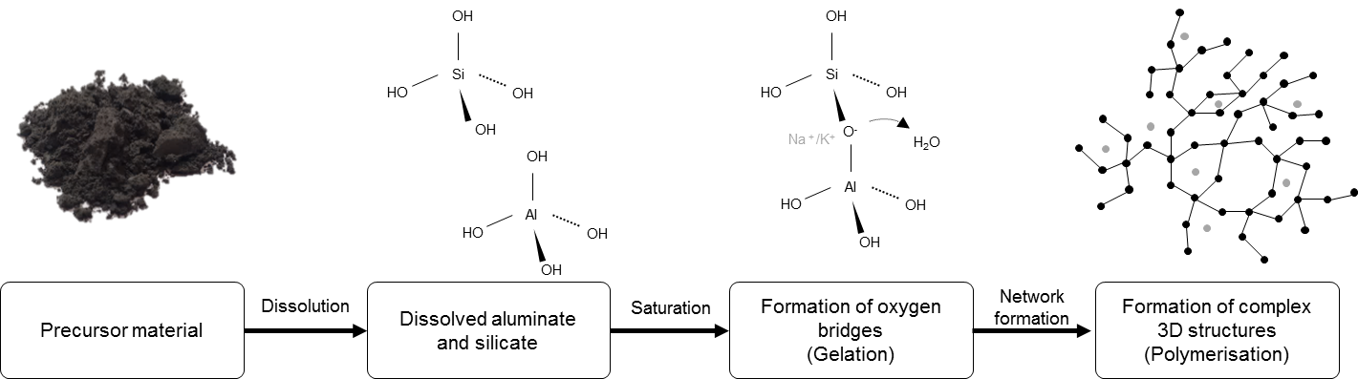
Figure 1 Simplified inorganic polymerisation process
Inorganic polymer is a more general term than geopolymer, and can be considered a supergroup with a deviation from the original aluminosilicate chemistry. Inorganic polymers (or IP) therefore also encompass other precursor materials, for instance, metallurgical slags, rich in Fe (Komnitsas et al., 2007; Onisei et al., 2012) among various other residues or wastes (Provis et al., 2015). As binders, inorganic- and geopolymers draw attention because of their satisfying properties, often surpassing those of conventional binders, such as high fire resistance, high compressive and flexural strength, and chemical resistance (Duxson et al., 2007b; Lloyd et al., 2012).
In addition to their excellent material properties and the potential of using various waste streams as raw material, Van Deventer et al. (2010) highlights the potential for alkali activated materials (a further, higher classification of binders of which inorganic polymers form a part) as a low carbon alternative to concrete, primarily due to the fact that the decomposition of limestone, releasing geogenic CO₂, is an unavoidable step in the production of ordinary Portland cement clinker. However, prior to 2010 (at the time of writing for Van Deventer) few LCA studies had been carried out to confirm this potential. Buchwald et al. (2005) provided a semi-quantitative assessment of environmental issues surrounding geopolymers alongside economic considerations as part of a multi criteria assessment, however Weil et al. (2009) provided the first major contribution in this area. In addition to the carbon reductions later pointed out by Van Deventer, Weil et al. also raised the need to go beyond just comparing CO₂ emissions to Portland cement. They broadly concluded that the silicate and NaOH solutions used to activate the precursor are a hotspot of impact, and their use should be reduced as much as is practical. They also concluded that resource intensive precursor materials (e.g. metakaolin) should be substituted if possible by less resource intensive or secondary materials (subject to availability and environmental limits). Sand and gravel, when used as aggregates, are a ’cold-spot’ i.e. even significant usage of these materials in the mix design contributes little to overall impact. Heat curing is also identified as a possible process hotspot.
Subsequent studies have confirmed these earlier findings, particularly when low resource intensity, secondary materials are utilised in the precursor. McLellan et al. (2011) and Turner and Collins (2013) both identified alkaline activators as the major source of climate change impact in the production of fly-ash based geopolymers, as did Mellado et al. (2014) when using a spent fluid cracking catalyst as the precursor. The alkali activating solution has been found to be a hotspot in a number of other impact measures (abiotic depletion, ozone layer depletion, human toxicity, freshwater ecotoxicity, marine ecotoxicity, photochemical oxidation, acidification and eutrophication) (Habert et al., 2011; Habert and Ouellet-Plamondon, 2016). This was to such an extent that while the climate change impact of this polymer was lower than comparable ordinary Portland cement, all other impacts were higher; an example of previously unseen burden shifting as a result of including more impact measures.
More recent studies (Peys et al., 2017; Provis, 2016) have again reiterated the importance of alkali activators, but also noted that the environmental benefits associated with the use of low resource intensity secondary materials can be quickly negated by the increased impacts associated with their transport where they are not processed locally to their site of production.
An additional concern associated with secondary materials which are especially amenable to alkali activation, in particular fly ash, is that their properties may be desirable in other applications (e.g. as a supplementary cementitious material in cement production (Thomas, 2007)). Weil et al.(2009) recognised this problem, stating rather presciently that “Competition with a traditional utilisation of the same secondary resource does not facilitate market introduction of a new technology. Thus, the development of geopolymer mixtures for different applications should preferentially favour secondary resources which are not already used as raw materials to a large extent in other industrial sectors”. This conclusion underlines one of the major motivations behind this study, namely taking an underutilised and abundant secondary resource, in the shape of bauxite residue, as the raw material for the production of new inorganic polymer mixes.

Bauxite residue
Bauxite residue (BR) is a by-product of alumina production. Of the estimated 150 million tonnes produced annually, less than 4 million tonnes (< 2.6%) are used productively (Evans, 2016). This is on top of an estimated stockpile of BR exceeding three thousand million tonnes (ibid.). Such a high volume of produced material requires a high-volume valorisation solution, thus while BR has the potential to be utilised for higher value material recovery (e.g. rare earth elements (Borra et al., 2016), scandium (Yagmurlu et al., 2017)), a high-volume application of this material is a desirable prospect for the alumina industry (Klauber et al., 2011; Pontikes and Angelopoulos, 2013).
Additionally, unlike fly-ash – the supply of which will potentially be affected by the increasing trend towards lower coal use in energy production – ongoing supply is unlikely to be a problem in at least the medium-term. Demand for aluminium continues to grow at a rate of 5-7% annually, with construction and transportation constituting the majority of demand (Aluminium Leader, 2015). The combination of increasing demand and use in long lived applications means that, regardless of the recycling rate of aluminium, primary production will continue to be a significant feature of aluminium supply for the foreseeable future (van der Voet et al., 2014). On average globally, approximately 1.35 tonnes of BR is produced per tonne of alumina (Evans, 2016) in the Bayer process. This translates to nearly 3 tonnes of BR per tonne of primary aluminium.
Several research works have focused on the use of BR in geopolymers. The poor reactivity of BR in an alkaline environment and the corresponding low release of reactive Si and Al are considered to be a major barrier for the use of BR as a single raw material for IP (Dimas et al., 2009). As a result, most of the work deals with the addition of established precursors, such as metakaolin (Dimas et al., 2009; Hajjaji et al., 2013; Kaya and Soyer-Uzun, 2015; Labrincha et al., 2014; Vukčević et al., 2013), ground granulated blast furnace slag (GGBFS) (Singh et al., 1996; Ye et al., 2014), fly ash (Kumar and Kumar, 2013; Mucsi et al., 2014; Zhang et al., 2010), rice husk ash (He et al., 2013) or ferronickel slag (Zaharaki et al., 2016) to BR. In most of these works BR acts solely physically, as a filler material, in some cases improving the mechanical properties to up to a certain level of content. High additions of BR generally lead to a significant loss in mechanical properties compared to corresponding reference systems. Promising results were nevertheless presented by, for instance, Dimas et al. (2009) who demonstrated the potential for good compressive strength values at higher levels of BR (85 wt.% BR, 15 wt.% metakaolin), however these materials suffered from insufficient flexural strength for use in tiles, and very low resistance to freeze-thaw weathering.
Different routes are suggested to overcome the low reactivity of BR including thermal (Ye et al., 2012), chemical (Hairi et al., 2015), and chemo-mechanical options (Geng et al., 2017) or a combination thereof. These works conclude that the reactivity of BR can be increased by such adaptations.
Inspired by the promising work on inorganic polymers synthesised from other industrial residues with a similar chemistry to BR, such as Cu (Onisei et al., 2015), CuNi (Kalinkin et al., 2012), Pb (Onisei et al., 2012) or FeNi slag (Giannopoulou et al., 2009; Komnitsas et al., 2007; Sakkas et al., 2014), Hertel et al. (2016) suggested a high temperature (1100 °C) transformation of BR into a reactive slag. The major differences between BR and the aforementioned industrial slags are the valence of Fe (bivalent in the industrial slags vs. trivalent in BR) and the mineralogy. While BR is mainly crystalline, the reactive slags are predominantly amorphous. Results of thermodynamic calculations (presented in detail elsewhere (Hertel et al., 2016)) have shown that heating BR in the presence of carbon leads to a transformation of Fe³⁺ to Fe²⁺and promotes the formation of liquid phase at lower temperatures (1100 °C), while additional silica leads to increased liquid phase formation. Quenching results in a semi-vitreous slag and potentially turns the BR-rich melt into a reactive raw material.

Materials and Methods

Overview of High BR Inorganic Polymer production
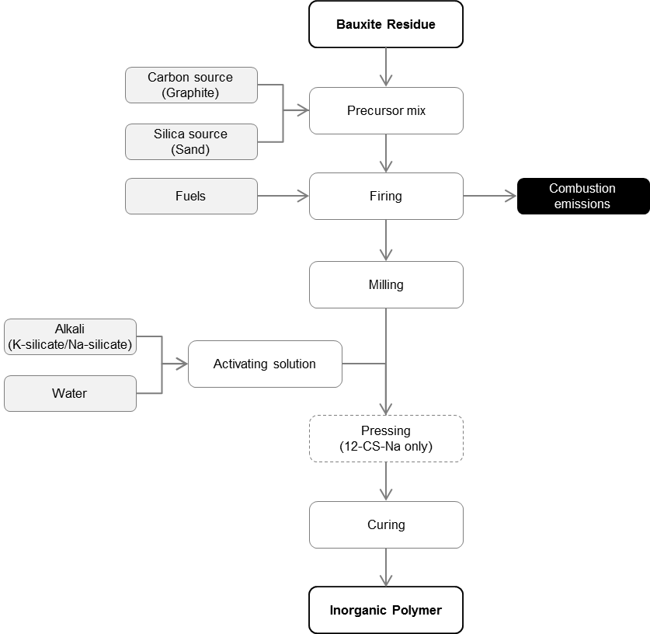
A simplified outline of the generalised process to produce IPs from BR is shown in Figure 2. BR is mixed with a carbon source and a silica source. The resulting precursor mix is then fired at a temperature between 1,100°C and 1,450°C. Following firing, the temperature of the precursor is rapidly decreased via air or water quenching. The fired precursor is then milled to a powder. Activating solution is prepared by diluting either potassium silicate (K-silicate) or sodium silicate (Na-silicate) with water. Mixing the precursor powder with the activating solution yields a paste which can then be moulded into blocks. These blocks can optionally be pressed prior to curing. Curing takes place at an elevated temperature (60°C) for 72 hours. The cured blocks can be used as block paving.
Figure 2 Generalised process for high BR Inorganic Polymer production

Modelling approach
We use an anticipatory LCA approach to assess the environmental aspects of the high BR inorganic polymer building materials being developed. The ethos of anticipatory LCA is to focus on the potential environmental impacts which may result from possible changes to the system resulting from R&D decisions (Wender et al., 2014). Anticipatory LCA employs a variety of modelling techniques in order both to deal with the less accurate data sets available, and to focus the modelling on such decisions (ibid.).
The main design variables in the process outlined in section 3.1 above which have the potential to be changed in R&D are as follows: the proportions of carbon and silica added to the precursor mix; the temperature of firing; the choice of alkali for the activating solution; the ratio of precursor to activating solution in the paste (the liquid to solid ratio); and whether the blocks are pressed prior to curing (Table 1).
The most significant constraint of the inorganic polymer system is that the resulting polymer must be able to be used as a building material. First the precursor must be chemically active enough to react with the alkali activating solution, and second the resulting block must have sufficient compressive strength for use in building applications. This cannot currently be modelled via computer simulation, therefore samples of six mix designs which had been prepared in the laboratory and in which the key parameters listed above had been varied were used as the basis for this assessment. The samples were prepared using filter pressed bauxite residue from Aluminium of Greece (AoG), derived from a mixture of Panassos-Ghiona and Trombetas bauxites. The procedure followed to produce these samples is described in Hertel et al. (2016). Details of the design variables for each of the six mix designs are presented in Table 1. The mix design IDs used in this paper consist of three parts representing the temperature of firing (11 = 1100°C, 12 = 1200°C, 14 = 1450°C), the additions made to the precursor (N = no additions, C = carbon added, CS = carbon and silica added), and the activating solution used (K = K-silicate, Na = Na-silicate).
Table 1 Details of mix designs prepared according to Hertel et al. (2016) and assessed in this study
Mix Design ID | Pre-fired composition  (%wt.) |  |  | Firing temperature  (°C) | Alkali for activating solution | Liquid to solid ratio | Pressing | 7-day compressive strength (MPa)
 | BR (dry) | Carbon | Silica
11-N-K | 100 | 0 | 0 | 1100 | K-silicate | 0.25 | No | 13.0 ± 0.4
11-C-K | 98.4 | 1.6 | 0 | 1100 | K-silicate | 0.25 | No | 19.7 ± 1.1
11-CS-K | 88.56 | 1.44 | 10 | 1100 | K-silicate | 0.25 | No | 43.5 ± 0.5
12-CS-K | 88.56 | 1.44 | 10 | 1200 | K-silicate | 0.25 | No | 80.0 ± 3.0
12-CS-Na | 88.56 | 1.44 | 10 | 1200 | Na-silicate | 0.15 | Yes | 149 ± 19.0
14-CS-K | 88.56 | 1.44 | 10 | 1450 | K-silicate | 0.25 | No | 90 ± 4.0

Rather than model the actual laboratory scale processes, a number of assumptions were made to theoretically scale up the designs to industrial scale. This allows us to draw conclusions relevant to the anticipated industrial application of the newly proposed technology. These assumptions are outlined in section 3.3.2 below, and described in detail in the supplementary materials.
LCOPT, a python based software for creating fully parameterised LCA foreground models (Joyce, 2017), was used to model the scaled up systems. A single model consisting of all of the possible inputs and outputs to each unit process, and the links between the unit processes, was created. Each of the mix designs was then described by giving the model a parameter set with the correct quantities for each of the flows (unused inputs are given a flow quantity of zero). These parameters can be set directly or by mathematical functions. Using mathematical functions in our modelling approach allows both greater consistency in modelling (e.g. ensuring percentages add to 100), and also allows mathematical relationships between flows to be modelled explicitly within the LCA foreground model itself. The full parameter sets are included in the supplementary materials. LCA results were calculated using Brightway (Mutel, 2017), which interfaces directly with LCOPT. Results were visualised using LCOPT.

Anticipatory LCA

Scope of LCA Study
The product system describes the hypothetical production of paving blocks made from high BR content IPs at an alumina refinery in Greece, using existing infrastructure. In LCA, the life cycle impacts of a product system are calculated relative to a quantified and well defined measure of the function of the product created, known as the functional unit. This allows for fair comparisons to be made between divergent product systems producing functionally equivalent items. The function of paving blocks is to provide a paved surface over a given area. The densities of the paving blocks differ between mix designs, meaning that a mass based functional unit would not provide a fair comparison on the basis of function in this study. An area based functional unit (1 m²) was therefore chosen. Paving blocks for driveways, patios, pathways and footways are typically 50 mm thick (Interpave, 2012), therefore a block thickness of 50 mm is assumed. In order to account for use phase impacts, a design life for the paving blocks must be specified. A design life of 20 years is typically specified for concrete block paving in both industry guidance documents (Bureau of Indian Standards, 2006; Concrete Manufacturers Association, 2004; Interpave, 2012) and academic literature (Rada et al., 1990; Sharma et al., 2016). Therefore a lifetime of 20 years is assumed in this study. The functional unit used in this study was therefore the provision of 1 m² of paving blocks, of thickness 50 mm, with a design life of 20 years, corresponding to a volume of 0.05 m³.
A cradle to grave analysis was performed, including the extraction of raw materials, the production of the blocks, a 20-year use phase and final disposal. As disposal is assumed to take place 20 years in the future, it is assumed that the 2020 target of the EU Waste Framework Directive (2008/98/EC) of 70% recycling of construction and demolition waste has been reached. 70% of the blocks are therefore assumed to be recycled, with the remaining 30% disposed of in inert materials landfill.
Transport of blocks to the point of use, and their installation and removal are excluded from the scope of this study. The distance between the hypothetical production and installation locations is both a highly uncertain parameter and one which cannot actively be influenced by the research and development process, and it is therefore not included in the baseline model for hotspot identification. It is important however to understand the potential magnitude of such transport impacts, therefore a sensitivity analysis including two different transport distances (50 km and 300 km) was carried out. These values were chosen based on the guidance contained within the European Energy Efficient Building guidance document for LCA of building products (Wittstock et al., 2011). In this document 300 km is suggested as a default assumption for the transport of all building products to site in the absence of specific data; however it is noted that according to Eurostat freight statistics, the majority of bulk products (of the category ‘Other non-metalling mineral products’) travel less than 50 km to site. Transport is assumed to be by 32t EURO4 lorry.
The ecoinvent cut-off system model was used (Wernet et al., 2016). This is an attributional system model, with economic allocation utilised where allocation is necessary. Under this system model, a cut-off approach to recycling is used. Where materials are recycled, a consistent approach is required to correctly allocate the environmental burdens and benefits to the system which produces the recyclable waste, and the system which carries out the recycling process. Under the cut-off system model, recyclable materials cross the system boundary at the point at which they are produced. As such, systems producing recyclable waste bear no burden from the processing of the material, but equally gain no benefit from the displacement of materials resulting from the utilisation of the recycled products. Systems utilising recyclable wastes receive the material burden free, as the burdens associated with their production are allocated entirely to the system which produced them, but bear the entire burden of their processing. Bauxite residue is assumed to be a recyclable waste of the alumina sector, and hence enters the system assessed in this study burden free. Less than 3% of BR produced each year is used productively, with many millions of tonnes stockpiled (Evans, 2016). This serves to highlight its negligible current economic value and confirm that it should be considered a recyclable waste and not an allocatable co-product. The 70% of the blocks recycled at end of life leave the system boundary, and hence no benefit or burden is allocated to the system as a result of their further processing.
For the Life Cycle Impact Assessment (LCIA) step, the 12 midpoint LCIA models recommended by the ILCD (Hauschild et al., 2013) were chosen. These are global warming (GW), terrestrial acidification (AC), particulate matter formation (PM), photochemical ozone formation (POC), ozone layer depletion (OZD), human toxicity carcinogenic effects (HT-C), human toxicity non-carcinogenic effects (HT-NC), ionizing radiation (IR-A), freshwater eutrophication (FE), marine eutrophication (ME), freshwater toxicity (FT) and resource depletion (RD).
As highlighted by Joyce et al. (2017), enhanced exposure to naturally occurring radionuclides is a potentially important source of human health impact in the life cycle of construction products. This is particularly important where Naturally Occurring Radioactive Materials (NORM), which include some BRs (Landsberger et al., 2017), are used in these applications. Therefore in addition to the 12 ILCD midpoint impact categories the impact of NORM exposure to human health from releases of NORM to environment (IR-N), was assessed using the LCIA method of Goronovski et al. (Goronovski et al., 2018). For two of the mix designs (12-CS-K and 12-CS-Na) data on the NORM content of the final products were available. In these two cases the use phase impact of NORM exposure was also considered.
The use phase NORM exposure method presented in Goronovski et al. (Goronovski et al., 2018) considers application of construction materials specifically for dwellings. In this study the materials described are proposed for outdoor use as paving, therefore we derived a set of separate characterisation factors for this application. Only gamma ray exposure is considered. In contrast to residential applications, where radon can accumulate, radon released from paving is assumed to disperse and decay without causing impact to human health.
The external dose rate coefficients, exposure area and occupancy time were taken from Markkanen (1995). Dose rate coefficients are dependent on the specific mass of the material considered, measured in units of kg m⁻², calculated by multiplying the density of the material (kg m⁻³) by its thickness (m). In this assessment, values for a specific mass of 200 kg m⁻² were used, as the paving blocks considered have a specific mass of 169 - 173 kg m⁻². The data used to derive the exposure factor for paving in a European context were taken from EUROSTAT database (EUROSTAT, 2017a, 2017b, 2016). Midpoint characterisation factors for 200 kg m⁻² materials are given in Table 2. Full details of the derivation of these factors, as well as characterisation factors for materials of specific mass between 25 - 500 kg m⁻² are provided in Appendix 2.
Table 2 Characterisation factors for use phase NORM exposure for materials used paving applications with a specific mass of 200 kg m⁻²
Isotope | man.SV per kBq
²³⁸U/²²⁶Ra | 5.31 × 10⁻⁸
²³²Th | 6.20 × 10⁻⁸
⁴⁰K | 4.43 × 10⁻⁹

Overview of Life cycle inventory
Background data from the ecoinvent 3.3 cutoff database (Ecoinvent Centre, 2016) were used in the construction of the life cycle inventory dataset. Full details, including a list of all used ecoinvent datasets are provided in Appendix 3.
All processes in the production of the polymer blocks are assumed to take place at an alumina plant in Greece. Firing of the precursor was assumed to take place in a rotary kiln, similar to those used in alumina calcining (at least in the recent past). Rotary kilns can be operated with a wide variety of fuels. In the base case it is assumed that the fuel types used the same as the primary fuels used in clinker production, in the same proportion as used in the ecoinvent clinker dataset. Additionally, an alternative option proposed for firing the precursor is a sintering process (Y. Pontikes, pers. comm.; RECOVER, 2017), in which the precursor is mixed with coke breeze and ignited with a natural gas flame. The impact of changing the rotary kiln fuel mix or firing type (the sintering option) is explored as a sensitivity analysis.
Potassium and sodium silicate with a molar ratio of 1.6 diluted in a ratio of 8 parts water to 1 part silicate were used as the activating solutions. The inputs required to produce potassium silicate (which does not appear in the ecoinvent database) were calculated based on ecoinvent data for the production of sodium silicate (details in Appendix 3). Representative data for milling, pressing and high temperature curing were taken from literature (details in Appendix 3). Transport of all purchased materials to the site is assumed to be by lorry (EURO4) over a distance of 50 km. NORM radionuclide content of the final polymers was determined via gamma spectroscopy (see Appendix 2) and carried out for two mix designs (12-CS-K and 12-CS-Na). This allows the assessment of use phase NORM exposure for these two products.
The reference flow for each mix design was calculated from the density of the precursor (3.58 g/cm³) and the alkali activating solution (2.6 g/cm³), and the liquid to solid (L/S) ratio. Thus, for mix designs using K-silicate (L/S ratio = 0.25) the reference flow is 169 kg of IP blocks, while for the Na-silicate activated mix (L/S ratio = 0.15) the reference flow is 173 kg of IP blocks.

Results

Mix design comparison
The impact of each of the mix designs in each of the assessed impact categories are shown in Table S1, broken down by life cycle stage. The percentage contribution from each life cycle stage is shown in Table S2. Across all mix designs, the processing stage has the highest contribution to all impact categories, with the exception of resource depletion, for which purchased raw materials have the largest impact. End of life treatment of the blocks contributes very little to their life cycle impact (<1%) in all but two impact categories (photochemical ozone formation and marine eutrophication). In these categories the contribution is still less than 2.5%.
Comparing between mix designs allows a broad assessment of the effect of design choices of environmental impact of the high BR IP process. The mix design with no additions of carbon or silica has the lowest impact across 11 of the 13 impact categories, but also has the lowest performance (compressive strength 13 ± 0.4 MPa, Table 1), making it unsuitable for use in construction applications. Likewise, the mix design with just carbon as an addition has a compressive strength too low for use in construction (19.7 ± 1.1 MPa, Table 1). Higher impact is correlated with increasing temperature across all impact categories for the otherwise identical potassium activated mix designs as a result of increased energy demand (green (1,100°C), purple (1,200°C) and yellow (1,450°C) circles in Figure 3).
The two impact categories in which there is most variation in impact between mix designs are ozone layer depletion (OZD, Figure 3), as a result of the higher impact of Na-silicate activating solution vs K-silicate, and global warming (GW, Figure 3), as a result of the contribution of the direct combustion of added carbon (and its absence in the 11-N-K mix).
By converting the ionising radiation impact from releases of artificial radionuclides (IR-A), measured with the characterisation method of Frischknecht and Braunschweig (Frischknecht and Braunschweig, 2000) from the original units of kg ²³⁵U-eq to man.Sv it is possible to compare the results to the ionising radiation impact from releases of NORM to the environment (IR-N) using the method of Goronovski et al. (2018) (Table S1). Across all mix designs, ionising radiation from artificial radionuclides (IR-A) has between 75% and 85% of the impact of that from releases of NORM to the environment (IR-N).
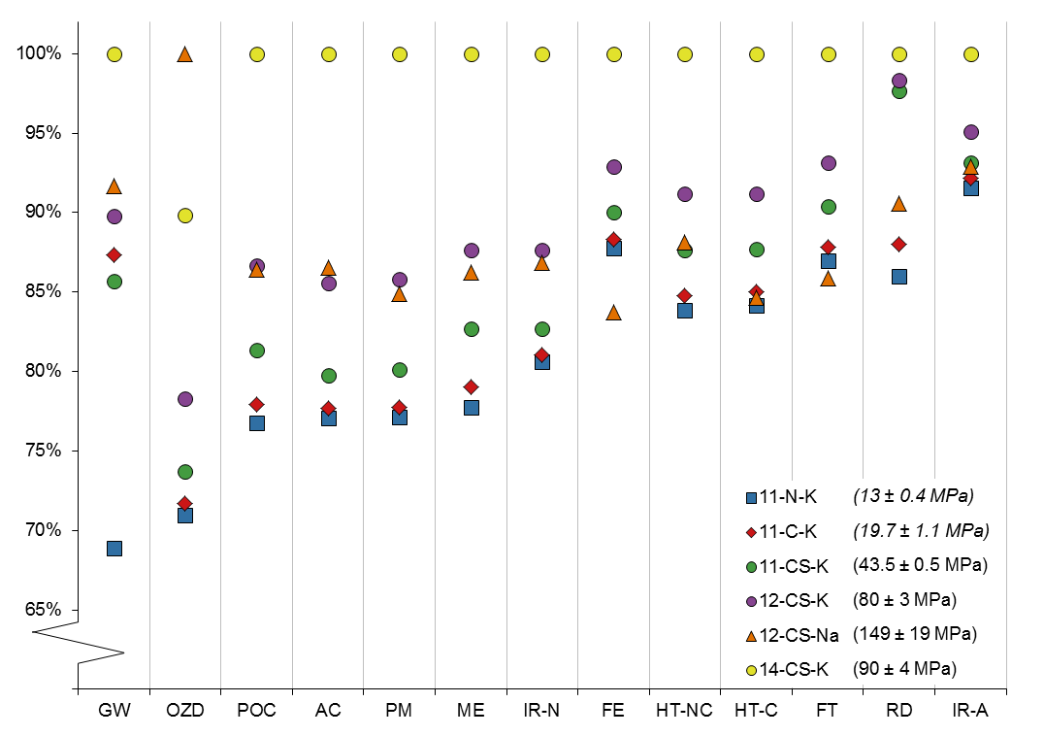
Figure 3 Relative impact of all six mix designs across the 13 impact categories. In all categories results are normalised to the mix design with the maximum impact in that category, such that the highest impact value is equal to 100%. Categories are ordered by the range between the highest and lowest impact. The shape of the points represents the materials and activating solutions used. Full details of the mix designs described by each of the ID codes are provided in Table 1. 7-day compressive strengths are shown in brackets.

K vs Na based activating solution (12-CS-K vs 12-CS-Na)
Broadly speaking, two major hotspots dominate the impact of the IP blocks across all impact categories, firing of the precursor and production of the activating solution, with milling of the precursor representing an additional hotspot in some impact categories (Figure 4, panel A).
Looking in more detail at individual mix designs allows for specific hotspots of environmental impact to be identified and explored. Two mix designs, the K-silicate activated 12-CS-K and Na-silicate activated 12-CS-Na were compared to assess the effect of activating solution. 12-CS-Na has a lower impact in 10 of the 13 impact categories, displaying a higher impact in global warming (GW), acidification (AC) and ozone depletion (OZD) (Figure 4, panel B). This is only partly explained by the impact of the activating solution itself (Figure 4, panel C). Na-silicate itself has a higher OZD impact than K-silicate, but a lower impact in the GW and AC categories. The higher impacts of 12-CS-Na in these two categories is explained by the lower liquid to solid ratio of this mix, meaning that there is a higher proportion of fired precursor in the final mix. For GW and AC, the proportion of impact resulting from the precursor is highest (89% and 87% of impact respectively), and in these cases the increased amount of precursor overrides the lower impact of the activating solution.
For these two mix designs it is also possible to consider ionising radiation impact at the use phase. In infrastructural applications, the dose received from the use phase is around 100 times greater than that resulting from releases of both artificial and NORM radionuclides to the environment in production (Error! Reference source not found.). The higher use phase exposure for 12-CS-K is as a result of the higher levels of potassium, and therefore the naturally occurring ⁴⁰K isotope from the K-silicate activating solution.
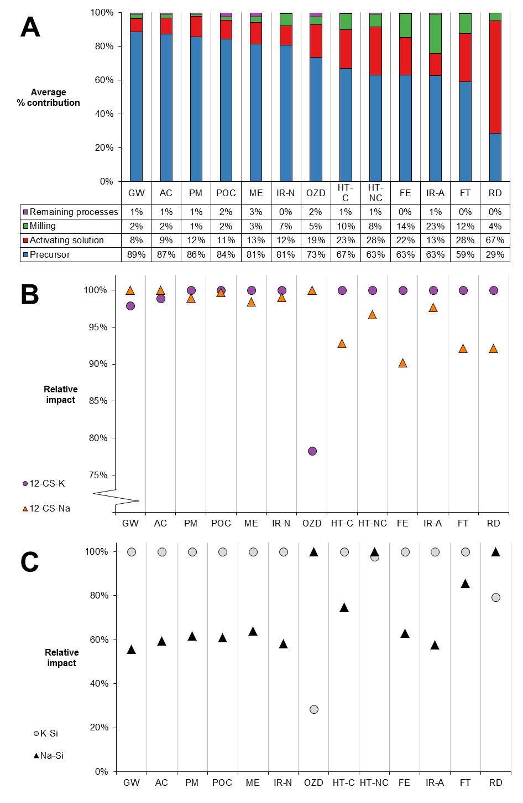
Figure 4 LCA results comparing the 12-CS-K vs 12-CS-Na mix designs. Panel A shows the average contribution to overall impact of the precursor, the activating solution, milling, and other processes (combined) for these two mix designs. Impacts in all three panels are ordered by the contribution of the precursor to the overall impact (descending). Panel B shows the relative impact of blocks produced from the 12-CS-K and 12-CS-Na mix designs. Results for all categories are normalised to the mix design with the maximum impact in that category, such that the highest impact value is equal to 100%. Panel C shows the relative impact of K-silicate and Na-silicate activating solutions. Results for all categories are normalised to the activating solution with the maximum impact in that category, such that the highest impact value is equal to 100%.
Table 3 Sources of ionising radiation dose from the life cycle of mix designs 12-CS-K and 12-CS-Na
Ionising radiation exposure route | Dose (man.Sv/m² paving)
 | 12-CS-K | 12-CS-Na
Releases of NORM radionuclides | 5.84 × 10⁻⁸ | 5.78 × 10⁻⁸
Releases of artificial radionuclides | 4.76 × 10⁻⁸ | 4.65 × 10⁻⁸
Use phase exposure from infrastructure | 5.35 × 10⁻⁶ | 5.12 × 10⁻⁶

Finer scale hotspots
Na based activation chemistry is likely to be more economically feasible in the alumina industry due to the availability of soda in the waste Bayer liquor and in the BR itself. Therefore 12-CS-Na was chosen for more detailed hotspot investigation.
Figure 5 uses a novel hierarchical pie chart or ‘bulls-eye’ diagram to show the contribution of four levels of upstream processes to IP block production for five of the impact categories considered. These charts present the same information as the more common Sankey tree diagram (for an example see Appendix 4, Figure S1), however rather than the thicknesses of the linking arrows representing the contribution to impact, this is represented by the arc angle of the pie chart. This makes the relative contributions easier to compare, and hotspots at multiple levels easier to identify.
As outlined in section 4.2 above, the fired precursor, the activating solution and milling are the major contributors to the total impact across all of the five impact categories shown. At the next level however, some differences are seen. For example, while the relative proportions of precursor and activating solution in Ring 2 for global warming impact and particulate matter formation are similar, the contribution of the direct combustion of the added carbon and the carbon content of the BR can be seen in the global warming diagram (Ring 3 – light purple, labelled).
For resource depletion, the production of sodium silicate is the major contributor, while the impact contribution made by the additives to the precursor mix, in particular the silica source is far greater than is seen for other impacts.
The different sources of impact in terms of ionising radiation can be clearly seen in the bottom right two diagrams of Figure 5. For ionising radiation from artificial nuclides, electricity used at the rotary kiln (to provide the rotation), and in milling is a far larger hotspot for this impact than it is for all others, while the largest contributor to releases of NORM radionuclides is the combustion of hard coal.
For the remaining impact categories, the pattern of hotspots is similar to that of particulate matter formation. The full results for all impact categories can be found in the electronic supplementary materials in the form of an .lcoptview file. This file can be opened and interactively explored using the free, open source software lcoptview. Instructions are included in the electronic supplementary materials.

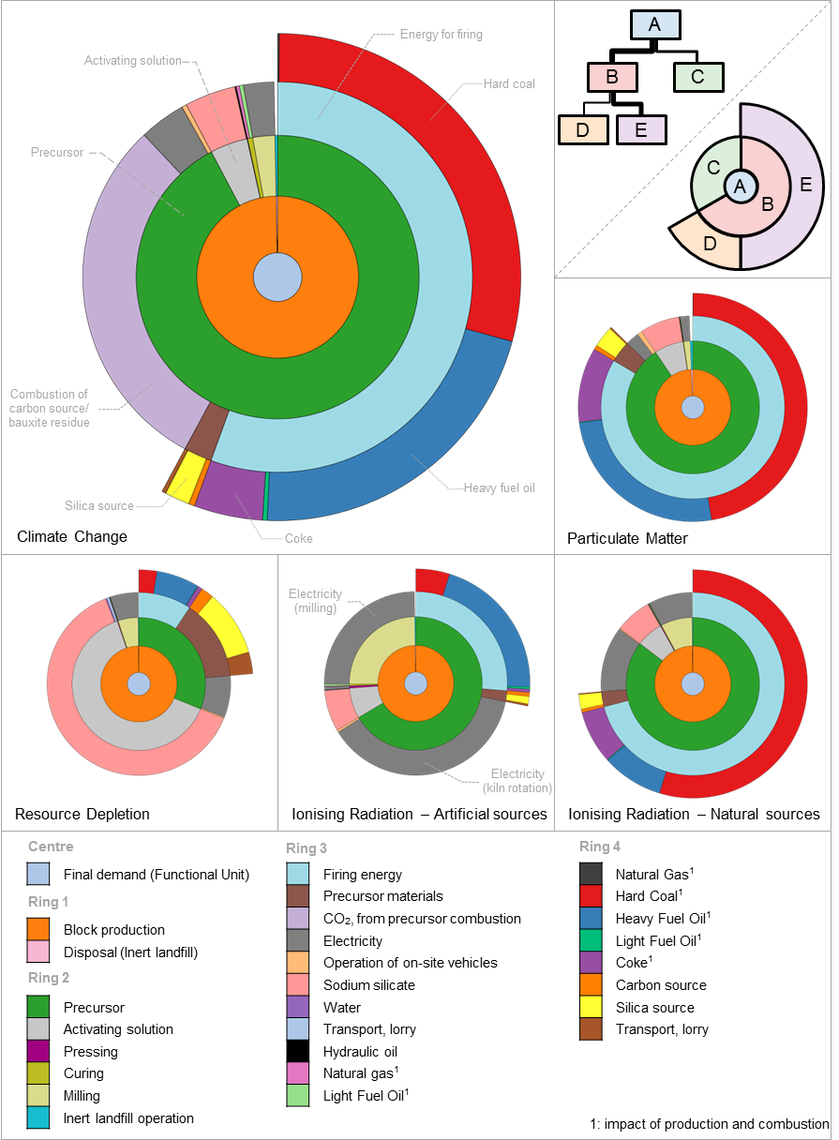
Figure 5 Hotspot diagrams for 12-CS-Na. These should be read as hierarchical pie charts, as outlined in the top right panel. Each ring represents a level of the system tree, with the arc angle representing the contribution to overall impact (as in a traditional pie chart). Selected hotspots are shown as annotations. In both ionising radiation categories only releases to the environment are considered. Use phase impacts of NORM are considered separately in Error! Reference source not found..

Sensitivity analyses

Firing alternatives
Two additional options for the firing of the precursor for mix design 12-CS-Na were assessed (100% natural gas, and sintering). The results of these assessments are summarised in Figure 6.

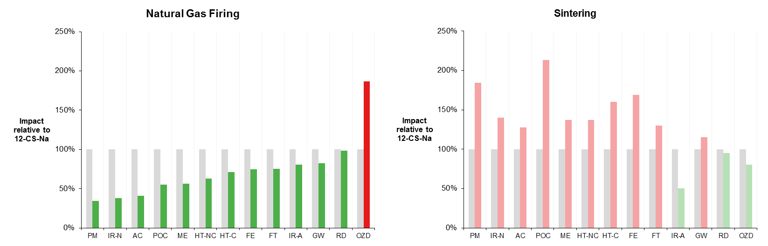
Figure 6 Comparison of impact of 12-CS-Na using natural gas firing and sintering to the base case. Grey bars are set to 100% and represent the base case results for 12-CS-Na. Natural gas firing and sintering results are shown relative to the impact of 12-CS-Na.
Use of natural gas as the energy source leads to a lower impact across all but one of the impact categories assessed (Figure 6). This one category is ozone depletion, and results primarily from emissions of the ozone depleting substances Halon 1301 and Halon 1211 which are used as fire suppressants in the production and transmission of natural gas. These chemicals were banned under the Montreal protocol however the use of Halon 1301 in the EU is considered a critical use under Annex VII of EC Regulation 2037/2000 (European Commission, 2000) in fire suppression in the gas and petrochemical sector.
Sintering has a higher impact across 10 of the 13 impact categories, including climate change and particulate matter formation. This is despite the fact that the sintering process uses slightly less energy than rotary kiln firing (1.46 MJ/kg vs 1.47 MJ/kg) and is as a result of the use of coke as the primary energy source.

Transport to installation
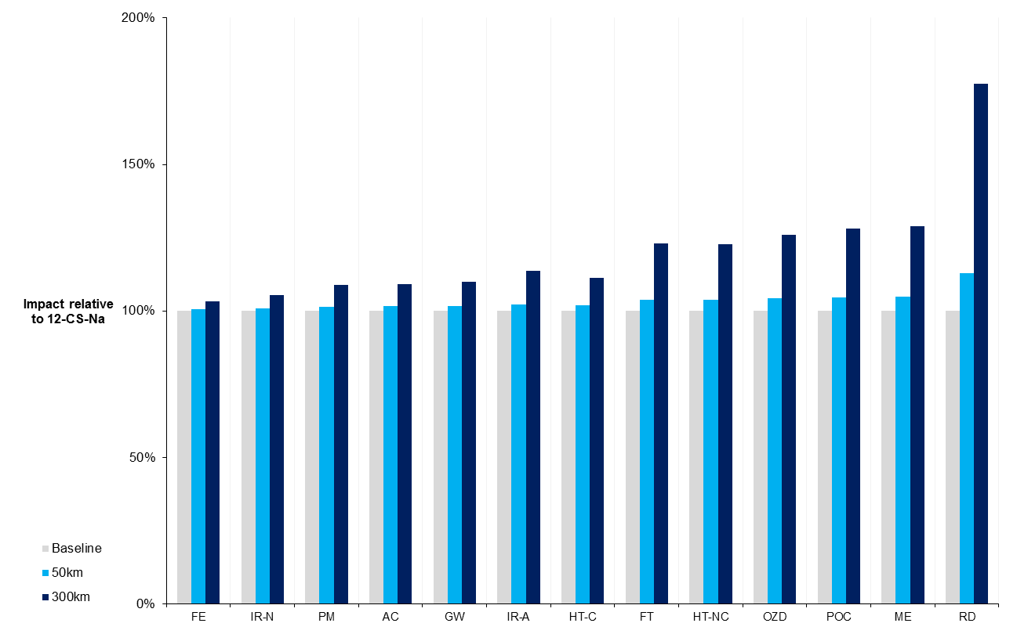
Figure 7 Effect of transport to point of installation vs the base case. Grey bars are set to 100% and represent the base case results for 12-CS-Na. The effect of including transport of 50 km (light blue) and 300 km (dark blue) are shown relative to the base case.
The results for the 12-CS-Na are relatively insensitive to the addition of local transport typical of bulk building products (50 km), with the greatest effect seen in the resource depletion impact category (113% of the baseline) (Figure 7). For all other impact categories including local transport results in impact no greater than 105% of the baseline. At 300km however, the effect is significant. Here transport to site becomes the single largest contributor to resource depletion, and makes a substantial contribution (>15% of total impact) to three further impact categories (FT, HT-NC, OZD, POC, ME).

Discussion
Hotspots analysis, broadly defined, can be used to identify the most significant environmental impacts associated with a given product or process and subsequently to both identify possible solutions to reduce this impact and prioritise these actions (Barthel et al., 2015). Individual life cycle elements or processes which contribute substantially to a range of impact categories can be considered high priority targets for substitution or improvement, as this is likely to have the greatest overall effect on reducing the life cycle environmental impact of the overall process. The potential hotspots of environmental impact identified in this study provide the first step on a route towards the reduction of the impact of the production of BR derived inorganic polymers in order to maximise the sustainability benefits of BR valorisation.
As with the overall LCA framework, hotspots analysis is commonly an iterative process, in particular it can be successively carried out at multiple scales or levels (UNEP-SETAC, 2014), leading to a hierarchy of hotspots. This is the case in this study. At the highest level, that of life cycle stages, processing of the BR into an active precursor material stands out as the most significant hotspot of environmental impact in the life cycle of BR derived inorganic polymer paving blocks across all but one impact category. Within the anticipatory LCA framework, this is also the part of the life cycle upon which research and development can have the most influence, and as such is of high priority for action to reduce the impact. Acquisition of raw materials, most significantly the alkali silicates required for the activating solution represents the most significant hotspot in the resource depletion impact category, and is a secondary hotspot in all other categories. This stands in contrast to many previous studies of secondary material based geopolymers, in which the activating solution is the major hotspot of impact.
Within the broader banner of ‘processing’, the energy used in the firing process is the most significant hotspot of impact, and represents a high priority target for improvement. Use of this energy is thermodynamically unavoidable, it is required to increase the reactivity of the BR, however options exist to potentially reduce the impact caused. For example, in the immediate future, ‘cleaner burning’ fuels could be utilised in the existing alumina plant rotary kiln. As shown in the sensitivity analysis, firing with natural gas leads to a decrease in impact in all but one impact category vs the baseline system. In some regions, bio-based secondary fuels (such as wood waste) may offer a suitable substitute energy source with a lower environmental impact, while promoting industrial symbiosis. The magnitude of any savings in this case would however depend on the impacts associated with transporting the fuels to the processing site.
In the medium term innovative new heating methods may offer a more sustainable outlook. Microwave heating has been trialled in the recovery of iron from BR and fast reaction times and instantaneous heating from within the material have been observed (Samouhos et al., 2013), which may result in lower energy use than conventional roasting. Additionally, the primary energy carrier for microwave heating is electricity, which can be generated from renewable sources. Preliminary investigations (Hertel & Cardenia, unpublished data) undertaken as part of the MSC-ETN REDMUD project (MSCA-ETN REDMUD, 2015) into the use of microwave roasting to increase the reactivity of BR for use in inorganic polymer applications have yielded positive results.
Although processing energy stands out as the largest hotspot, the contribution of the activating solution is worthy of note. Compared on a kg for kg basis, Na based activating solution has a lower impact than the K based solution in the majority of the impact categories considered. Based on the recommendations of previous studies one would expect that using a smaller amount of a lower impact activating solution (cf. mix design 12-CS-K and 12-CS-Na) would lead to a decrease in impact. However, as the impact of the precursor material is higher still in some impact categories, taking such steps actually has the opposite effect in terms of global warming impact. Because the functional unit is based on a required volume of blocks, the increased proportion of precursor in the mix leads to this counterintuitive result.
This result should not be interpreted to mean that BR IPs based on K-silicate chemistry are a better option. When taken alongside steps to reduce the amount or the impact of activated precursor material, a shift to Na-based chemistry is a better long-term option. One potential action, specific to BR, which could reduce the impact of the activating solution, is utilising waste soda from the Bayer process (either the chemically bound Na in the BR or from the residual spent liquor in the BR slurry) as a source of alkali for activation. The addition of additional alkali (in the form of sodium silicate) to the Bayer liquor, or simply the evaporation of water in order to concentrate the liquor, may transform it into a solution which could be used as an alkaline activator for the treated BR.
Ionising radiation exposure from NORM in the use phase of the paving blocks was shown to be substantially higher than that from releases of NORM to the environment during production. The scale of the difference is however far smaller than that seen for use phase NORM exposure from residential applications of BR in Goronovski et al. (Goronovski et al., 2018). The characterisation factors for residential exposure from ²³⁸U, ²³²Th and ⁴⁰K calculated by Goronovski et al. are 707, 181 and 198 times higher respectively than those calculated here for exposure from paving. This result suggests that the use of TENORM materials such as BR in building products should focus on non-residential use cases to further minimise the risks associated with enhanced NORM exposure.
At a product level, the impacts associated with the preparation of the precursor could be further reduced by simply using less precursor material in the preparation of the final paving blocks. Such reductions in the amount of activated precursor required could potentially be achieved via dilution, either with sands and aggregates as suggested in Weil et al. (2009), or with ‘raw’ unactivated BR. Dilution of BR derived precursor with raw BR maintains the benefits of a high-volume utilisation route for BR, while also avoiding the need to extract and transport large quantities of aggregate.
In addition to the hotspots identified in this study, both the pressing and curing processes stand out in an opposite manner, as ‘coldspots’, contributing very little to any of the impacts measures. The pressed, sodium activated sample in this study (12-CS-Na) had a 7-day compressive strength of 149 (± 19.0) MPa. Standards for paving blocks vary worldwide, and by application, however requirements for compressive strength are, in most cases in the region of 45-50 MPa (Houben et al., 1984). For example, the BS 6717 standard (British Standards Institution, 1993) sets a minimum compressive strength of 49 MPa. There is therefore a substantial amount of leeway in the 12-CS-Na mix design to add unreactive material and maintain sufficient compressive strength. Preliminary investigations have determined that pressed samples using a diluted precursor containing 70% ‘raw’ BR achieved a 7 day compressive strength in excess of 50 MPa (Hertel et al., 2017). Innovative treatment of the blocks during casting to increase compressive strength of ‘sub-optimal’ mix designs is a potentially very valuable avenue to explore, which may allow high levels of dilution, milder precursor processing conditions, or a combination of the two to be utilised.
One further consideration for the practical implementation of the production of BR IP paving blocks is the existence of a local market for the product. As evidenced in the sensitivity analysis, the impacts associated with transporting the finished product long distances (>300 km) to market have the potential to temper the potential environmental benefits achieved, particularly with regard to resource depletion.

Conclusions
Identifying potential hotspots of environmental impact at an early stage in the development of a new technology allows changes to be made in advance of ‘lock-in’ effects. By using an anticipatory LCA approach it is evident that for the industrial scale production of novel high BR content inorganic polymer paving blocks, the procedures required to increase the reactivity of BR to function as an alkali activated precursor stand out as the major hotspot of environmental impact. By conducting this analysis at an early stage in design, measures to reduce this impact can be tested for their technical feasibility at laboratory scale. These measures include microwave roasting of the precursor material and dilution with aggregates or BR. These new designs can, and should, be reassessed from a life cycle perspective, and compared to the baseline established in this study, in order to provide more options for the future development and enhance the iterative optimisation of this emerging technology. Following such a route has the potential to lead to the development of novel building materials which simultaneously deal with the pressing need for the treatment of bauxite residue while providing a lower environmental impact alternative to current materials.
In addition to the environmental credentials, it has been suggested that hotspots analysis can be a useful tool has the assessment of economic, ethical and social impacts (UNEP-SETAC, 2014). The practical implementation of a high-volume reuse pathway for BR will depend on each of these aspects in addition to environmental and technical aspects discussed here. LCA can however be used alongside other forms of prospective analysis to help optimise developing technologies along multiple axes simultaneously. Azapagic (1999) introduced the concept of Life Cycle Process Development (LCPD) – an optimisation process combining LCA data and economic considerations to produce Multiple Optimisation (MO) models for processes. Life cycle costing (LCC) has been identified as an important complement to LCA (Fazeni et al., 2014) in moving towards LCPD. Such an assessment, taking into account the avoided costs associated with the treatment and future remediation of BR disposal areas alongside the present costs and revenues associated with inorganic polymer production, may serve to additionally explore the economic feasibility of these high BR paving blocks. This type of analysis likely to become increasingly important as the remaining capacity for on-site disposal of BR becomes critical in the coming years.

Acknowledgements
The authors would like to thank Dr Karel van Acker of KU Leuven for helpful discussions. The research leading to these results has received funding from the European Community’s Horizon 2020 Programme ([H2020/2014–2019]) under Grant Agreement no. 636876 (MSCA-ETN REDMUD). This publication reflects only the authors’ view, exempting the Community from any liability. Project website: http://www.etn.redmud.org

References
Aluminium Leader, 2015. How the aluminium market works [WWW Document]. URL http://www.aluminiumleader.com/economics/how_aluminium_market_works/ (accessed 5.29.17).
Azapagic, A., Clift, R., 1999. Life cycle assessment and multiobjective optimisation. J. Clean. Prod. 7, 135–143. doi:10.1016/S0959-6526(98)00051-1
Barthel, M., Fava, J.A., Harnanan, C.A., Strothmann, P., Khan, S., Miller, S., 2015. Hotspots Analysis: Providing the Focus for Action, in: Sonnemann, G., Margni, M. (Eds.), Life Cycle Management. LCA Compendium – The Complete World of Life Cycle Assessment. Springer, Dordrecht, pp. 149–167. doi:10.1007/978-94-017-7221-1_12
Bjørn, A., Strandesen, M., 2011. The Cradle to Cradle concept - is it always sustainable? Life Cycle Manag. Conf. Towar. Life Cycle Sustain. Manag.
Borra, C.R., Blanpain, B., Pontikes, Y., Binnemans, K., Van Gerven, T., 2016. Recovery of Rare Earths and Other Valuable Metals From Bauxite Residue (Red Mud): A Review. J. Sustain. Metall. 2, 365–386. doi:10.1007/s40831-016-0068-2
BRE Global, 2016. BREEAM International New Construction 2016 Technical Manual.
Brentner, L.B., Eckelman, M.J., Zimmerman, J.B., 2011. Combinatorial life cycle assessment to inform process design of industrial production of algal biodiesel. Environ. Sci. Technol. 45, 7060–7067. doi:10.1021/es2006995
British Standards Institution, 1993. BS6717: Part 1: Precast concrete paving blocks, Part 1. Specification for paving blocks.
Buchwald, A., Dombrowski, K., Weil, M., 2005. Evaluation of Primary and Secondary Materials under Technical, Ecological and Economic Aspects for the Use as Raw Materials in Geo-Polymeric Binders. 2nd Int. Symp. Non-Traditional Cem. Concr. 32–40.
Bureau of Indian Standards, 2006. BIS:15658: Indian Standard for Precast Concrete Blocks For Paving.
Concrete Manufacturers Association, 2004. Concrete Block Paving: Book 2 – Design Aspects.
Davidovits, J., 1991. Geopolymers. J. Therm. Anal. 37, 1633–1656. doi:10.1007/BF01912193
De Man, R., Friege, H., 2016. Circular economy: European policy on shaky ground. Waste Manag. Res. 34, 93–95. doi:10.1177/0734242X15626015
Dimas, D.D., Giannopoulou, I.P., Panias, D., 2009. Utilization of Alumina Red Mud for Synthesis of Inorganic Polymeric Materials. Miner. Process. Extr. Metall. Rev. 30, 211–239. doi:10.1080/08827500802498199
Duxson, P., Fernández-Jiménez, A., Provis, J.L., Lukey, G.C., Palomo, A., Van Deventer, J.S.J., 2007a. Geopolymer technology: The current state of the art. J. Mater. Sci. 42, 2917–2933. doi:10.1007/s10853-006-0637-z
Duxson, P., Provis, J.L., Lukey, G.C., van Deventer, J.S.J., 2007b. The role of inorganic polymer technology in the development of “green concrete.” Cem. Concr. Res. 37, 1590–1597. doi:10.1016/j.cemconres.2007.08.018
Ecoinvent Centre, 2016. ecoinvent 3.3 [WWW Document]. URL http://www.ecoinvent.org/database/ecoinvent-33/ecoinvent-33.html (accessed 3.28.17).
European Commission, 2015. Closing the loop - An EU action plan for the Circular Economy.
European Commission, 2008. Directive 2008/98/EC of the European Parliament and of the Council of 19 November 2008 on waste and repealing certain directives. Off. J. Eur. Union L13, 3–30. doi:2008/98/EC.; 32008L0098
European Commission, 2000. Regulation (EC) No 2037/2000 of the European Parliament and the Council of 29 June 2000 on substances that deplete the ozone layer. Off. J. Eur. Communities 4, L244/1-24.
EUROSTAT, 2017a. Population change – Demographic balance and crude rates at national level [WWW Document]. URL http://ec.europa.eu/eurostat/en/web/products-datasets/-/T2020_RD110 (accessed 11.9.17).
EUROSTAT, 2017b. Built-up areas [WWW Document]. URL http://ec.europa.eu/eurostat/en/web/products-datasets/-/T2020_RD110 (accessed 11.9.17).
EUROSTAT, 2016. Land cover, land use and landscape [WWW Document]. URL http://ec.europa.eu/eurostat/statistics-explained/index.php/Land_cover,_land_use_and_landscape (accessed 11.9.17).
Evans, K., 2016. The History, Challenges, and New Developments in the Management and Use of Bauxite Residue. J. Sustain. Metall. 2, 316–331. doi:10.1007/s40831-016-0060-x
Fazeni, K., Lindorfer, J., Prammer, H., 2014. Methodological advancements in Life Cycle Process Design: A preliminary outlook. Resour. Conserv. Recycl. 92, 66–77. doi:10.1016/j.resconrec.2014.08.011
Frischknecht, R., Braunschweig, A., 2000. Human health damages due to ionising radiation in life cycle impact assessment. Environ. Impact Assess. Rev. 20, 159–189.
Gasafi, E., Meyer, L., Schebek, L., 2003. Using Life-Cycle Assessment in Process Design. Supercritical Water Gasification of Organic Feedstocks. J. Ind. Ecol. 7, 75–91. doi:10.1162/108819803323059415
Geng, J., Zhou, M., Zhang, T., Wang, W., Wang, T., Zhou, X., Wang, X., Hou, H., Red, P.Á., Coal, Á., 2017. Preparation of blended geopolymer from red mud and coal gangue with mechanical co-grinding preactivation. Mater. Struct. 50, 1–11. doi:10.1617/s11527-016-0967-5
Gerber, L., Gassner, M., Maréchal, F., 2011. Systematic integration of LCA in process systems design: Application to combined fuel and electricity production from lignocellulosic biomass. Comput. Chem. Eng. 35, 1265–1280. doi:10.1016/j.compchemeng.2010.11.012
Giannopoulou, I., Dimas, D., Maragkos, I., Panias, D., 2009. Utilization of Metallurgical Solid By-Products for the Development of Inorganic Polymeric Construction Materials. Glob. Nest J. 11, 127–136.
Goronovski, A., Joyce, P.J., Björklund, A., Finnveden, G., Tkaczyk, A.H., 2018. Impact assessment of enhanced exposure from Naturally Occurring Radioactive Materials (NORM) within LCA. J. Clean. Prod. 172, 2824–2839. doi:10.1016/j.jclepro.2017.11.131
Guo, M., Littlewood, J., Joyce, J., Murphy, R., 2014. The environmental profile of bioethanol produced from current and potential future Poplar feedstocks in the EU. Green Chem. 4680–4695. doi:10.1039/c4gc01124d
Habert, G., Espinose, J.B., Lacaillerie, D., Roussel, N., 2011. An environmental evaluation of geopolymer based concrete production : reviewing current research trends. J. Clean. Prod. 19, 1229–1238. doi:10.1016/j.jclepro.2011.03.012
Habert, G., Ouellet-Plamondon, C., 2016. Recent update on the environmental impact of geopolymers. RILEM Tech. Lett. 1, 17–23. doi:10.21809/rilemtechlett.2016.6
Hairi, S.N.M., Jameson, G.N.L., Rogers, J.J., MacKenzie, K.J.D., 2015. Synthesis and properties of inorganic polymers (geopolymers) derived from Bayer process residue (red mud) and bauxite. J. Mater. Sci. 50, 7713–7724. doi:10.1007/s10853-015-9338-9
Hajjaji, W., Andrejkovičová, S., Zanelli, C., Alshaaer, M., Dondi, M., Labrincha, J.A., Rocha, F., 2013. Composition and technological properties of geopolymers based on metakaolin and red mud. Mater. Des. 52, 648–654. doi:10.1016/j.matdes.2013.05.058
Hauschild, M.Z., Goedkoop, M., Guinée, J., Heijungs, R., Huijbregts, M., Jolliet, O., Margni, M., De Schryver, A., Humbert, S., Laurent, A., Sala, S., Pant, R., 2013. Identifying best existing practice for characterization modeling in life cycle impact assessment. Int. J. Life Cycle Assess. 18, 683–697. doi:10.1007/s11367-012-0489-5
He, J., Jie, Y., Zhang, J., Yu, Y., Zhang, G., 2013. Synthesis and characterization of red mud and rice husk ash-based geopolymer composites. Cem. Concr. Compos. 37, 108–118. doi:10.1016/j.cemconcomp.2012.11.010
Hellweg, S., Milà i Canals, L., 2014. Emerging approaches, challenges and opportunities in life cycle assessment. Science (80-. ). 344, 1109–1113. doi:10.1126/science.1248361
Hertel, T., Blanpain, B., Pontikes, Y., 2017. High Temperature Processing Options for the Valorisation of Bauxite Residue towards New Materials, in: Proceedings of 35th International ICSOBA Conference, Hamburg, Germany, 2 – 5 October, 2017.
Hertel, T., Blanpain, B., Pontikes, Y., 2016. A Proposal for a 100 % Use of Bauxite Residue Towards Inorganic Polymer Mortar. J. Sustain. Metall. 2, 394–404. doi:10.1007/s40831-016-0080-6
Houben, L.J.M., van der Kreeft, S.G., Leewis, M., 1984. Specifications and standards for concrete paving blocks - A world-wide survey based on an inquiry by the programme committee CBP, in: Second International Conference on Concrete Block Paving. Delft, pp. 2–14.
Interpave, 2012. Guide to the properties, design, construction, reinstatement and maintenance of concrete blocks pavements Edition 2.
Joyce, P.J., 2017. Lcopt - An interactive tool for creating fully parameterised Life Cycle Assessment (LCA) foreground models. J. Open Source Softw. 2. doi:10.21105/joss.00339
Joyce, P.J., Goronovski, A., Tkaczyk, A.H., Björklund, A., 2017. A framework for including enhanced exposure to naturally occurring radioactive materials (NORM) in LCA. Int. J. Life Cycle Assess. 22, 1078–1095. doi:10.1007/s11367-016-1218-2
Kalinkin, A.M., Kumar, S., Gurevich, B.I., Alex, T.C., Kalinkina, E.V., Tyukavkina, V.V., Kalinnikov, V.T., Kumar, R., 2012. Geopolymerization behavior of Cu–Ni slag mechanically activated in air and in CO2 atmosphere. Int. J. Miner. Process. 112–113, 101–106. doi:10.1016/j.minpro.2012.05.001
Kaya, K., Soyer-Uzun, S., 2015. Evolution of structural characteristics and compressive strength in red mud-metakaolin based geopolymer systems. Ceram. Int. 42, 7406–7413. doi:10.1016/j.ceramint.2016.01.144
Klauber, C., Gräfe, M., Power, G., 2011. Bauxite residue issues: II. options for residue utilization. Hydrometallurgy 108, 11–32. doi:10.1016/j.hydromet.2011.02.007
Komnitsas, K., Zaharaki, D., Perdikatsis, V., 2007. Geopolymerisation of low calcium ferronickel slags. J. Mater. Sci. 42, 3073–3082. doi:10.1007/s10853-006-0529-2
Kumar, A., Kumar, S., 2013. Development of paving blocks from synergistic use of red mud and fly ash using geopolymerization. Constr. Build. Mater. 38, 865–871. doi:10.1016/j.conbuildmat.2012.09.013
Labrincha, J.A., Marques, J.I., Hajjaji, W., Senff, L., Zanelli, C., Dondi, M., Rocha, F., 2014. Novel inorganic products based on industrial wastes. Waste and Biomass Valorization 5, 385–392. doi:10.1007/s12649-013-9281-4
Landsberger, S., Sharp, A., Wang, S., Pontikes, Y., Tkaczyk, A.H., 2017. Characterization of bauxite residue (red mud) for 235U, 238U, 232Th and 40K using neutron activation analysis and the radiation dose levels as modeled by MCNP. J. Environ. Radioact. 173, 97–101. doi:10.1016/j.jenvrad.2016.12.008
Lloyd, R.R., Provis, J.L., Deventer, J.S.J., 2012. Acid resistance of inorganic polymer binders. 1. Corrosion rate. Mater. Struct. 45, 1–14. doi:10.1617/s11527-011-9744-7
Markkanen, M., 1995. Radiation Dose Assessments for Materials with Elevated Natural Radioactivity, Nuclear Safety.
McLellan, B.C., Williams, R.P., Lay, J., Van Riessen, A., Corder, G.D., 2011. Costs and carbon emissions for geopolymer pastes in comparison to ordinary portland cement. J. Clean. Prod. 19, 1080–1090. doi:10.1016/j.jclepro.2011.02.010
Mellado, A., Catalán, C., Bouzón, N., Borrachero, M. V., Monzó, J.M., Payá, J., 2014. Carbon footprint of geopolymeric mortar: study of the contribution of the alkaline activating solution and assessment of an alternative route. RSC Adv. 4, 23846. doi:10.1039/c4ra03375b
MSCA-ETN REDMUD, 2015. Red Mud Project [WWW Document]. URL http://redmud.org/ (accessed 4.27.15).
Mucsi, G., Lakatos, J., Molnár, Z., Szabó, R., 2014. Development of geopolymer using industrial waste materials. 9th Int. Conf. “ENVIRONMENTAL Eng. 1–8. doi:10.3846/enviro.2014.039
Mutel, C., 2017. Brightway: An open source framework for Life Cycle Assessment. J. Open Source Softw. 2. doi:10.21105/joss.00236
Onisei, S., Lesage, K., Blanpain, B., Pontikes, Y., 2015. Early Age Microstructural Transformations of an Inorganic Polymer Made of Fayalite Slag. J. Am. Ceram. Soc. 98, 2269–2277. doi:10.1111/jace.13548
Onisei, S., Pontikes, Y., Van Gerven, T., Angelopoulos, G.N., Velea, T., Predica, V., Moldovan, P., 2012. Synthesis of inorganic polymers using fly ash and primary lead slag. J. Hazard. Mater. 205–206, 101–110. doi:10.1016/j.jhazmat.2011.12.039
Peys, A., Arnout, L., Blanpain, B., Rahier, H., van Acker, K., Pontikes, Y., 2017. Mix-design Parameters and Real-life Considerations in the Pursuit of Lower Environmental Impact Inorganic Polymers. Waste and Biomass Valorization 0, 0. doi:10.1007/s12649-017-9877-1
Pontikes, Y., Angelopoulos, G.N., 2013. Bauxite residue in cement and cementitious applications: Current status and a possible way forward. Resour. Conserv. Recycl. 73, 53–63. doi:10.1016/j.resconrec.2013.01.005
Provis, J.L., 2016. Alkali-activated materials. Cem. Concr. Res. doi:10.1016/j.cemconres.2017.02.009
Provis, J.L., Palomo, A., Shi, C., 2015. Advances in understanding alkali-activated materials. Cem. Concr. Res. 78, 110–125. doi:10.1016/j.cemconres.2015.04.013
Rada, G., Smith, D.R., Miller, J., Witczak, M., 1990. Structural Design of Concrete Block Pavements. J. Transp. Eng. 116, 615–635. doi:10.1061/(ASCE)0733-947X(1990)116:5(615)
RECOVER, 2017. RECOVER: Techology [WWW Document]. URL https://recover.technology/technology/ (accessed 11.10.17).
Sakkas, K., Nomikos, P., Sofianos, A., Panias, D., 2014. Utilisation of FeNi-Slag for the production of inorganic polymeric materials for construction or for passive fire protection. Waste and Biomass Valorization 5, 403–410. doi:10.1007/s12649-013-9278-z
Samouhos, M., Taxiarchou, M., Tsakiridis, P.E., Potiriadis, K., 2013. Greek “red mud” residue: A study of microwave reductive roasting followed by magnetic separation for a metallic iron recovery process. J. Hazard. Mater. 254–255, 193–205. doi:10.1016/j.jhazmat.2013.03.059
Sharma, P., Batra, R.K., Scholar, P.G., Engg, C., Engg, C., 2016. Cement Concrete Paver Blocks for Rural Roads.
Singh, M., Upadhayay, S.N., Prasad, P.M., 1996. Preparation of special cements from red mud. Waste Manag. 16, 665–670. doi:10.1016/S0956-053X(97)00004-4
Thomas, M.D.A., 2007. Optimizing the Use of Fly Ash in Concrete. Portl. Cem. Assoc. 24.
Turner, L.K., Collins, F.G., 2013. Carbon dioxide equivalent (CO2-e) emissions: A comparison between geopolymer and OPC cement concrete. Constr. Build. Mater. 43, 125–130. doi:10.1016/j.conbuildmat.2013.01.023
Ullman, D.G., 1997. The mechanical design process, 2. ed.. ed, McGraw-Hill series in mechanical engineering. McGraw-Hill, New York.
UNEP-SETAC, 2014. Hotspots Analysis: mapping of existing methodologies, tools and guidance and initial recommendations for the development of global guidance. UNEP/SETAC Life Cycle Initiat. - Flagsh. Proj. 3a (Phase 1) 2014.
USGBC, 2017. LEED v4 for Building Design and Construction.
van der Voet, E., van Oers, L., Huele, R., 2014. Topical paper 10. Assessment of historical resource efficiency improvements in the aluminium industry.
Van Deventer, J.S.J., Provis, J.L., Duxson, P., Brice, D.G., 2010. Chemical research and climate change as drivers in the commercial adoption of alkali activated materials. Waste and Biomass Valorization 1, 145–155. doi:10.1007/s12649-010-9015-9
Vukčević, M., Turović, D., Krgović, M., Bošković, I., Ivanović, M., Zejak, R., 2013. Utilization of geopolymerization for obtaining construction materials based on red mud. Mater. Tehnol. 47, 99–104.
Weil, M., Dombrowski, K., Buchwald, A., 2009. Life-cycle analysis of geopolymers, in: Provis, J.L., Van Deventer, J.S.J. (Eds.), Geopolymers: Structure, Processing, Properties and Industrial Applications. Woodhead Publishing Limited, Oxford, pp. 194–210. doi:10.1533/9781845696382.2.194
Wender, B.A., Foley, R.W., Hottle, T.A., Sadowski, J., Prado-López, V., Eisenberg, D.A., Laurin, L., Seager, T.P., 2014. Anticipatory life-cycle assessment for responsible research and innovation. J. Responsible Innov. 1, 200–207. doi:10.1017/CBO9781107415324.004
Wernet, G., Bauer, C., Steubing, B., Reinhard, J., Moreno-Ruiz, E., Weidema, B., 2016. The ecoinvent database version 3 (part I): overview and methodology. Int. J. Life Cycle Assess. 21, 1218–1230. doi:10.1007/s11367-016-1087-8
Wittstock, B., Gantner, J., Lenz, K., Saunders, T., Anderson, J., Carter, C., Gyetvai, Z., Kreißig, J., Braune, A., Lasvaux, S., Bosdevigie, B., Bazzana, M., Schiopu, N., Jayr, E., Nibel, S., Chevalier, J., Hans, J., Fullana-i-Palmer, P., Gazulla, C., Mundy, J.-A., Barrow-Williams, T., Sjöström, C., 2011. EeBGuide Guidance Document 297.
Yagmurlu, B., Dittrich, C., Friedrich, B., 2017. Precipitation Trends of Scandium in Synthetic Red Mud Solutions with Different Precipitation Agents. J. Sustain. Metall. 3, 90–98. doi:10.1007/s40831-016-0098-9
Ye, N., Yang, J., Ke, X., Zhu, J., Li, Y., Xiang, C., Wang, H., Li, L., Xiao, B., 2014. Synthesis and characterization of geopolymer from bayer red mud with thermal pretreatment. J. Am. Ceram. Soc. 97, 1652–1660. doi:10.1111/jace.12840
Ye, N., Zhu, J., Liu, J., Li, Y., Ke, X., Yang, J., 2012. Influence of Thermal Treatment on Phase Transformation and Dissolubility of Aluminosilicate Phase in Red Mud. MRS Proc. 1488, imrc12–1488–7b–055. doi:10.1557/opl.2012.1546
Zaharaki, D., Galetakis, M., Komnitsas, K., 2016. Valorization of construction and demolition (C&D) and industrial wastes through alkali activation. Constr. Build. Mater. 121, 686–693. doi:10.1016/j.conbuildmat.2016.06.051
Zhang, G., He, J., Gambrell, R., 2010. Synthesis, Characterization, and Mechanical Properties of Red Mud-Based Geopolymers. Transp. Res. Rec. J. Transp. Res. Board 2167, 1–9. doi:10.3141/2167-01

Building Research Establishment Environmental Assessment Method
Leadership in Energy and Environmental Design
The Waste Hierarchy: 1. Prevention, 2. Preparing for reuse, 3. Recycling, 4. Other recovery 5. Disposal

