The environmental impacts of municipal solid waste landfills in Europe: a life cycle assessment of reference cases to support decision making
SAUVE Giovannaª, VAN ACKER Karelª
ª Department of Materials Engineering, KU Leuven, Kasteelpark Arenberg 44 - box 2450, 3001 Leuven, Belgium

Abstract
In Europe, 23% of the generated municipal solid waste (MSW) was landfilled in 2017. Despite the landfill targets which define waste and landfill requirements, there is still high variability in the waste management performance between EU Member States. Aim of the study was to give an overview of the variability of environmental impacts of MSW sanitary landfills in Europe in relation to the different levels of implementation of the requirements. Life cycle assessment (LCA) was adopted as tool to define the impacts of the different landfill conditions over a 100-year period. Based on previous studies, consistent methodological choices were made to allow comparability of the results. Four reference cases were defined based on average bulk MSW compositions to represent the European conditions, with $L_{0}$ values of 18, 61, 90 and 138 [m³ CH₄/ t waste]. Furthermore, multiple scenario analysis was used to increase the relevance of the assessment and address the variability of site-specific factors, such as waste composition, climatic conditions and landfill management, which influence the impacts of landfills. Results of the study showed the range of potential impacts in Europe in relation to the variation of influencing factors, with values for climate change ranging from 124 to 841 kg CO2 eq., and with environmental savings obtained for categories such as ecotoxicity and human toxicity for scenarios with landfill gas - to - energy (LFGTE) solutions. The results emphasized the dependence of landfill impacts on waste composition, but also on the LFG treatment and climatic conditions. The outcome of the study also highlights how low amounts of biodegradable fractions reduce the impacts of landfills, as well as their variability in relation to leachate production rates or LFG treatment solutions. Therefore the overall results support the current targets and requirements reported in the Waste Directive 2008/98/EC, Circular Economy package and Landfill Directive 1999/31/EC.

Key Words
Landfill; Municipal Solid Waste; Life Cycle Assessment; Waste Composition; Leachate; Landfill Gas

List of Acronyms
AP | Acidification Potential | LCI | Life Cycle Inventory
DOC | Degradable Organic Carbon | LCIA | Life Cycle Impact Assessment
EEA | European Environment Agency | LFG | Landfill Gas
EP | Eutrophication Potential | MAP | Mean Annual Precipitation
EPA | Environmental Protection Agency | MSW | Municipal Solid Waste
ET | Eco Toxicity | ODP | Ozone Depletion Potential
FOD | First Order Decay | PE | Person Equivalent
GWP | Global Warming Potential | PET | Potential Evapotranspiration
HT | Human Toxicity | SWMS | Solid Waste Management System(s)
ILCD | International Reference Life Cycle Data System | WWT | Wastewater Treatment
IPCC | Intergovernmental Panel on Climate Change | WWTP | Wastewater Treatment Plant
LCA | Life Cycle Assessment

Introduction
Municipal solid waste (MSW) represents only 10% of the total waste generated in Europe on average (Eurostat, 2019). However, landfills are still broadly used as waste disposal sites for MSW despite the environmental impacts and risks for human health, and despite being the least favourable option in the waste hierarchy (Circular Economy Package, Directive 2008/98/EC). Directive 1999/31 and Waste Directive 2008/98/EC, together with more recent amendments (2018/850 and 2018/851) and the Circular Economy package, have set the requirements to close open and/or illegal dumpsites and to control the structure of engineered landfills. New targets have been defined to ban the landfilling of biodegradable waste, to reduce landfilling rates of MSW by 10%, and to phase out the landfilling of recyclable waste by 75%. Nevertheless, around 32% of total MSW was landfilled in Europe in 2012, 23% in 2017 (Eurostat, 2019). While the decrease in MSW landfilling rates can be attributed to the landfill targets, there is still a high waste management performance variability between the EU Member States (EPRS, 2017). While countries such as Germany, Belgium, the Netherlands, etc., have already met the 2030 targets and have advanced waste and landfill management solutions, other countries can have more difficulties in reaching the targets. Due to differences in socio-economic conditions, EU countries are characterized by a wide range of waste generation rates, availability of waste management technologies and their related performance (EPRS, 2017). In this context, the overall goal of the study is to give an overview of the range of impacts of current MSW sanitary landfills in Europe. The study would enable to understand how the landfill waste targets and landfill management requirements address the environmental impacts related to MSW disposal sites.
Life cycle assessment (LCA) is commonly used to assess the environmental impacts of products or systems throughout their life cycle. It has gained increasing importance in supporting policy- and decision-making (Margallo et al., 2019). Moreover, it has been extensively adopted to assess the environmental performance of waste management technologies (Astrup et al., 2015; Cleary, 2009; Damgaard et al., 2011; Fruergaard et al., 2010; Laurent et al., 2014a, 2014b, Manfredi et al., 2010a, 2011; Moberg et al., 2005). The application of LCA to landfills is, however, more challenging compared to other waste management solutions, given the complexity of landfill sites and their management strategies, and given the long term effects of this disposal solution (Obersteiner et al., 2007). A literature review performed on LCA studies of landfills in Europe has highlighted the factors which have a higher influence on the environmental impacts of landfill sites: waste composition, climatic conditions and landfill management. As reported by Manfredi et al., (2010a, 2010b), the organic content of the landfilled waste has direct influence on the LFG generation and on the leachate composition. Manfredi et al. (2010a) present the positive implications of landfilling waste with a lower content of biodegradable matter, while Obersteiner et al. (2007) mentioned how different fractions determine different impacts to either water, air or soil. On the other hand, Damgaard et al. (2011) reported the impacts of different types of MSW landfills in Denmark, from the open dump to a conventional sanitary landfill with energy recovery. Furthermore, the landfill concept with accelerated aftercare was shown to reduce the emission potential stored in the landfill and reduce long term impacts (Ménard et al., 2004; Turner et al., 2017). The geographical location also affects the emission potential of the disposal sites. The leachate generation and emission potential is dependent on factors such as the meteorology, material properties, morphological factors, height and waste density of the landfill, etc. (Hjelmar et al., 2000; Obersteiner et al., 2007). In particular, arid or humid places affect differently the leachate generation in landfills (in orders of magnitude) (Damgaard et al., 2011; Hjelmar et al., 2000; Obersteiner et al., 2007).
The literature review also showed the limited comparability of landfill LCA studies due to differences in the LCA framework itself, assumptions and other methodological choices, life cycle inventory and case specific conditions. Complete results of the review are reported in the Supplementary Materials, and additional considerations can be found in Laurent et al. (2014a), Obersteiner et al. (2007). The choice of life cycle inventories, goal and scope, impact assessment method, assumptions, etc. influence the results (Cleary, 2009; Gentil et al., 2010; Henriksen et al., 2018; Kulczycka et al., 2015; Laurent et al., 2014a, 2014b; Obersteiner et al., 2007). Additional differences derive from different tools, methods and databases used for the assessment of the impacts (Kulczycka et al., 2015). The quality of the inventory data is of great importance, as are the software chosen for the LCA and the method for the impact assessment (Gentil et al., 2010; Kulczycka et al., 2015). For example, in terms of life cycle inventory, data related to waste management systems can either be empirically derived from measurements, or estimated based on modelling results. When addressing landfills, data must often be modelled or estimated due to the lack of monitoring data, site reports, etc. the long term emissions, and impacts, of landfills, cannot be modelled with precision. Assumptions and predictions are instead required, leading to increased uncertainties in the inventory and in the results (Henriksen et al., 2018; Obersteiner et al., 2007). In particular, Henriksen et al. (2018) discussed the need for LCI data to be representative of the systems assessed to provide relevant results and support decision making. The authors estimated the environmental impacts of landfills by highlighting how increasing context specificity in terms of technological and geographical characteristics can lead to increased representativeness of the LCI data.
The outcome of the literature review emphasized how the results of LCA studies of landfills are strictly dependent on the modelling choices, assumptions and quality of the data (Cleary, 2009; Gentil et al., 2010; Henriksen et al., 2018; Laurent et al., 2014a; Margallo et al., 2019; Obersteiner et al., 2007). Moreover, the type of landfill, waste composition, landfill management and site location significantly influence landfill emissions, making each assessment case-specific (Chalvatzaki & Lazaridis, 2010; Lou & Nair, 2009; Manfredi et al., 2009c, 2010a, 2010b; Margallo et al., 2019; Obersteiner et al., 2007).
To overcome the difficult comparability of landfill LCA studies due to methodological choices, the goal of the study is two-fold. On one side, the aim is to define a consistent LCA framework to assess, and compare, environmental impacts of landfills under varying site-specific conditions. On the other side, aim and novelty of the study is the assessment and comparison, under a consistent methodological framework, of the potential impacts of MSW sanitary landfills in the European context. The study could give an overview on how the different levels of implementation of the landfill targets in EU Member States define the range of impacts of MSW sanitary landfill in Europe. The estimation of the environmental impacts of landfills at a European level and under a same LCA framework would improve the comparability of the studies and underline the influence of site-specific conditions. The results could then be used to support currently implemented landfill targets. The study aims at providing means of comparison for European landfill cases, and is meant for waste management operators, policy makers and anyone who would be interested in understanding the influence of site-specific factors on the impacts of landfills.
To obtain relevant results and achieve the above mentioned aim(s), the study builds on approaches already presented in reviewed studies (Henriksen et al., 2018; Manfredi et al., 2010b). Challenging for this study is, in fact, the definition and assessment of the European scenario while still maintaining the site/context-specificity required to obtain representative LCI modelling for landfills and relevant results (Henriksen et al., 2018).

Material and methods
Multiple scenarios are developed to assess the influence of waste composition, climatic conditions and landfill management on the impacts of disposal sites, and to estimate a range of impact values for the European context. The approach adopted follows the one presented in (Henriksen et al., 2018) with the aim of improving the representativeness of the LCI data for the European cases. The study follows four main steps: (i) identification of European reference cases; (ii) scenario development; (iii) definition of a consistent LCA framework for the comparative assessment of the European cases; (iv) sensitivity analysis to address choices in parameter values and methodological assumptions. The following paragraphs introduce the reference cases, the reasoning behind their definition, and the calculation of landfill emissions. Eventually, the life cycle assessment framework is defined and results reported and discussed.

Characteristics of the cases
The aim of the study is to assess landfill impacts at a European, and thus more general level, while still considering site-specific factors influencing the landfill performance. To improve the representativeness of the LCA models for the European context, reference cases are developed by analyzing available data on the emission potential of landfilled MSW in European countries. In particular, landfill gas (LFG) and leachate emission potential for each case were estimated from the waste composition and considering the landfill climatic conditions of the case studies. However, given the lack of direct data from specific landfills, assumptions are made and will be reported in the study. For example, due to the limited statistic data available, no consistent information was found on the amount of each MSW fraction sent to landfill in each European country. The emission potential for the European cases is thus derived from data available in literature. In particular, the first order decay (FOD) model is used to estimate landfill gas production rates and emissions (Amini et al., 2012; Chalvatzaki et al., 2010; Krause et al., 2016b, 2016a; Laurent et al., 2014b). The US EPA LandGem model (version 3.02), which relies on the FOD model, is used in this study to calculate the amount of LFG generated per ton of waste. The main parameters required as input for the FOD model are the methane generation potential $L_{0}$ [m³ CH₄/ t waste] and the methane generation rate k [year⁻¹]. k represents the rate of degradation of the waste and depends on the moisture content of the landfill waste, the climatic conditions, engineered conditions, environmental conditions (temperature, moisture content, etc.). $L_{0}$ represents the total amount of methane obtainable from the carbon present in the landfill and expresses the landfill gas production potential of the landfilled waste. Further information on $L_{0}$ and k is provided in Appendix B in the SM.

Methane generation potential (L0)
Fraction-related values to calculate $L_{0}$ were found in literature (Amini et al., 2012; Krause et al., 2016a; Manfredi et al., 2010b). However, no information on waste fractions was available for all European countries considered. On the other hand, reported $L_{0}$ values from 2012 were found for most European countries in the National Inventory report (Krause et al., 2016b) and are reported in the Supplementary Materials (Table 5, Appendix B). The $L_{0}$ values reported by each country refer to the methane generation potential per ton of MSW landfilled in that specific country. Being methane generation potential values available for most European countries and assuming that $L_{0}$ represents the different waste compositions, the $L_{0}$values are used in this study. In fact, these values represent the best available values to compare the potential environmental impacts of MSW landfills around Europe and describe the dependency of the FOD model on the $L_{0}$ and therefore on the DOC and on the waste composition. Nevertheless, it is important to consider the high variability of country-specific protocols in the definition of the parameters and the consequent uncertainties in the analysis.

Methane generation rate (k)
The values for k are defined based on the IPCC (2006) reported values and considering average climate European conditions. In particular, default and average values of k are reported in the IPCC Guidelines for both dry and wet zones. Dry and wet zones are defined by the ration between the Mean Annual Precipitation (MAP) and the Potential Evapotranspiration (PET), with MAP/PET>1 representing a wet zone and MAP/PET <1 a dry zone.

Selection of the reference cases
Four reference cases are identified based on the country-specific methane generation potentials obtained in literature (Krause et al., 2016b). The definition of the reference cases is made by statistically clustering the values, and thus countries, in groups. Further information on the approach is available in Appendix B of the SM. From the results of the clustering, four groups of countries in Europe with similar values for $L_{0}$ are identified. These groups define the four reference cases, or geographic zones, which are further assessed in the study. The same k-means clustering algorithm used gives as output the mean $L_{0}$ values for every zone which is used as input for each case in the LandGem model. For every zone, values for the surface area, MAP and PET are defined. More information is available in Appendix B of the SM. The amount of leachate is calculated from the water balance applied to the site (Adhikari et al., 2014; Hjelmar et al., 2000) assuming no storage of water within the landfill body, no change in moisture of the waste, no change in moisture of the landfill itself, and no water run-off. These simplifications are a consequence of the generalisations made to identify the cases and on the relative lack of more specific data on the landfill and waste in the identified zones. The final amount of leachate potentially generated per year is calculated as the difference between the amount of rainfall (MAP) and the evapotranspiration (ET). The results for the four reference cases are summarized in Table 1.
Table 1. Definition and characterization of the 4 identified European zones in terms of surface area, Mean Annual Precipitation (MAP), Evapotranspiration (ET), MAP/PET and annual leachate generation [mm/year].
Zone | $L_{0}$[m³ CH₄/ton MSW] | Countries | Surface area [km²] | MAP [mm/year] | ET [mm/year] | MAP/PET | Leachate generation [mm/year]
1 | 18 | DE, BE, NL, L, SI | 91981.00 | 828.02 | 414.59 | 1.99 | 404.00
2 | 61 | HR, DK, BG, HU, LT, PL, RO, SK, ES, UK, EE | 1648157.00 | 729.52 | 420.93 | 1.73 | 275.00
3 | 90 | CZ, FI, GR, IE, IT, LV, PT | 1079285.00 | 771.33 | 420.93 | 1.83 | 306.00
4 | 138 | CY | 366419.00 | 498.00 | 218.00 | 2.28 | 280.00

Considering the MAP/PET values obtained for the zones, $k=0.09$ [year⁻¹] is chosen. This value is the default value suggested in the IPCC Guidelines for Continental climates when considering bulk waste and when MAP/PET > 1 (Pipatti et al., 2006).

The LandGem model and the landfill gas (LFG) emission potential of the cases
Other required user inputs for the LandGem model are the landfill open and closure years and the waste design capacity. Based on the literature studies, average values for the bulk waste density (1 t/m³), for the landfill waste capacity (18’000’000 t), and for the average filling phase of 20 years (from 2012 to 2032) are chosen (Cherubini et al., 2009; Fernandez-Nava et al., 2014; Manfredi & Christensen, 2009a; Niskanen et al., 2009). Based on these values, the waste acceptance rate is assumed constant throughout the 20 years of operational period at 900’000 t/y. The possible variations of $L_{0}$ and k due to the variation in waste composition and climate conditions of the countries during the 20 years is neglected in the model. Indeed, both factors can vary significantly over the years, if considering the varying amount of precipitations and the increasing temperatures. Climate change will lead to more extreme weather events, such as heat waves and droughts, heavy rainfalls and flooding. Moreover, the new waste targets (Landfill Directive 1999/31/EC, Waste Framework Directive 2008/98/EC, EU Action Plan for the Circular Economy) could lead to changing parameters in time. Nevertheless, these uncertainties are not considered in this study.
The results from the LandGem model provide data on the amount of landfill gas produced in each case over a time period of 100 years. The results are reported in Figure 1 and confirm the dependency of the amount of landfill gas produced, and the consequent impacts, on the waste composition and in particular on the amount of biodegradable organic matter (Manfredi et al., 2010a; Obersteiner et al., 2007; Pipatti et al., 2006).
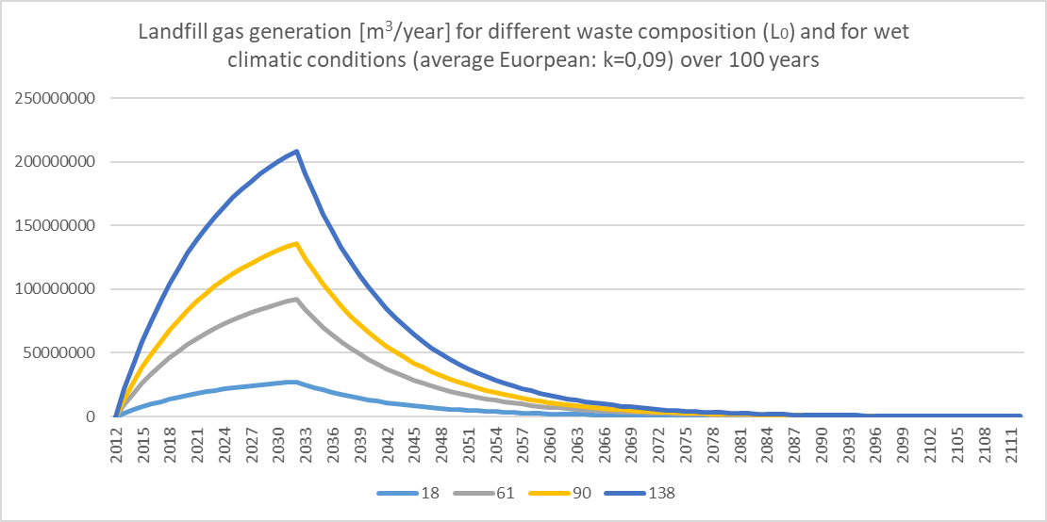
Figure 1. Results from the LandGem model on the amount of landfill gas produced [m³/year] for the 4 different cases ($L_{0}$=18, 61, 90, 138) over 100 years.

Landfill gas and leachate composition
To calculate the amount of pollutants emitted for both LFG and leachate, an empirical model provided in the study by Manfredi et al. (2010b) is adopted. In the study, the cumulative emissions of each substance are calculated as function of the amount of pollutant in each waste fraction, the percentage of decomposable matter, and the actual amount of element that is emitted as either leachate or landfill gas. From the cumulative emissions of each element for the total waste stream, concentrations of each element in the emitted LFG or leachate are then calculated and reported as [g/Nm³] and [mg/l] respectively. Since the implementation of this methodology requires waste fractions as inputs to the model, an average European composition of landfilled MSW is taken as reference from the study by Laner et al. (2016). The waste composition of the young landfill described in the study is assumed to be similar to fresh MSW and taken as reference. This reference waste composition is represented by a $L_{0}=87$ [m³ CH₄/Mg MSW]. The waste fractions reported are then used to derive the concentrations of pollutants [g/Nm³]. Having calculated the amount of pollutants [g/Nm³] for $L_{0}=87$, which represents the literature average waste composition, the amounts of pollutants for the four European reference cases are calculated proportionally. In fact, the concentrations of pollutants in LFG are a function of the organics, paper and OCW (other combustible waste), or simply of the biodegradable fractions. Considering the mentioned relation between $L_{0}$ and the amount of biodegradable fractions in the cases, and considering the dependency of the amount of pollutants on the amount of biodegradable fraction, the proportional relation is considered acceptable for the estimation of the case-specific landfill gas emissions and for the scope of the study.
The composition of leachate is also derived by first calculating it for the average case ($L_{0}=87$) and then proportionally calculated for the four cases. However, it must be taken into account that considering the quality of leachate proportional to the biodegradable fraction, and thus to $L_{0}$, is a considerable simplification. In fact, leachate composition is also dependent on other fractions, such as metals, glass, plastics and ONCW (other non-combustible waste) (Manfredi et al., 2010b). The lack of specific data on the waste fractions for the case studies prevents a complete estimation. This simplification is here considered acceptable based on the goal of the study. In fact, the influence of waste composition, local climatic conditions and system boundaries can still be assessed.

Scenario development
A similar approach as in (Henriksen et al., 2018) is adopted in this study. Several scenarios are developed to assess the influence of site-specific factors on the landfill impacts and to estimate a range of impact values for the European context. While (bulk) waste composition is used to define the reference cases, the scenarios are built in relation to varying climatic conditions and landfill gas treatment technologies. For each reference case, 12 additional scenarios are developed to integrate in the assessment a combined variability of the factors. Figure 2 summarizes the scenario development process. The choice of factors and the scenarios developed are in line with the goal of the study of evaluating impacts of MSW sanitary landfills in Europe. Differences with the study by Henriksen et al. (2018) lie in the inclusion of waste composition for the definition of the cases, and the choice of the technological and geographical parameters.
Figure 2. Scenario development approach with varying site-specific factors. The scheme and approach were adapted from the study by (Henriksen et al., 2018).
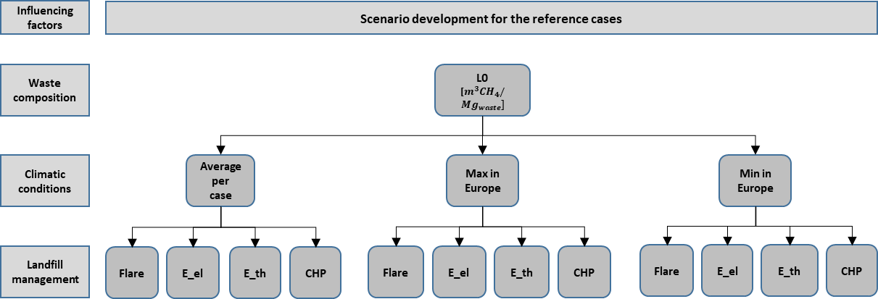
For each case, 3 leachate production rates and 4 LFG treatment technologies are assessed. The leachate production rates considered are the average per zone, and the maximum and minimum values obtained in Europe, 875 mm/year and 111 mm/year respectively. In this study, three LFG to energy (LFGTE) scenarios are analyzed for each case to assess the potential environmental benefits that could derive from different technology setups and for different LFG production rates. Energy recovery from landfill gas can be performed in different ways, from heat recovery, to electricity production, to recovery of methane for further applications or its conversion to bio-diesel or methanol (Bove & Lunghi, 2006). In this study, heat recovery from direct combustion in boiler and electricity production with an internal combustion engine (ICE) are assessed. A further analysis is conducted to take into account the potential cogeneration of electricity and heat. Benefits of CHP for LFG to energy applications is the increased overall efficiency that can be obtained (Ken et al., 2017). Energy recovery scenarios are compared to on-site flaring of the LFG. Flares are usually used as alternative for LFG treatment in landfills when the combustion of landfill gas for energy recovery is not implemented (Landfill Directive 1999/31/EC).
The variability in LFG and leachate collection efficiencies, and LFG oxidation rates, were not taken into account in the scenario definition, but are further discussed in the sensitivity analysis.

Life cycle assessment framework
Life cycle assessment is a tool, defined under the ISO 14040:2006, which is used to estimate the environmental impacts of product systems throughout their whole life cycle. The LCA framework includes four main steps defined by the ISO standards 14041-14045: (i) goal and scope definition, where the goal of the study, the system boundaries, and the functional unit on which the scenarios are compared are described; (ii) the life cycle inventory (LCI); (iii) the life cycle impact assessment (LCIA), where emissions are classified in impact categories and characterize to define the impact values; (iv) interpretation.
For the LCA of the 48 scenarios, GaBi 8.0 was used. Although aware of the benefits of using dedicated waste-LCA tools for the modelling of waste management strategies (Kulczycka et al., 2015; Laurent et al., 2014a, 2014b), the choice of the software was dictated by its availability. Moreover, since no reviewed study appeared to use this tool, it was considered an interesting addition to the literature.

Goal and Scope definition
The goal of this study is to assess the impacts of MSW sanitary landfills in the European context to understand the environmental implications of landfills and waste directives. The comparison of scenarios under a consistent methodological framework would then allow to evaluate the impact of methodological choices and site-specific factors on the environmental impacts of disposal sites.
The chosen functional unit for the study is “1 ton of MSW waste disposed in a landfill with an average height of 20 m and a waste density of 1 t/m³”. A time frame of 100 year from the start of the operational period of the landfill is considered.
Figure 3 summarizes the system boundaries adopted for the four reference cases. Waste collection and source separation are not taken into account in this study, as no specific data on collection strategies can be identified as these are usually locally defined. However, since the aim of the study was also to assess the impact of modelling choices, capital goods and transport are included.
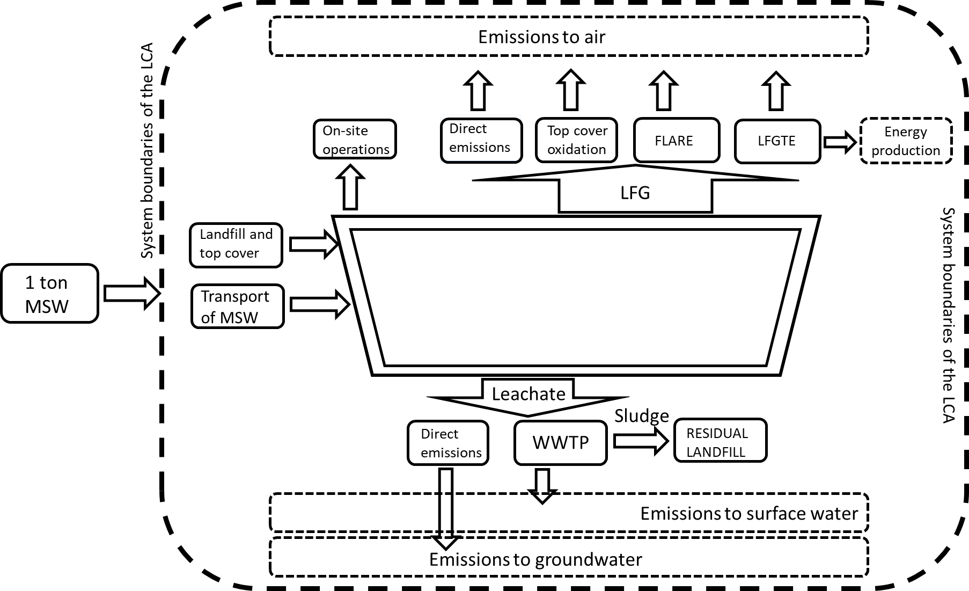
Figure 3. Schematic diagram of the system boundaries of the LCA studies of the four cases, as recommended in the ILCD Handbook (Laurent et al., 2014b).

Life Cycle Inventory
The inventory data for this study was mainly obtained from literature studies reviewed (Amini et al., 2012; Damgaard et al., 2011; Doka, 2003, 2009, Laner et al., 2012, 2016, Manfredi et al., 2009c, 2010b, 2010a, 2009a), and from statistical values (Eurostat). The landfill model includes the landfill infrastructure with leachate and landfill gas collection and treatment system. The treatment of leachate in an on-site wastewater treatment plant (WWTP) is considered. The data for the modelling of the landfill site was taken from Doka (2009) and adapted to the landfill characteristics. The model also included the electricity and diesel consumption for the operation of the landfill in terms of machinery to compact waste, landfill gas collection system, final cover installation, etc. (see Tables 7 and 8 in the Supplementary Information). For the background processes, such as the energy mix, average European processes were used.
Landfill gas and leachate collection and treatment
Given the complexity of landfills and of their management over time, the 100 year time frame is divided in four periods to better represent the variations in time of the emissions. Variations in time of LFG and leachate emissions, collection and treatment efficiencies are then modelled according to the time periods identified (Table 2) and following previous studies (Damgaard et al., 2011; Manfredi et al., 2009b, 2009c, 2010a, 2010b; Niskanen et al., 2009).
Table 2. Summary of the collection and treatment parameters’ values for both leachate and landfill gas.
 | Period 1 | Period 2 | Period 3 | Period 3 | Period 4 | Period 4
 |  |  |  | Top-cover installed |  | no aftercare
Years | 2 | 8 | 10 | 20 | 10 | 50
Leachate
Leachate production [%] | 100.00 | 90.00 | 80.00 | 50.00 | 40.00 | 40.00
Leachate collection [%] | 95.00 | 95.00 | 95.00 | 95.00 | 95.00 | 0.00
Landfill gas
LFG production [%] | 0.43 | 15.10 | 36.00 | 40.50 | 4.76 | 3.23
LFG collection (and flaring) [%] | 0.00 | 50.00 | 50.00 | 75.00 | 75.00 | 0.00
LFG oxidised [%] | 0.00 | 0.00 | 0.00 | 36.00 | 36.00 | 36.00

According to literature, landfill gas collection efficiency can range from around 45% to an ideal value of 100% (Arena et al., 2003; Cherubini et al., 2009; Fernandez-Nava et al., 2014; Fiorentino et al., 2015; Moberg et al., 2005) and is affected by the landfill cover and by the extension of the collection system (Barlaz et al., 2009). The LFG collection efficiency is often dependent on the cover type used at the site. Based on the results of the study by Barlaz, Chanton and Green (2009), different efficiencies are identified for the different periods considered in this study. For leachate, instead, a collection efficiency of 95% is assumed constant throughout the whole period. The remaining 5% is assumed to be directly emitted to groundwater. However, this simplification does not take into account the possible degradation and failure of the containment system. This is further discussed in the sensitivity analysis in paragraph 2.4.4. After the aftercare period of 30 years, a 0% collection efficiency is assumed for both leachate and landfill gas for the remaining 50 years. Indeed, this represents a significant approximation, as the length of the aftercare period depends on the environmental regulations at the site.
For landfill gas flaring an efficiency of 100% is considered (Willis, 2013). For energy recovery, the LFG is either directly combusted in a boiler for heat recovery, with an efficiency of 80% (Damgaard et al., 2011), or treated in internal combustion engines (ICE) for electricity recovery with an efficiency of 33% (Bove et al., 2006). A further solution considers the treatment of LFG for combined heat and power recovery (CHP) with an electrical efficiency of 30% and a thermal efficiency of 45% (Ken et al., 2017). The emissions for the different landfill gas technologies were obtained from literature (Damgaard et al., 2011; USEPA, 2008).
The methane oxidation potential of the landfill top cover is derived from literature (Abushammala et al., 2014). The main factors influencing the oxidation rate are soil texture, moisture and organic content, pH, temperature, oxygen and methane concentrations. The range of values can vary from 0% to 100%, depending also on the thickness of the soil cover. For an average soil type cover, the average oxidation rate is 36% of the methane not collected and transported in the soil (Chanton et al., 2009). This value, although very different from other values encountered in literature (Damgaard et al., 2011; Manfredi et al., 2009a), better represents the case (soil type cover) and is here used. The carbon dioxide emissions from flaring and methane oxidation are calculated from the methane combustion reaction, obtaining a factor of 2.75 which is then multiplied by the amount of methane emitted [g/m³ LFG], and either oxidized or flared, and added to the direct CO₂ emissions from the gas.
For the treatment of the collected leachate from the landfill, a waste water treatment plant (WWTP) model is created using the Ecoinvent database, the related documentation by Doka et al. (2009), and adapted to the study. Average transfer coefficients are available in the Ecoinvent report and are here used and adapted to model the four cases studied (Doka, 2003). Transfer coefficients (Table 11 in the Appendix) are used to assess the percentage of pollutant that precipitates and ends in the sludge, the percentage that is emitted to air (in case of the carbon compounds), and the percentage that is emitted to surface water. The final disposal of the sludge derived from the WWTP is instead considered to be re-landfilled. The Ecoinvent model is used without further modification.
The emissions and transfer coefficients adopted in this study for LFG and leachate treatment are reported in Appendix B.

Life cycle Impact Assessment
Given the high impacts of landfills on human health and ecosystems caused by the release of chemicals (Cleary, 2009; Laurent et al., 2014b), both ordinary and toxicity-related impact categories are considered in the impact assessment. In particular these include climate change (GWP, Global Warming Potential), Acidification Potential (AP), Ozone Depletion Potential (ODP), Human Toxicity Potential (HT), Ecotoxicity (ET), Terrestrial and Aquatic (Marine and Freshwater) Eutrophication (EUx). In this study, the ILCD methodology, which can be found in GaBi and which relies on the recommended assessment methods reported in the ILCD Guidelines (JRC European commission, 2011), is chosen for the estimation of the results. A summary of the recommended assessment methods for the categories is reported in the Supplementary Materials (Table 12, Appendix B). The normalization step is also included in the assessment. In this stage of the LCA, results of the LCIA are normalized based on the average impact per person over a year. The normalization factors (NFs) recommended in the ILCD Guidelines are used in this study (Table 1, Appendix B).

Sensitivity analysis
A sensitivity analysis is performed on site-specific parameters which depend on the landfill site conditions and on potential events (i.e. degradation/failure of the bottom liner) which should be considered in the estimation of the landfill performance (Damgaard et al., 2011; Manfredi et al., 2009a; Pivato, 2011; Turner et al., 2017). In particular, the parameters to address are identified based on previous research and assumptions made in this study. A further explanation of the choice of parameters and values is presented in Appendix B of the SM. Table 3 summarizes the parameters addressed in the sensitivity analysis and the values used.
Table 3. Summary of collection efficiencies used in the benchmark scenario and in the sensitivity analysis for landfill gas and leachate.
 | Period 1 | Period 2 | Period 3 | Period 3.2 | Period 4 | Period 4.2
 |  |  |  | top cover soil |  | no aftercare
Years | 2 | 8 | 10 | 20 | 10 | 50
Fixed parameters
LFG production [%] | 0.40 | 13.80 | 34.00 | 41.45 | 5.80 | 4.60
Leachate production [%] | 100.00 | 90.00 | 80.00 | 50.00 | 40.00 | 40.00
Parameters for the sensitivity
LFG collection [%] | 0.00 | 50.00 | 50.00 | 75.00 | 75.00 | 0.00
LFG collection + 10% | 0.00 | 0.00 | 55.00 | 82.50 | 82.50 | 0.00
LFG collection – 10% | 0.00 | 0.00 | 45.00 | 67.50 | 67.50 | 0.00
LFG flaring efficiency [%] | 0.00 | 0.00 | 100.00 | 100.00 | 100.00 | 0.00
LFG flaring efficiency – 10% | 0.00 | 0.00 | 90.00 | 90.00 | 90.00 | 0.00
Methane oxidation [%] | 0.00 | 0.00 | 0.00 | 36.00 | 36.00 | 36.00
IPCC Guidelines [%] | 0.00 | 0.00 | 0.00 | 10.00 | 10.00 | 10.00
Literature | 0.00 | 0.00 | 0.00 | 80.00 | 80.00 | 80.00
Leachate collection [%] | 95.00 | 95.00 | 95.00 | 95.00 | 95.00 | 0.00
Leachate collection with degradation of bottom liner [%] | 95.00 | 95.00 | 95.00 | 70.00 | 50.00 | 0.00

A further sensitivity analysis is performed on the transport process to define the influence of modelling choices on the LCA results. The transport distance was varied by +/- 50% leading to values of 25km and 75 km.
To assess the sensitivity of the results to the variation of the parameters, the sensitivity ratio (SR) is estimate for all scenarios according to equation 1.
$SR=\frac{\frac{∆result}{initial result}}{\frac{∆parameter}{initial parameter}}$) (1)
The SR defines how much the results can vary for the variation of the addressed parameter. It communicates the sensitivity of the model to parameter uncertainty (Clavreul et al., 2012).

Results
A contribution analysis was conducted on all 48 scenarios to assess the influence of methodological choices and the effects of climatic conditions and LFG treatment options on the results of the impact categories. In particular, two aspects related to the definition of the system boundaries were analysed: the inclusion of infrastructure and transportation of the MSW to the disposal site. Different studies have reported different contributions of infrastructure to impact categories, with values ranging from 1-2% for climate change to 85% for several other impact categories (Laurent et al., 2014c). The influence depends on the solid waste management systems (SWMS) analysed and impact categories addressed. In this study, the contribution analysis showed how capital goods had high influence on categories such as acidification potential (AP), terrestrial eutrophication (EUt), Ozone depletion (OD), and the toxicity categories (HT, ET). However, the values were seen to vary depending on the scenarios, and particularly with the LFG treatment solution applied which had high contributions to the same categories. Moreover, the influence of infrastructure on the results decreased with increasing value of $L_{0}$, as direct emissions from landfill, WWT and LFG treatment gained increasing importance in the results. These results confirm the relative contribution of infrastructure to the overall results and the dependence on the SWMS assessed and the impact categories addressed (Laurent et al., 2014b). Similar results can be seen for the transport process, although with a reduced overall influence on the results. Values for transport range from 0-17% depending on the categories and on the reference cases. The impact categories majorly influenced by the transport process are AP and EUt, followed by EUm and GWP. Figure 4 shows the results of the contribution analysis for the mentioned impact categories. The values per reference case are average values of the 12 scenarios dependent on each $L_{0}$ value. Complete results of the contribution analysis can be found in the SM (Tables 14 to 17 in Appendix B).
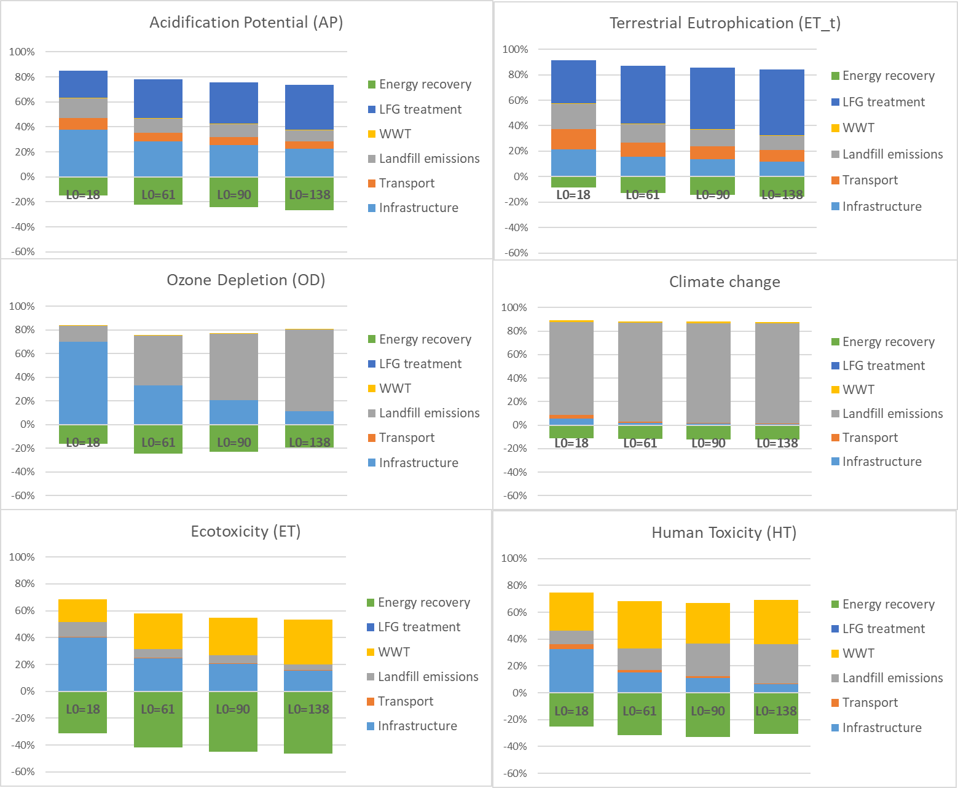
Figure 4. Contribution analysis for six impact categories where infrastructure and transport have highest influence.
In Figure 5 the results for the comparative assessment of the 48 scenarios are plotted for climate change [kg CO₂ eq./FU], ecotoxicity [CTUe/FU], and human toxicity [CTUh/FU]. These categories were chosen as they are affected by the LFG and leachate emissions and treatment (Henriksen et al., 2018). Normalized results for all impact categories are reported in Table 4, and additional information on the results is available in the SM.
Table 4. Summary of normalized results for all impact categories addressed. Results are reported in min, mean and max values per reference cases. The values represent the ranges of results obtained for the 12 scenarios for each case.
 |  | GWP | AP | EUt | EUm | EUf | OD | HT | ET
 | Min | 1.04E-02 | 3.07E-03 | 2.62E-03 | 6.62E-03 | 1.57E-02 | 2.60E-04 | -8.66E-03 | -6.85E-03
18 | Mean | 1.17E-02 | 3.94E-03 | 5.01E-03 | 2.23E-02 | 1.01E-01 | 3.16E-04 | 4.33E-02 | 3.02E-03
 | Max | 1.36E-02 | 4.73E-03 | 7.43E-03 | 4.00E-02 | 1.99E-01 | 4.00E-04 | 9.99E-02 | 1.32E-02
 | Min | 3.11E-02 | 2.76E-03 | 2.74E-03 | 1.66E-02 | 4.81E-02 | 2.97E-04 | -9.26E-02 | -4.16E-02
61 | Mean | 3.56E-02 | 5.69E-03 | 1.08E-02 | 6.53E-02 | 3.12E-01 | 4.85E-04 | 7.38E-02 | -8.93E-03
 | Max | 4.20E-02 | 8.35E-03 | 1.91E-02 | 1.30E-01 | 6.68E-01 | 7.72E-04 | 2.75E-01 | 2.62E-02
 | Min | 4.50E-02 | 2.51E-03 | 2.79E-03 | 2.33E-02 | 6.99E-02 | 5.47E-04 | -1.49E-01 | -6.56E-02
90 | Mean | 5.17E-02 | 6.83E-03 | 1.48E-02 | 9.73E-02 | 4.75E-01 | 8.25E-04 | 1.02E-01 | -1.71E-02
 | Max | 6.12E-02 | 1.07E-02 | 2.69E-02 | 1.89E-01 | 9.85E-01 | 1.25E-03 | 3.93E-01 | 3.43E-02
 | Min | 6.82E-02 | 2.15E-03 | 2.92E-03 | 3.46E-02 | 1.06E-01 | 1.36E-03 | -2.33E-01 | -1.04E-01
138 | Mean | 7.83E-02 | 8.78E-03 | 2.13E-02 | 1.42E-01 | 6.87E-01 | 1.79E-03 | 1.37E-01 | -3.11E-02
 | Max | 9.30E-02 | 1.48E-02 | 3.98E-02 | 2.90E-01 | 1.51E+00 | 2.43E-03 | 5.98E-01 | 4.87E-02

The ranges of values in Table 4 represent the range of impacts for the 12 scenarios per reference case. These ranges show how the variability of the influencing factors affects the results, and to what extent. In particular, for all impact categories, a variation in waste composition increases the range of results in both positive (burden) and negative (savings) impacts. This confirms the significant influence of waste composition and, in particular, of the amount of biodegradable fraction on the impacts of landfills, independently from the landfill management and climatic conditions. For the scenarios with LFG treatment for energy recovery, higher avoided impacts are achieved for higher $L_{0}$ values. This is due to the higher amount of LFG produced. However, in categories mainly affected by direct landfill emissions, such as climate change and ozone depletion, the savings associated to energy recovery do not outweigh the impacts. On the other hand, the impacts associated to ecotoxicity are also highly affected by the avoided burdens from energy recovery. In scenarios with electricity recovery and CHP, the savings outweigh the impacts related to WWT and direct landfill emissions. A similar trend can be observed for human toxicity (HT), where however the benefits of electricity recovery do not compensate the impacts from landfill emissions and WWT in as many scenarios as for ET. It is important to notice that the results for the scenarios with energy recovery are strictly related to the electricity mix and heat production process considered as energy technologies. In this study, heat production by natural gas and an average EU electricity mix were used.
The influence of leachate production rates on landfill impacts can be seen in the results of EUm, EUf, ET and HT. In these categories, WWT emissions and direct leachate emissions from the landfill have high contributions. The variation in leachate production volumes, and thus amount of leachate to groundwater and to treatment, influences the results. Moreover, being leachate composition dependent on the waste composition, scenarios related to higher values of $L_{0}$ show higher variations in the results for the mentioned categories with varying climatic conditions.
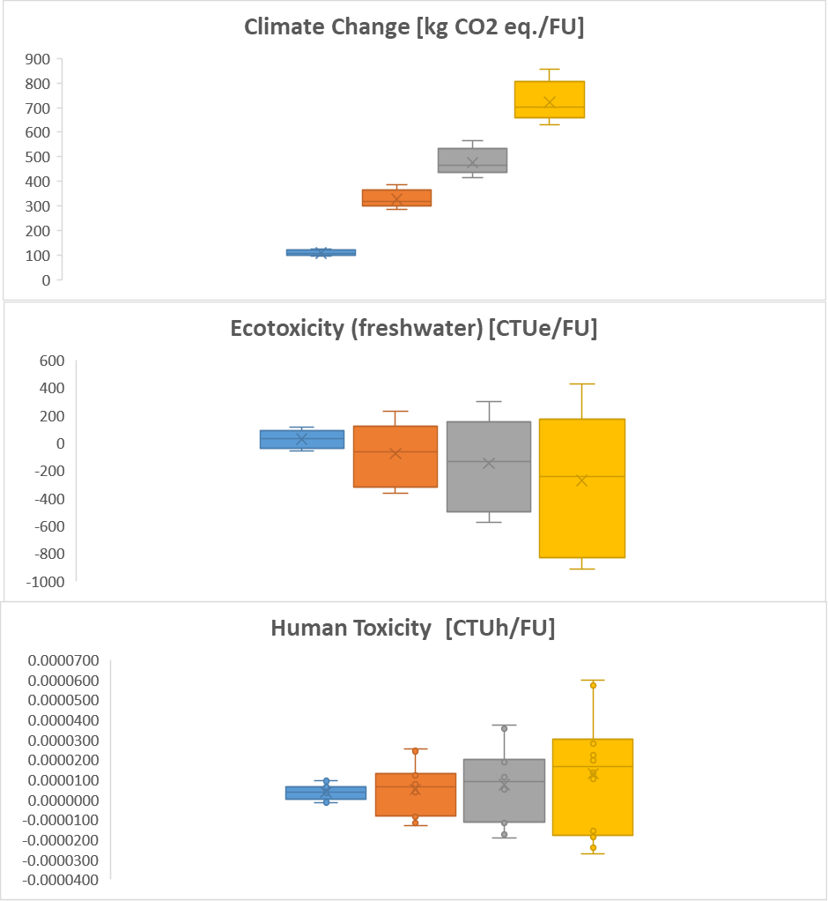
Figure 5. Results of the comparative assessment for climate change [kg CO₂ eq./FU], human toxicity [CTUh/FU], ecotoxicity [CTUe/FU]. All results are reported in unit/functional unit (1 ton of MSW landfilled). The box-plots are created based on the results for the 12 scenarios per reference case.
The results of the sensitivity analysis confirm the considerations made above. The influence of flaring and oxidation efficiencies on GWP and OD is proportional to the waste composition, with SRs increasing with increasing $L_{0}$ (Table 5). In particular, the results for the two impact categories are highly sensitive to the flaring efficiency. A variation of 10% of this parameter could lead to a variation of 3-17% in the GWP results. On the other hand, the toxicity categories have a less expected behaviour when addressing leachate collection. As main contributors to these categories are the WWT and energy recovery processes, the resulting sensitivity indices appear to suggest a decrease of impacts when reducing the leachate collection efficiency, due to the treatment of a lower amount of leachate. However, these results are strictly related to the modelling choice and the contribution analysis, and should be interpreted accordingly. In particular, high SR values are obtained for $L_{0}$ =18 in ecotoxicity for scenarios with CHP and high leachate production rates. Due to lower LFG production rates, ecotoxicity results are dominated by impacts related to WWT and, in particular, sludge disposal. These impacts are higher than the ones related to direct landfill emissions, dominating the impact trend in the sensitivity analysis. This effect is less evident in the other cases, characterized by higher LFG production rates and thus higher influence of LFG treatment.
Table 5. Summary of results of the sensitivity analysis. Sensitivity ratios are reported for the 4 reference cases and averaged over the scenarios. The reported results are related to the impact categories mostly influenced by the parameters’ variation. Only results of SR>1 are considered here.
 |  | $L_{0}$ =18 |  |  | $L_{0}$ =61
 | Min | Average | Max | Min | Average | Max
LFG collection_GWP | -0.20 | -0.17 | -0.13 | -0.20 | -0.17 | -0.12
LFG collection_HT | -0.83 | -0.06 | -0.01 | -0.52 | -0.13 | 0.00
LFG collection_ET | -1.18 | -0.12 | 0.00 | -0.21 | -0.13 | 0.00
Leachate collection_EUm | -0.17 | -0.13 | -0.06 | -0.20 | -0.15 | -0.08
Leachate collection_EUf | 0.25 | 0.28 | 0.44 | 0.27 | 0.29 | 0.48
Leachate collection_HT | 0.06 | 0.25 | 0.59 | 0.09 | 0.24 | 0.76
Leachate collection_ET | 0.02 | 0.09 | 1.24 | 0.02 | 0.08 | 0.22
LFG_flaring_GWP | -0.30 | 0.00 | 0.00 | -1.61 | 0.00 | 0.00
LFG flaring_OD | -0.13 | 0.00 | 0.00 | -0.82 | 0.00 | 0.00
LFG flaring_HT | 0.00 | 0.00 | 0.00 | -0.12 | 0.00 | 0.00
LFG oxidation rate_GWP | -0.16 | -0.15 | -0.13 | -0.19 | -0.17 | -0.14
 |  | $L_{0}$ =90 |  |  | $L_{0}$ =138
 | Min | Average | Max | Min | Average | Max
LFG collection_GWP | -0.21 | -0.17 | -0.13 | -0.21 | -0.18 | -0.13
LFG collection_HT | -0.60 | -0.09 | 0.00 | -0.35 | -0.10 | -0.01
LFG collection_ET | -0.19 | 0.09 | 0.00 | -0.18 | -0.11 | 0.00
Leachate collection_EUm | -0.19 | -0.16 | -0.08 | -0.18 | -0.16 | -0.08
Leachate collection_EUf | 0.27 | 0.28 | 0.48 | 0.26 | 0.28 | 0.49
Leachate collection_HT | 0.08 | 0.24 | 0.98 | 0.07 | 0.24 | 0.63
Leachate collection_ET | 0.01 | 0.16 | 0.25 | 0.02 | 0.17 | 0.27
LFG_flaring_GWP | -1.64 | 0.00 | 0.00 | -1.69 | 0.00 | 0.00
LFG flaring_OD | -1.07 | 0.00 | 0.00 | -1.25 | 0.00 | 0.00
LFG flaring_HT | -0.20 | 0.00 | 0.00 | -0.31 | 0.00 | 0.00
LFG oxidation rate_GWP | -0.19 | -0.17 | -0.14 | -0.19 | -0.17 | -0.14

The sensitivity results highlight the significant dependence of landfill impacts on waste composition and, though to a minor extent, to climatic conditions. Moreover, the results also emphasize the importance of LFG treatment and the efficiencies of the processes. It is, however, important to consider the influence of modelling choices and the related uncertainties when analysing these results.

Discussion
In relation to the modelling choices, the high contributions of infrastructure and, to a minor extent, transport in certain impact categories (AP, EUt, ET, HT, OD) have shown how these processes should not be neglected a priori. Choices related to system boundaries should be made based on the goal of the study and the system(s) assessed and compared (Cleary, 2009; Fernandez-Nava et al., 2014; Laurent et al., 2014b).
The outcome confirmed a wide range of performances of landfills in different EU Member States (EPRS, 2017). The study highlighted the dependency of environmental impacts of disposal sites on waste composition (in all impact categories), as well as climatic conditions (HT, ET, EUm, EUf, etc.), and landfill gas management (GWP, AP, EUt, OD, HT, ET). The results of the study are in line with previous literature, although differences exist due to modelling choices and data availability (see Table 25 in Appendix B). In particular, Arena et al. (2003) reported results for GWP of 500 kg CO₂ eq./t waste with an $L_{0}$ value of 60 m³ CH₄/t waste. This result appears higher than the result of the scenarios with $L_{0}$ =61. On the other hand, results from Damgaard et al. (2011) and Manfredi et al. (2009b and 2009a) report lower impacts for all scenarios, with results reaching negative values for those with energy recovery. Results obtained go from -0.025 to +0.02 PE/t waste, for landfills with $L_{0}$ values of 73 to 85.5 m³ CH₄/t waste. According to the results of this study, these values could be associated to scenarios with $L_{0}$ values between 18 and 61. These differences could be linked to the different LFG collection efficiencies (higher in the reviewed studies), or modelling choices and assumptions made. Moreover, different normalization factors are used in the studies which could lead to further differences. For the categories of ET and HT, results are instead in line with previous literature. The results in Henriksen et al. (2018) show high environmental savings in GWP (293 to -457 kg CO₂ eq./ t waste), which are not obtained in the 48 scenarios of this study (841 to 95.7 kg CO₂ eq.). In Henriksen et al. (2018), the environmental savings are dependent on the energy recovery but also on the biogenic carbon stored in the landfill, which is here not accounted for. Higher HT values were instead obtained in this study, with values ranging from -2.68E-05 to 5.99E-05 CTUh/t waste. The differences with the other studies (Henriksen et al., 2018; Manfredi et al., 2010a) could be due to the high leachate production rates, waste compositions considered, and modelling choices. The high impacts for freshwater eutrophication (EUf), which dominate the total normalized results in this study (Table 22 and Figure 6 in Appendix B), are related to the disposal of the sludge from the WWT process in a residual landfill as confirmed by the contribution analysis. The much higher impacts associated to the category compared to previous studies can be related to modelling choices, as an ecoinvent process for residual landfill was directly used in the model without further adaptation. Moreover, overestimations of the impacts in EUf could be due to the assumption of disposal of the total amount of sludge produced. According to (Doka, 2009), a drying process is usually implemented to reduce the moisture content, and amount, of the sludge. However, given the lack of specific data on the process, the ecoinvent process was adopted and applied as described. These considerations should be taken into account when considering the results of EUf. On the other hand, the overall trend of the impacts still takes into account the influence of site-specific factors.
Further differences in the results, in all categories, could also be related to the choice of the technological and geographical factors in the scenario development. For example, high LFG collection efficiencies assumed in some scenarios could lead to decreased landfill emissions and increased LFG treatment and energy recovery which directly affect the GWP values. The data availability, and thus simplifications and modelling assumptions, could the affect the results.
Major limitation in the study is the LCI data gathered for the modelling of the LCA. Literature data was used for the comparative assessment of 48 landfill scenarios and no further uncertainty analysis was conducted. The simplifications applied for the estimation of leachate emissions also lead to uncertainties (Clavreul et al., 2012). Although a scenario analysis and sensitivity analysis were performed to overcome, to some extent, this limitation and increase the representativeness of the models, the results carry a high level of uncertainty. Moreover, not all factors were addressed in the scenario development and sensitivity analysis. Therefore, results must be considered and used in relation to the data used and assumptions made.
It must also be considered that, although efforts have been made to highlight the different emission profiles of different waste- and climatic-zones, high levels of uncertainties remain due to the long-term emission potential of landfills. The 100-year time horizon chosen for the study assumes that all easily released substances are emitted throughout the period (Gentil et al., 2010). However, as previously mentioned, leachate emissions occur over a longer time horizon and the leachability of substances depends on physic- and chemical properties of the site (Doka & Hischier, 2005; Hellweg & Frischknecht, 2004; Henriksen et al., 2018; Hjelmar et al., 2000; Kjeldsen et al., 2002; Laner, 2009, 2011; Turner et al., 2017). However, these time-related considerations have here not been taken into account, leading to possible under- or over-estimations of emissions (Collinge et al., 2013; Laurent et al., 2014b; Levasseur et al., 2010; Pinsonnault et al., 2014).
A further limitation of the study is the focus on sanitary MSW landfills. In other studies, different landfill types have been discussed and compared to assess the variation of potential impacts as a function of other factors (Henriksen et al., 2018; Manfredi et al., 2009a; Turner et al., 2017). Referring to previous studies, bioreactor-, flushing bioreactor-, or semi aerobic landfills could achieve further reduction in environmental impacts. However, the impacts of these landfills also depend on technological and geographical factors as discussed in (Henriksen et al., 2018)
Despite the mentioned limitations, the study allows to have a wide overview of the range of impacts of MSW sanitary landfills in Europe. The study serves for a general estimation of the environmental performance of landfills while still considering the site-specificity of their impacts. Landfill stakeholders could, based on site-specific data such as waste composition ($L_{0}$), climatic conditions and landfill management, relate their specific case to the reference cases and scenarios for a first assessment of the results. Moreover, the study confirms the need to reach the landfill targets described in the directives. In fact, as was clear from the results, a decrease in the amount of biodegradable fraction in the disposed waste could limit the landfill impacts related to higher leachate production rates (higher precipitations and leachate collection efficiencies), and less advanced landfill management solutions. The results further emphasized the environmental benefits of advanced LFG treatment technologies, in line with the directive 1999/31/EC.

Conclusions
According to Henriksen et al. (2018) and Laurent et al. (2014c), decision- and policy- makers in the field of solid waste management (SWM) should rely on LCA studies with high context specificity to obtain relevant results. Laurent et al. (2014c) also emphasized how generalised models should be used with caution. This study aimed at providing a broad overview of the impact of average MSW sanitary landfills in Europe while still considering site-specific factors to increase the context specificity and the relevance of the results. To overcome the lack of direct landfill data, the study used multiple scenario analysis to assess the impacts of disposal sites under varying conditions to reflect the conditions in the EU Member States. 48 scenarios were built on the basis of 4 average European waste compositions, 3 leachate production rates per case and 4 LFG treatment technologies. The multiple scenario assessment and sensitivity analysis allowed to include context specificity while addressing average European conditions based on literature and statistical data.
The study provided a range of results for all impact categories based on the variation of technological and geographical factors. The ranges of results for all impact categories represent the high variability of landfill performance in the European context. Scenarios with lower $L_{0}$ values, representing lower amounts of biodegradable fractions in waste, showed lower impacts also in case of varying climatic conditions. The results obtained support the currently implemented ban of biodegradable waste from MSW landfill to decrease the environmental impacts. The study also confirmed the importance of LFG technologies and their efficiencies, mostly when treating MSW with high methane generation potential. This outcome is in line with the landfill directive 1999/31/EC.
While modelling choices and data quality are important limitations of the study, the results are in line with the expected outcome and with the literature the study referred to. Indeed, the results still carry several degrees of uncertainty due to the limitations in the LCA framework and due to the simplifications and assumptions made. Nevertheless, the ranges of values could serve landfill stakeholders to support implemented waste policies and targets, as the results represent potential impacts of waste disposal in different EU Member States.
Acknowledgements

This project has received funding from the European Union's EU Framework Programme for Research and Innovation Horizon 2020 under Grant Agreement No 721185.

References
Abushammala, M. F. M., Ezlin, N., Basri, A., Irwan, D., & Younes, M. K. (2014). Methane Oxidation in Landfill Cover Soils : A Review. Asian Journal of Atmospheric Environment, 8(March), 1–14. https://doi.org/10.5572/ajae.2014.8.1.001
Adhikari, B., Dahal, K. R., & Khanal, S. N. (2014). A Review of Factors Affecting the Composition of Municipal Solid Waste Landfill Leachate, 3(5), 273–281.
Amini, H. R., Reinhart, D. R., & Mackie, K. R. (2012). Determination of first-order landfill gas modeling parameters and uncertainties. Waste Management, 32(2), 305–316. https://doi.org/10.1016/j.wasman.2011.09.021
Arena, U., Mastellone, M. L., & Perugini, F. (2003). The environmental performance of alternative solid waste management options: A life cycle assessment study. Chemical Engineering Journal, 96(1–3), 207–222. https://doi.org/10.1016/j.cej.2003.08.019
Astrup, T. F., Tonini, D., Turconi, R., & Boldrin, A. (2015). Life cycle assessment of thermal Waste-to-Energy technologies: Review and recommendations. Waste Management, 37, 104–115. https://doi.org/10.1016/j.wasman.2014.06.011
Barlaz, M. a, Chanton, J. P., & Green, R. B. (2009). Controls on landfill gas collection efficiency: instantaneous and lifetime performance. Journal of the Air & Waste Management Association (1995), 59(12), 1399–1404. https://doi.org/10.3155/1047-3289.59.12.1399
Bove, R., & Lunghi, P. (2006). Electric power generation from landfill gas using traditional and innovative technologies. Energy Conversion and Management, 47(11–12), 1391–1401. https://doi.org/10.1016/j.enconman.2005.08.017
Chalvatzaki, E., & Lazaridis, M. (2010). ESTIMATION OF GREENHOUSE GAS EMISSIONS FROM LANDFILLS : APPLICATION TO THE AKROTIRI LANDFILL SITE ( CHANIA , GREECE ), 12(1), 108–116.
Chanton, J. P., Powelson, D. K., & Green, R. B. (2009). Methane oxidation in landfill cover soils, is a 10% default value reasonable? Journal of Environmental Quality, 38(2), 654–663. https://doi.org/10.2134/jeq2008.0221
Cherubini, F., Bargigli, S., & Ulgiati, S. (2009). Life cycle assessment (LCA) of waste management strategies: Landfilling, sorting plant and incineration. Energy, 34, 2116–2123. https://doi.org/10.1016/j.energy.2008.08.023
Clavreul, J., Guyonnet, D., & Christensen, T. H. (2012). Quantifying uncertainty in LCA-modelling of waste management systems. Waste Management, 32(12), 2482–2495. https://doi.org/10.1016/j.wasman.2012.07.008
Cleary, J. (2009). Life cycle assessments of municipal solid waste management systems : A comparative analysis of selected peer-reviewed literature. Environment International, 35(8), 1256–1266. https://doi.org/10.1016/j.envint.2009.07.009
Collinge, W. O., Landis, A. E., Jones, A. K., Schaefer, L. A., & Bilec, M. M. (2013). Dynamic life cycle assessment: Framework and application to an institutional building. International Journal of Life Cycle Assessment, 18(3), 538–552. https://doi.org/10.1007/s11367-012-0528-2
Damgaard, A., Manfredi, S., Merrild, H., Stensøe, S., & Christensen, T. H. (2011). LCA and economic evaluation of landfill leachate and gas technologies. Waste Management, 31(7), 1532–1541. https://doi.org/10.1016/j.wasman.2011.02.027
Damgaard, A., Riber, C., Fruergaard, T., Hulgaard, T., & Christensen, T. H. (2010). Life-cycle-assessment of the historical development of air pollution control and energy recovery in waste incineration. Waste Management, 30(7), 1244–1250. https://doi.org/10.1016/j.wasman.2010.03.025
Doka, G. (2003). Life cycle inventory of wastewater treatment. In: Life Cycle Inventories of Waste Treatment Services – Ecoinvent Report No.13., (13), 54.
Doka, G. (2009). Life Cycle Inventories of Waste Treatment Services. ecoinvent report. Swiss Centre for Life Cycle Inventories, (13).
Doka, G., & Hischier, R. (2005). Waste treatment and assessment of long-term emissions. International Journal of Life Cycle Assessment, 10(1), 77–84. https://doi.org/10.1065/lca2004.12.181.9
EPRS. (2017). Towards a circular economy - Waste management in the EU. Retrieved from http://www.europarl.europa.eu/RegData/etudes/STUD/2017/581913/EPRS_STU%282017%29581913_EN.pdf
Fernandez-Nava, Y., del Río, J., Rodríguez-Iglesias, J., Castrillon, L., & Maranon, E. (2014). Life cycle assessment of different municipal solid waste management options : a case study of Asturias ( Spain ), 81, 178–189. https://doi.org/10.1016/j.jclepro.2014.06.008
Fiorentino, G., Ripa, M., Protano, G., Hornsby, C., & Ulgiati, S. (2015). Life Cycle Assessment of Mixed Municipal Solid Waste : Multi-input versus multi-output perspective. Waste Management, 46, 599–611. https://doi.org/10.1016/j.wasman.2015.07.048
Fruergaard, T., Hyks, J., & Astrup, T. (2010). Life-cycle assessment of selected management options for air pollution control residues from waste incineration. Science of the Total Environment, 408(20), 4672–4680. https://doi.org/10.1016/j.scitotenv.2010.05.029
Gentil, E. C., Damgaard, A., Hauschild, M., Finnveden, G., Eriksson, O., Thorneloe, S., … Christensen, T. H. (2010). Models for waste life cycle assessment: Review of technical assumptions. Waste Management, 30(12), 2636–2648. https://doi.org/10.1016/j.wasman.2010.06.004
Hellweg, S., & Frischknecht, R. (2004). Evaluation of Long-Term Impacts in LCA. The International Journal of Life Cycle Assessment, 9(5), 339–341. https://doi.org/10.1007/BF02979427
Henriksen, T., Astrup, T. F., & Damgaard, A. (2018). Linking Data Choices and Context Specificity in Life Cycle Assessment of Waste Treatment Technologies: A Landfill Case Study. Journal of Industrial Ecology, 22(5), 1039–1049. https://doi.org/10.1111/jiec.12709
Hjelmar, O., Andersen, L., & Hansen, J. (2000). Leachate emissions from landfills. AFR Rapport, (January). Retrieved from http://naturvardsverket.se/Documents/publikationer/afr-r-265-se.pdf
JRC European commission. (2011). ILCD Handbook: Recommendations for Life Cycle Impact Assessment in the European context. Vasa. https://doi.org/10.278/33030
Ken, D., Rick, T., Wang, J., & Hampson, A. (2017). Catalog of CHP Technologies. Section 2 . Technology Characterization – Reciprocating Internal Combustion Engines. Catalog of Chp Technologies, (March).
Kjeldsen, P., Barlaz, I. M. A., Rooker, A. P., Ledin, A., & Christensen, T. H. (2002). Present and Long-Term Composition of MSW Landfill Leachate : A Review, 32(4), 297–336.
Krause, M. J., Chickering, G. W., Townsend, T. G., Krause, M. J., Chickering, G. W., Townsend, T. G., … Townsend, T. G. (2016a). Translating landfill methane generation parameters among first-order decay models models. Journal of the Air & Waste Management Association, 66(11), 1084–1097. https://doi.org/10.1080/10962247.2016.1200158
Krause, M. J., W. Chickering, G., Townsend, T. G., & Reinhart, D. R. (2016b). Critical review of the methane generation potential of municipal solid waste. Critical Reviews in Environmental Science and Technology, 46(13), 1117–1182. https://doi.org/10.1080/10643389.2016.1204812
Kulczycka, J., Lelek, Ł., Lewandowska, A., & Zarebska, J. (2015). Life Cycle Assessment of Municipal Solid Waste Management – Comparison of Results Using Different LCA Models. Pol. J. Environ. Stud, 24(1), 125–140. https://doi.org/10.15244/pjoes/26960
Laner, D. (2009). The consideration of long-term emissions from landfills within life-cycle assessment. ISSN 0734–242X Waste Management & Research, 27, 463–470. https://doi.org/10.1177/0734242X09102335
Laner, D. (2011). Understanding and evaluating long-term environmental risks from landfills [online]. PhD Dissertation, 1–225. Retrieved from https://www.wien.gv.at/umweltschutz/nachhaltigkeit/pdf/laner.pdf [Accessed 26 June 2016]
Laner, D., Cencic, O., Svensson, N., & Krook, J. (2016). Quantitative analysis of critical factors for the climate impact of landfill mining. Environmental Science & Technology, acs.est.6b01275. https://doi.org/10.1021/acs.est.6b01275
Laner, D., Crest, M., Scharff, H., Morris, J. W. F., & Barlaz, M. A. (2012). A review of approaches for the long-term management of municipal solid waste landfills. Waste Management, 32(3), 498–512. https://doi.org/10.1016/j.wasman.2011.11.010
Laurent, A., Bakas, I., Clavreul, J., Bernstad, A., Niero, M., Gentil, E., … Christensen, T. H. (2014a). Review of LCA studies of solid waste management systems - Part I: Lessons learned and perspectives. Waste Management, 34(3), 573–588. https://doi.org/10.1016/j.wasman.2013.10.045
Laurent, A., Clavreul, J., Bernstad, A., Bakas, I., Niero, M., Gentil, E., … Hauschild, M. Z. (2014b). Review of LCA studies of solid waste management systems – Part II : Methodological guidance for a better practice. Waste Management, 34(3), 589–606. https://doi.org/10.1016/j.wasman.2013.12.004
Levasseur, A., Lesage, P., Margni, M., Deschěnes, L., & Samson, R. (2010). Considering time in LCA: Dynamic LCA and its application to global warming impact assessments. Environmental Science and Technology, 44(8), 3169–3174. https://doi.org/10.1021/es9030003
Lou, X. F., & Nair, J. (2009). Bioresource Technology The impact of landfilling and composting on greenhouse gas emissions – A review. Bioresource Technology, 100(16), 3792–3798. https://doi.org/10.1016/j.biortech.2008.12.006
Manfredi, S., & Christensen, T. H. (2009a). Environmental assessment of solid waste landfilling technologies by means of LCA-modeling. Waste Management, 29(1), 32–43. https://doi.org/10.1016/j.wasman.2008.02.021
Manfredi, S., Christensen, T. H., Scharff, H., & Jacobs, J. (2010a). Environmental assessment of low-organic waste landfill scenarios by means of life-cycle assessment modelling ( EASEWASTE ), (October 2008), 130–140. https://doi.org/10.1177/0734242X09104127
Manfredi, S., Niskanen, A., & Christensen, T. H. (2009b). Environmental assessment of gas management options at the Old Ämmässuo landfill (Finland) by means of LCA-modeling (EASEWASTE). Waste Management, 29(5), 1588–1594. https://doi.org/10.1016/j.wasman.2008.10.005
Manfredi, S., Pant, R., Pennington, D. W., & Versmann, A. (2011). Supporting environmentally sound decisions for waste management with LCT and LCA. International Journal of Life Cycle Assessment (Vol. 16). https://doi.org/10.1007/s11367-011-0315-5
Manfredi, S., Tonini, D., & Christensen, T. H. (2009c). Landfilling of waste: accounting of greenhouse gases and global warming contributions. Waste Management & Research, 27(8), 789–799. https://doi.org/10.1177/0734242x09348529
Manfredi, S., Tonini, D., & Christensen, T. H. (2010b). Contribution of individual waste fractions to the environmental impacts from landfilling of municipal solid waste. Waste Management, 30(3), 433–440. https://doi.org/10.1016/j.wasman.2009.09.017
Margallo, M., Ziegler-Rodriguez, K., Vázquez-Rowe, I., Aldaco, R., Irabien, Á., & Kahhat, R. (2019). Enhancing waste management strategies in Latin America under a holistic environmental assessment perspective: A review for policy support. Science of the Total Environment, 689, 1255–1275. https://doi.org/10.1016/j.scitotenv.2019.06.393
Ménard, J.-F., Lesage, P., Deschênes, L., & Samson, R. (2004). Comparative life cycle assessment of two landfill technologies for the treatment of municipal solid waste. The International Journal of Life Cycle Assessment, 9(6), 371–378. https://doi.org/10.1007/BF02979080
Moberg, Å., Finnveden, G., Johansson, J., & Lind, P. (2005). Life cycle assessment of energy from solid waste — part 2 : landfilling compared to other treatment methods, 13, 231–240. https://doi.org/10.1016/j.jclepro.2004.02.025
Niskanen, A., Manfredi, S., Christensen, T. H., & Anderson, R. (2009). Environmental assessment of Ammässuo Landfill (Finland) by means of LCA-modelling (EASEWASTE). Waste Management & Research, 27(5), 542–550. https://doi.org/10.1177/0734242X08096976
NTSG, University of Montana, 2011, Evapotranspiration Web Viewer: Average annual evapotranspiration measured by NASA's Moderate Resolution Imaging Spectroradiometer (MODIS), http://www.arcgis.com/apps/OnePane/main/index.html?appid=b1a0c03f04994a36b93271b0c39e6c0f (last accessed November 2019)
Obersteiner, G., Binner, E., Mostbauer, P., & Salhofer, S. (2007). Landfill modelling in LCA - A contribution based on empirical data. Waste Management, 27, S58–S74. https://doi.org/10.1016/j.wasman.2007.02.018
Pinsonnault, A., Lesage, P., Levasseur, A., & Samson, R. (2014). Temporal differentiation of background systems in LCA: relevance of adding temporal information in LCI databases. International Journal of Life Cycle Assessment, 19(11), 1843–1853. https://doi.org/10.1007/s11367-014-0783-5
Pipatti, R., Svardal, P., Wagner Silva Alves, J., Qingxian, G., Lopez Cabrera, C., Mareckova, K., … Yamada, M. (2006). 2006 IPCC Guidelines for National Greenhouse Gas Inventories- Volume 5-Chapter 3: Waste (pp. 1–40).
Pivato, A. (2011). Landfill Liner Failure : An Open Question for Landfill Risk Analysis, 2011(May), 287–297. https://doi.org/10.4236/jep.2011.23032
The World Bank Group, 2019, Average precipitation in depth (mm per year), https://data.worldbank.org/indicator/AG.LND.PRCP.MM (last accessed November 2019)
Turner, D. A., Beaven, R. P., & Woodman, N. D. (2017). Evaluating landfill aftercare strategies: A life cycle assessment approach. Waste Management, 63, 417–431. https://doi.org/10.1016/j.wasman.2016.12.005
USEPA. (2008). Air Emission Factors and Quantification. AP-42, Vol. I, Section 2.4, Municpal Solid Waste Landfills (Vol. 2008).
Willis, J. (2013). Flare Efficiency Estimator and Case Studies. Water Intelligence Online, 12. https://doi.org/10.2166/9781780404882

"Statistical cooperation in and around Europe". Eurostat. European Comission. 24 September 2018. Retrieved 26 June2019.

