PRECIPITATION TRENDS OF SCANDIUM IN SYNTHETIC RED MUD SOLUTIONS WITH DIFFERENT PRECIPITATION AGENTS

Bengi Yagmurlu^{1,2}, Carsten Dittrich¹, Bernd Friedrich²
¹MEAB Chemie Technik GmBH, Dennewartstr. 25, 52068 Aachen/Germany
²RWTH Aachen, IME Institute of Process Metallurgy and Metal Recycling, Intzestr. 3, 52056 Aachen/Germany
Corresponding author e-mail: bengi@meab-mx.com
Corresponding author telephone: +49 1575 4954583

ABSTRACT
This research presents an alternative method for scandium recovery (Sc) from impure bauxite residue (BR) solutions containing Fe(III), Al, Ca, Nd and Y through the use of hydroxide and phosphate precipitation. Among hydroxide donors, ammonia solution removed the most Fe(III) from solution while co-precipitation of other elements in the synthetic pregnant leach solution (PLS) remained negligible. When using dibasic phosphate as the precipitant, in the pH range of 1.5 – 2.5, both Sc and Fe were removed rapidly, while co-precipitation of other ions remained low. Experimental results were used in the preliminary design of a three stage precipitation process capable of producing a scandium product from highly impure process solutions.

Keywords: Scandium, Bauxite Residue, Red Mud, Precipitation, Recovery

1. Introduction
Scandium (Sc) is an extremely expensive element for industrial usage at the moment. However, despite its price, the demand of Sc increasing worldwide owing to the recent developments of a wide range of promising applications. The Al-Sc alloys which mainly targets aeronautical and transportation industries, sporting equipment and military demand, have superior properties compared to its counterparts including high thermal resistance, light weight and high strength as well as can be proposed as a solution to problems occurring during welding operations in aluminium [1-3]. In addition, the extreme oxygen-ion conductivity of scandia-stabilized zirconia make it a suitable material for use in solid-oxide fuel cells[4,5].
Due to very limited and rare direct sources of Sc ores, it must be extracted as a by-product which leads to complex metallurgical processes combined with high production and purification expenses. Lots of effort have been given to produce Sc as a by-product from uranium, tungsten, titanium and nickel laterite ores using hydrometallurgical processes especially with ion-exchange and solvent extraction or the combination of both these processes [6-9]. Bauxite residue (i.e. red mud) is the by-product and the waste obtained from processing bauxite via Bayer Process and is currently stockpiled in huge amounts all over the world. Estimated amount of red mud stocks are around four billion tonnes and it is continually growing [10]. The cost of transporting and depositing large amounts of bauxite residue affects both the production costs of aluminium/alumina and has a large potential for negative environmental impact, if not handled appropriately. Conversely, red mud can contain significant amounts of valuable elements including Ti, Sc, Y, Nd, Ce, etc. and has the potential to be a precious resource.
As a result of the low concentration of Sc in bauxite residue leachates, previous studies regarding Sc recovery from bauxite residue were mainly focused on solvent extraction and ion-exchange processes [11-15]. Previous works considered bauxite residues obtained from different parts of world, showing that nearly complete Sc recovery was achieved by the proposed processes. Unfortunately, due to high concentrations of Fe, Al and Ti, co-extraction became a problem for these hydrometallurgical operations, and intensive purification was required to produce a high quality product.
This paper investigates a different approach for Sc recovery from bauxite residue, precipitating Sc with different precipitation agents, and incorporating the consideration of co-precipitation of the major constituent elements into the synthetic red mud leachates used in the work.

2. Experimental Procedure
A red mud sample was obtained from Aluminium of Greece, subject to lithium borate fusion, and analyzed using ICP-MS/AAS, as shown in Table 1 (Vassiliadou V., internal communications, 2015).

Table 1. Chemical composition of the red mud [16]
Major Compounds | % | Minor Compounds | %
Fe₂O₃ | 42.34 | La₂O₃ | 0.09
Al₂O₃ | 16.25 | CeO₂ | 0.06
CaO | 11.64 | Sc₂O₃ | 0.02
SiO₂ | 6.97 | Nd₂O₃ | 0.01
TiO₂ | 4.27 | Y₂O₃ | 0.01
Na₂O | 3.83 | Others | 1.85
LOI | 12.66

EU H2020 ETN Red Mud is a collaborative project between industry and research institutes and mainly focuses on complete valorisation of the bauxite residue. As a member of this project, this study considers the expected pregnant leach solutions obtained by sulphuric acid leaching after recovering Fe by pyrometallurgical methods, Al by combining pyrometallurgical and hydrometallurgical processes and Ti by liquid extraction procedures in accordance to recent developments by linked studies within the project. Hence, the synthetic solution mentioned in this study is the predictive of the speciation of real PLS in cooperation with the linked studies. In addition to the major impurity elements presented in the bauxite residue PLS (e.g. Fe, Al and Ca), Nd and Y preferred as the representative elements of light and heavy group REEs, since the sub-groups of REEs distinguishes similar chemical properties,.
Synthetic solutions were prepared by adding necessary amount of Fe₂(SO₄)₃.9H₂O, Al₂(SO₄)₃.18H₂O, Sc₂(SO₄)₃.5H₂O, NdCl₃.6H₂O and YCl₃.6H₂O. Chloride salts were first precipitated as hydroxides and converted into sulphate before addition to avoid unwanted chlorine ions which can result in unwanted complex formation. Considering the conversion of Fe(II) to Fe(III) in open system, to form a similar synthetic solution to the real one, only Fe(III) was chosen to use in the solution. All precipitation solutions were prepared from reagent grade salts. Concentrations of the precipitation agents were 12.5%wt. for CaCO₃ (limestone) slurry, 1 mol/L for NaOH, NH₃(aq) and KOH, 0.1 mol/L for hexamethylenetetramine (HMTA), and 1mol/L for K₂HPO₄, (NH₄)₂HPO₄, Na₂HPO₄.
The concentration of the synthetic PLS is presented in Table 2. To investigate the precipitation behaviours, synthetic solution was prepared by using reagent grade salts of the existing ions and sulphuric acid was added to aqueous solution in order to maintain pH between 1.2-1.4. In all precipitation trials, the same PLS composition was used to compare the effect of different experimental conditions and precipitants used.

Table 2. Composition of the synthetic PLS obtained from red mud after the recovery of Fe, Al and Ti
 | Concentration(mg/L)
Al | 450
Fe (III) | 400
Ca | 250
Sc | 100
Y | 100
Nd | 100

The precipitation agents mentioned were carefully dripped by precision burette into 50 ml of the synthetic PLS while monitoring the pH and temperature. All experiments presented in this study were done at room temperature. For hydroxide precipitation; agents were added until target pH was attained under mild agitation to reach homogeneity in the solution and to prevent local pH differences.
For hexamethylenetetramine, precipitant solution (0.1mol/L) with varying volumes, 50 ml, 75 ml, 100 ml and 125 ml, were dripped into 100 ml of solution with a rate of 5 ml/min to ensure the necessary amount of ammonia was released from the reagent. The pH and the temperature were carefully monitored during addition.
Precipitation solution of dibasic phosphates (1 mol/L) was added by to the 50 ml synthetic PLS starting with 0.5 mmol and in each case the amount added was doubled until reaching pH > 5. One reason for choosing dibasic phosphates was to observe the behaviour of precipitation in different pH ranges.
The resulted suspension for each case is then stabilized and homogenized at a given pH and temperature for 2 hours and subsequently filtered through fine filter paper via suction filtration. The separated solid residue was washed with distilled water and dried at 110⁰C for 24h. Both filtered solutions and the solid residues were assayed.
The concentrations of the constituent ions of iron (Fe), aluminium (Al), scandium (Sc), yttrium (Y) and neodymium (Nd) were determined by microwave plasma optical emission spectroscopy (Agilent MP-AES 4100). Each sample was prepared by adding 100 µL of caesium ionization buffer and 500 µL of ultrapure concentrated HNO₃ to 10 mL of sampled solution. Quantitative analyses were performed at 371.993 nm, 396.152 nm, 361.383 nm, 371.029 nm and 430.358 nm spectral emission lines for Fe, Al, Sc, Y and Nd respectively.
The measurements for pH were performed using WTW ProfiLine pH 197 series pH-meter with Sentix 81 precision electrode. The pH meter was calibrated with standard technical buffering solutions at pH 2.00, 4.01 and 7.00 to achieve maximum sensitivity in pH measurements.

3. Results and Discussion
3.1 Simulation of the Solution System
Visual MINTEQ™ is a software capable of simulating equilibrium states of the species while taking into consideration the thermodynamic parameters, and can be also used to calculate the equilibrium composition of aqueous solutions. The precipitation mechanism of the red mud leachate was simulated by the addition of necessary amount of OH⁻ ions to the system to reach the target pH value. Figure 1 clearly indicates the dependencies of pH and the precipitation ranges of the constituent ions in the solution. According to this figure, precipitation order is resolved as Fe⁺³>Al⁺³>Sc⁺³>Y⁺³>Nd⁺³>Fe⁺²>Ce⁺³.

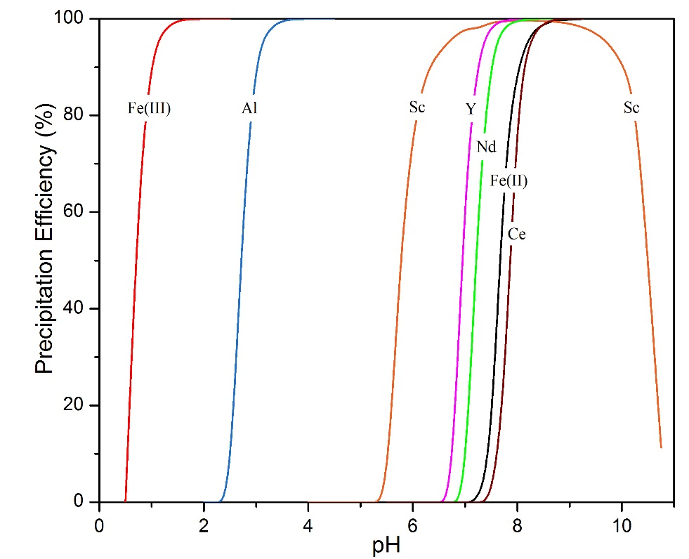
Figure 1. Visual Minteq Simulation for Hydroxide Precipitation from Red Mud Leachate

Although Sc precipitation concluded at pH 8, after reaching this point Sc starts to dissolve again in the system according to the simulated solution system as a consequence of stabilization of Sc(OH)₆⁻³ complex which is soluble in highly alkaline environment [17].
According to the simulation results of the solution system, separation of Fe(III) and Al from the other constituents in the solution by hydroxide precipitation seems to be a similar task, however, owing to the formation of intermediate complexes and interactions of ions with each other in the multicomponent system during precipitation, co-precipitation that takes place is ignored by the software. Since, the major problem of the scandium recovery by precipitation from multicomponent solution is co-precipitation with ions presented in the system, especially with iron, experimental investigation of the system is necessary.

3.2 Hydroxide Precipitation
In order to observe the precipitation behaviour of Sc with both conventional and unconventional precipitation agents, solution containing only 0.5 g/L Sc was tested. Figure 2 demonstrates the experimental results of precipitation of Sc(OH)₃ with limestone, NaOH, NH₃(aq) and hexamethylenetetramine (HMTA). The conventional hydroxide precipitation agents, limestone, NaOH and NH₃(aq), showed similar behaviour in the absence of other constituent ions. The precipitation begins from the addition of the agents, has plateaus between pH 2-5, and then is followed with the rise of the precipitation rate until completion of the reaction.
Figure 2. Hydroxide precipitation with limestone, NaOH, NH₃ and HMTA of solution containing only 0.5 g/L Sc
On the other hand, HMTA which undergoes a slow hydrolysis reaction that results in the release of formaldehyde and ammonia in low pH or elevated temperatures, exhibits a totally different behaviour when compared to the rest of the solutions [18,19]. In this case, immediate pH change was not detected upon addition, due to slow decomposition of the precipitation agent. However, as a result of ammonia discharge in acidic environment, precipitation started with the addition of the agent to the system.
Addition of limestone, NaOH, NH₃(aq) and KOH to synthetic multi element red mud solution was investigated as well, and the precipitation trends of the ions in the system can be seen from Figure 3. Since the release of formaldehyde gas by adding HMTA into the acidic system is toxic, this precipitation agent was not used in these comparisons.
The first aim is to remove Fe(III) from the system with minimal amount of co-precipitation of the other ions in the solution. Addition of limestone slurry to the system initially triggered the Fe(III) precipitation around pH 2.8 which then finalises the precipitation at pH 3.5. During complete Fe(III) precipitation, all other elements were co-precipitated around 15-20%. Similar precipitation behaviour was also seen in the case of NaOH and KOH addition where Fe(III) precipitation was observed to occur between ph 2.5-3.5, and co-precipitation of the others were in the range between 15-30% for both precipitants. The precipitation order for these experiments were determined as Fe(III)>Al≈Sc>Y=Nd.
In the case of NH₃(aq) addition Fe(III) precipitation started at pH 3.1 and concludes at approximately pH 3.8. The minimum co-precipitation values were obtained with ammonia solution addition to the system. When Fe(III) was almost completely eliminated from the system, Sc and REE losses were between 4-10%. This indicates ammonia addition is superior, compared to other hydroxide donors with regards to the co-precipitation of valuable and recoverable ions in the system. A possible reason for low Sc co-precipitation as Fe(III) is almost completely precipitated is because of the occurrence of scandium hexammine complex upon addition of ammonia to the system which can inhibit the interaction between Fe and Sc and prevent co-precipitation in the system[17,20,21].
Figure 3. Hydroxide precipitation of synthetic red mud leachate solution by a)Limestone, b)NaOH, c)KOH, d)NH₃(aq)
a)
b)
c)
d)
Analogous to solvent extraction parameters, selectivity coefficients (S) can also be used as suitable tool to compare the selectivity of the different precipitation agents. Selectivity of the element A over B can be calculated by the Eq. (1):
and Eq. (1)

where, D_{A} or D_{b} is the distribution coefficient of the mentioned element, C_{prec} is the concentration of the element in the precipitate, C_{aq} is the concentration of the element in the aqueous solution after precipitation, S_{A/B} is the selectivity coefficient which indicates the selectivity of A over B.
Table 3a and 3b show the critical pH values for Fe(III) removal by comparing all precipitation agents according to precipitation efficiency and indicates the selectivity coefficients of Fe(III) over Sc.
As it can be clearly seen from the Table 3a and 3b, in all cases, ammonia solution showed superior selectivity when it compared to the other precipitation solutions. It is obvious that the most efficient precipitation agent for partial and nearly complete Fe(III) removal whilst keeping Sc and the other recoverable precious ions in the solution is ammonia solution within the pH range of 3.3-3.6.

Table 3a. Critical pH values for 70% Fe(III) removal from the system by hydroxide precipitation and precipitation % of the constituent ions with selectivity of Fe over Sc
Precipitation Agent | pH | Fe(%) | Sc(%) | Al(%) | Y(%) | Nd(%) | S_{Fe/Sc}
Limestone | 3.28 | 72.7 | 12.9 | 11.8 | 11.4 | 12.1 | 18
NaOH | 3.16 | 71.3 | 16.4 | 11.9 | 19.0 | 17.7 | 13
KOH | 3.20 | 69.7 | 26.7 | 22.4 | 27.7 | 28.1 | 6
NH₃(aq) | 3.35 | 73.5 | 1.6 | 7.4 | 1.4 | 1.3 | 170

Table 3b. Critical pH values for above 90% Fe(III) removal from the system by hydroxide precipitation and precipitation % of the constituent ions with selectivity of Fe over Sc
Precipitation Agent | pH | Fe(%) | Sc(%) | Al(%) | Y(%) | Nd(%) | S_{Fe/Sc}
Limestone | 3.54 | 95.1 | 17.0 | 14.8 | 15.1 | 17.1 | 95
Limestone | 3.83 | 95.6 | 18.7 | 15.8 | 18.9 | 17.4 | 94
NaOH | 3.40 | 94.6 | 22.1 | 18.7 | 23.6 | 23.1 | 62
NaOH | 3.57 | 97.1 | 28.4 | 22.3 | 25.4 | 24.3 | 84
KOH | 3.68 | 96.7 | 28.9 | 24.1 | 29.3 | 28.9 | 72
NH₃(aq) | 3.48 | 92.1 | 4.0 | 8.4 | 1.9 | 1.9 | 280
NH₃(aq) | 3.65 | 96.6 | 8.9 | 16.7 | 6.7 | 7.6 | 291
NH₃(aq) | 3.82 | 98.1 | 20.4 | 18.7 | 12.3 | 11.8 | 201

3.3 Phosphate Precipitation
This section of the study investigates the precipitation of Sc and REEs by the addition of 1mol/L dibasic phosphate solutions. Previous studies showed that, Y³⁺ and REE ions indicated strong affinity towards PO₄³⁻, compared to SO₄²⁻ upon the addition of phosphate salts to sulphate solution of Y and REEs [22-25]. As the behavioural similarities between Sc and REEs, the similar precipitation can be triggered by the addition of dibasic salts.
Dibasic salts, K₂HPO₄, (NH₄)₂HPO₄ and Na₂HPO₄, were tested for Sc precipitation according to the given Eq. (2):
Eq.(2)

These specific dibasic phosphates were chosen to observe the effect of pH on precipitation efficiency and precipitated products without addition of basic solutions. Upon dissolution in aqueous solutions, these dibasic phosphates decompose into its base (KOH, NH₃ and NaOH in this specific case) and the phosphate ion, so the favoured complexes formed with different reactions in various pH values can also be observed.
The precipitation behaviour of Sc in a pure solution with dibasic phosphate salts are indicated in Fig. 4 with respect to change in pH values. Immediate precipitation was observed after the addition of these precipitation solutions. For all of the cases, precipitation was finalised between pH 2-3 and all of the precipitation agents showed similar behaviour in the absence of another impurity ion.

Figure 4. Phosphate precipitation with K₂HPO₄, (NH₄)₂HPO₄ and Na₂HPO₄ of solution containing only 0.5 g/L Sc

When impurity ions were introduced into the system, the precipitation agents again showed similar behaviours as observed in the pure solution. However, the efficiencies of the reactions are distinctive for each cases. Figure 5 shows the precipitation trends of the individual ions present in the system after the addition of dibasic phosphate precipitation solution. Since protons were released via H_{x}PO₄^{x-3} (1≤x≤3) during precipitation of the constituents with a pH change, it is postulated that there has been a change in reaction mechanism. For all cases, precipitation order was observed to be Sc=Fe(III)>Y=Nd>Al.
Addition of K₂HPO₄ solution into the synthetic red mud leachate resulted in immediate reaction of both Sc and Fe(III), while the co-precipitation of the other impurities remained at low levels (Figure 5a). Addition of 0.2 mmol of precipitation solution resulted in the precipitation of 73% of Sc in the solution while 66% Fe, 7% Al, 16% Nd and 17% Y were co-precipitated at pH 1.35. Further additions of the precipitant increase the pH, and alter the stability of the phosphate ion. When Sc is completely precipitated, 94% of Fe, 34% of Al, 51% of Y and 48% of Nd were also co-precipitated.
In accordance with Figure 5b, although (NH₄)₂HPO₄ solution showed analogous precipitation behaviour with the K₂HPO₄ solution, rather than an instant reaction, it was observed that the reaction rate was lower than the others but the co-precipitation percentages of the impurity ions were limited. 86% of the Sc was recovered from the leachate whereas 80% Fe, 25% Al, 18% Y and Nd were co-precipitated with Sc at pH 1.9. Once Sc almost completely recovered from the solution the precipitation efficiencies of Fe, Al, Y and Nd observed as 89%, 37%, 48% and 46% respectively. Furthermore, decomposition of (NH₄)₂HPO₄ into NH₃(aq) and its phosphate in aqueous solutions, can be followed by the formation of hexammine complexes and the change in precipitation behaviour than the other phosphates used.
Figure 5c shows the precipitation behaviour of the synthetic red mud leachate upon the addition of Na₂HPO₄ solution. The precipitation behaviour was very similar which was also detected in the case of K₂HPO₄ precipitation. As the precipitant was added to the solution system, precipitates immediately formed. 74% Fe, 20% Al, 32% Y and 29% Nd were precipitated whereas Sc had 79% precipitation efficiency at pH 1.8. 92% of Fe, 38% of Al, 51% of Y and 49% of Nd in the solution was precipitated from the system when almost complete Sc recovery was fulfilled.
Critical recovery percentages and the related pH values considering maximum Sc recovery with the lowest co-precipitation percentages of the ions in the solution can be found in the Table 4.

Figure 5. Phosphate precipitation of synthetic red mud leachate solution by a) K₂HPO₄, b) (NH₄)₂HPO₄, c) Na₂HPO₄
a)
b)
c)

Table 4. Critical pH values for above 80% Sc recovery from the solution system by dibasic phosphate precipitation and the precipitation efficiencies of the constituent ions
Precipitation Agent | pH | Fe(III)(%) | Sc(%) | Al(%) | Y(%) | Nd(%)
K₂HPO₄ | 1.84 | 84.2 | 91.2 | 21.6 | 35.1 | 33.1
K₂HPO₄ | 2.45 | 94.8 | 97.1 | 33.9 | 50.7 | 47.7
(NH₄)₂HPO₄ | 1.93 | 80.1 | 86.3 | 25.4 | 18.1 | 18.4
(NH₄)₂HPO₄ | 2.85 | 89.1 | 97.6 | 36.5 | 47.8 | 45.6
Na₂HPO₄ | 1.79 | 73.6 | 78.7 | 19.5 | 32.4 | 29.2
Na₂HPO₄ | 2.80 | 91.8 | 94.2 | 37.8 | 51.2 | 49.2

When the dibasic phosphate solutions were compared, the best pH range for low co-precipitation was established to be between from 1.5 to 2.5. The precipitation efficiencies for all species in the system are observed to be higher once pH reaches greater values, owing to the additional complexes forming in the system, which is the main cause for this amplified yield. For instance, aside from FePO₄, precipitation of Fe(OH)₃ was also favoured at higher pH values compared to the previously mentioned pH interval. The formation of hydroxide species at higher pH values also adversely affects the selectivity for Sc and Fe precipitation. In addition, in the pH range used, the phosphate complex has a higher thermodynamic stability than the double sulphate complex, thus, the final precipitates contained no double sulphates.
In terms of selectivity for Sc over the impurities in the solution, K₂HPO₄ was more selective for Sc compared to Na₂HPO₄ as shown in Table 5. On the other hand, (NH₄)₂HPO₄ displayed superior performance compared to other precipitation agents, for both partial and the complete Sc recovery from the solution. It has the highest Sc recovery percentages, in addition to lowest co-precipitation percentages among the dibasic phosphate salts.

Table 5. Selectivity coefficients of Sc over Al, Y and Nd for partial and almost complete Sc recovery from the solution by dibasic phosphate precipitation
Precipitation Agent | pH | S_{Sc/Al} | S_{Sc/Y} | S_{Sc/Nd}
K₂HPO₄ | 1.84 | 38 | 19 | 21
K₂HPO₄ | 2.45 | 65 | 33 | 37
(NH₄)₂HPO₄ | 1.93 | 19 | 29 | 28
(NH₄)₂HPO₄ | 2.85 | 71 | 44 | 49
Na₂HPO₄ | 1.79 | 15 | 8 | 9
Na₂HPO₄ | 2.80 | 27 | 15 | 17

4. Assessment and Conclusion
Two different precipitation approaches were tested on synthetic red mud pregnant leach solution for recovery of Sc from sulphate media. Different hydroxide donors; limestone, NaOH, NH₃(aq) and KOH were investigated, and among those, NH₃(aq) showed superior performance in the removal of Fe(III) from the system, and had the lowest co-precipitation percentages of the remaining species in solution. While above 90% of the Fe(III) was removed from the solution, Sc losses owing to co-precipitation with Fe(III) were 4% at pH 3.5. At pH 3.35, Fe can be removed by almost 75%, while keeping Sc losses at approximately 1.5%. A two-step process for Fe removal is proposed prior to final Sc separation from the PLS.
The other approach examined is phosphate precipitation using dibasic phosphate solutions as the precipitant. As a consequence of addition of dibasic phosphate to the synthetic PLS, almost instantaneous and selective Sc and Fe precipitation was achieved. (NH₄)₂HPO₄ exhibited greater yield in terms of Sc and Fe(III) precipitation with minimal Al and REEs co-precipitation. Selective Sc separation is possible with dibasic phosphates only if Fe in the solution is removed beforehand.
Calcium, one of the major impurities in the BR, tends to react with none of the precipitation agents introduced to the system, therefore no additional steps needed for Ca removal from the system. On the contrary, due to the problematic behaviour of Fe(III) during various purification steps, co-precipitation with Sc, or loading, scrubbing and stripping problems throughout solvent extraction, etc., aluminium remaining in the system can be removed with additional minor steps.
Taking into consideration the results attained from this study, a possible process route is proposed, which may be directly applicable to the highly impure PLS (Figure 6). A dual stage Fe removal process with ammonia solution addition prior to the final Sc recovery stage, by the addition of dibasic phosphate in the absence of Fe, in the PLS is proposed. This is expected to result in high yield and selectivity for the recovery of Sc from solution. To allow minimal losses of Sc during the second iron removal stage, the residue obtained from the 2nd stage is recycled and used as seed material for the 1st stage of iron removal. Since this residue contains lower amount of Fe in its composition compared to the residue obtained by 1st Fe removal stage, recycling it directly into the PLS will not affect the initial composition drastically and will provide a driving force for nucleation/precipitation. The resulting ScPO₄ precipitate produced, which contains a small amount of Al and REEs can be converted into hydroxide, via dissolution in NaOH for further product purification.

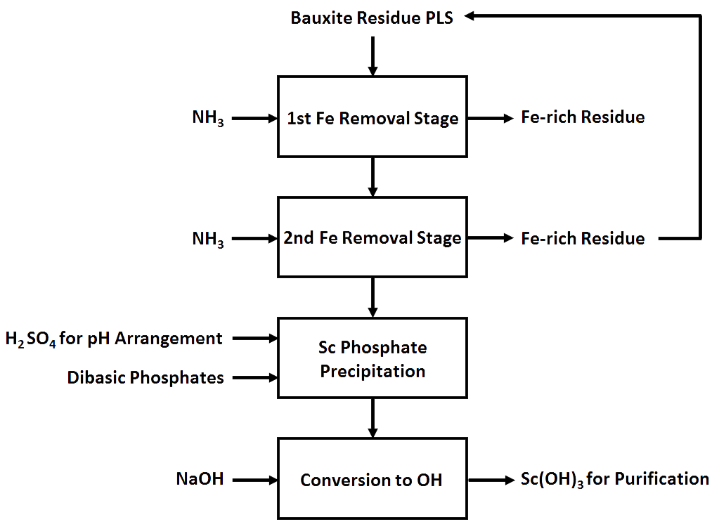
Figure 6. Proposal flow sheet for Sc recovery from Bauxite Residue PLS

To enhance the efficiency of the process, kinetics and the temperature dependence of the mentioned reactions need more detailed examination.

5. Acknowledgements
The research leading to these results has received funding from the European Community’s Horizon 2020 Programme ([H2020/2014–2019]) under Grant Agreement no. 636876 (MSCA-ETN REDMUD). This publication reflects only the author’s view, exempting the Community from any liability. Project website: http://www.etn.redmud.org.

6. References
1. Lathabai S, Lloyd P (2002) The effect of scandium on the microstructure, mechanical properties and weldability of a cast Al–Mg alloy. Acta Materialia 50 (17):4275-4292
2. Lee S, Utsunomiya A, Akamatsu H, Neishi K, Furukawa M, Horita Z, Langdon T (2002) Influence of scandium and zirconium on grain stability and superplastic ductilities in ultrafine-grained Al–Mg alloys. Acta Materialia 50 (3):553-564
3. Marquis E, Seidman D (2001) Nanoscale structural evolution of Al 3 Sc precipitates in Al (Sc) alloys. Acta materialia 49 (11):1909-1919
4. Ormerod RM (2003) Solid oxide fuel cells. Chemical Society Reviews 32 (1):17-28
5. Yamamoto O (2000) Solid oxide fuel cells: fundamental aspects and prospects. Electrochimica Acta 45 (15):2423-2435
6. Feuling RJ (1991) Recovery of scandium, yttrium and lanthanides from titanium ore. Google Patents,
7. Gongyi G, Yuli C, Yu L (1988) Solvent Extraction off Scandium from Wolframite Residue. JOM 40 (7):28-31
8. Wang W, Cheng CY (2011) Separation and purification of scandium by solvent extraction and related technologies: a review. Journal of Chemical Technology and Biotechnology 86 (10):1237-1246
9. Wang W, Pranolo Y, Cheng CY (2011) Metallurgical processes for scandium recovery from various resources: A review. Hydrometallurgy 108 (1):100-108
10. Power G, Gräfe M, Klauber C (2011) Bauxite residue issues: I. Current management, disposal and storage practices. Hydrometallurgy 108 (1):33-45
11. Borra CR, Pontikes Y, Binnemans K, Van Gerven T (2015) Leaching of rare earths from bauxite residue (red mud). Minerals Engineering 76:20-27
12. Ochsenkühn-Petropoulou MT, Hatzilyberis KS, Mendrinos LN, Salmas CE (2002) Pilot-plant investigation of the leaching process for the recovery of scandium from red mud. Industrial & engineering chemistry research 41 (23):5794-5801
13. Ochsenkühn-Petropulu M, Lyberopulu T, Ochsenkühn K, Parissakis G (1996) Recovery of lanthanides and yttrium from red mud by selective leaching. Analytica Chimica Acta 319 (1):249-254
14. Wang W, Pranolo Y, Cheng CY (2013) Recovery of scandium from synthetic red mud leach solutions by solvent extraction with D2EHPA. Separation and Purification Technology 108:96-102
15. Ochsenkühn-Petropulu M, Lyberopulu T, Parissakis G (1995) Selective separation and determination of scandium from yttrium and lanthanides in red mud by a combined ion exchange/solvent extraction method. Analytica Chimica Acta 315 (1):231-237
16. Vassiliadou V (2015). Aluminum of Greece, Internal Communications
17. Horovitz CT (2012) Scandium Its Occurrence, Chemistry Physics, Metallurgy, Biology and Technology. Elsevier
18. Chen PL, Chen IW (1993) Reactive cerium (IV) oxide powders by the homogeneous precipitation method. Journal of the American Ceramic Society 76 (6):1577-1583
19. Li JG, Ikegami T, Mori T, Yajima Y (2004) Sc2O3 nanopowders via hydroxyl precipitation: effects of sulfate ions on powder properties. Journal of the American Ceramic Society 87 (6):1008-1013
20. Stevenson PC, Nervik WE (1961) The radiochemistry of the rare earths: scandium, yttrium, and actinium, vol 3020. National Academies
21. Vickery RC (1960) The chemistry of yttrium and scandium, vol 2. Oxford
22. Firsching FH, Brune SN (1991) Solubility products of the trivalent rare-earth phosphates. Journal of Chemical and Engineering Data 36 (1):93-95
23. Liu X, Byrne RH (1997) Rare earth and yttrium phosphate solubilities in aqueous solution. Geochimica et Cosmochimica Acta 61 (8):1625-1633
24. Lucas S, Champion E, Bregiroux D, Bernache-Assollant D, Audubert F (2004) Rare earth phosphate powders RePO 4· nH 2 O (Re= La, Ce or Y)—part I. Synthesis and characterization. Journal of Solid State Chemistry 177 (4):1302-1311
25. Beltrami D, Deblonde GJ-P, Bélair S, Weigel V (2015) Recovery of yttrium and lanthanides from sulfate solutions with high concentration of iron and low rare earth content. Hydrometallurgy 157:356-362

